Vital

Updating Digital Object Properties

A digital object on Vital has several properties that can be updated. To update a digital object, first authenticate with the Sign In button on the top right of the screen. Select the Site the digital object resides.

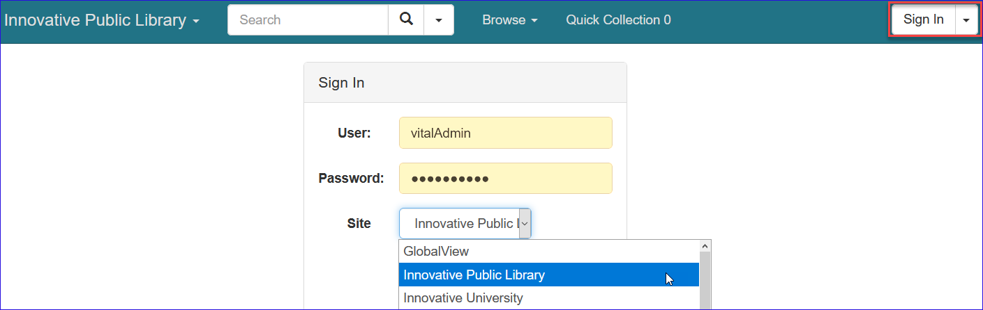

Search and retrieve the digital object to update.

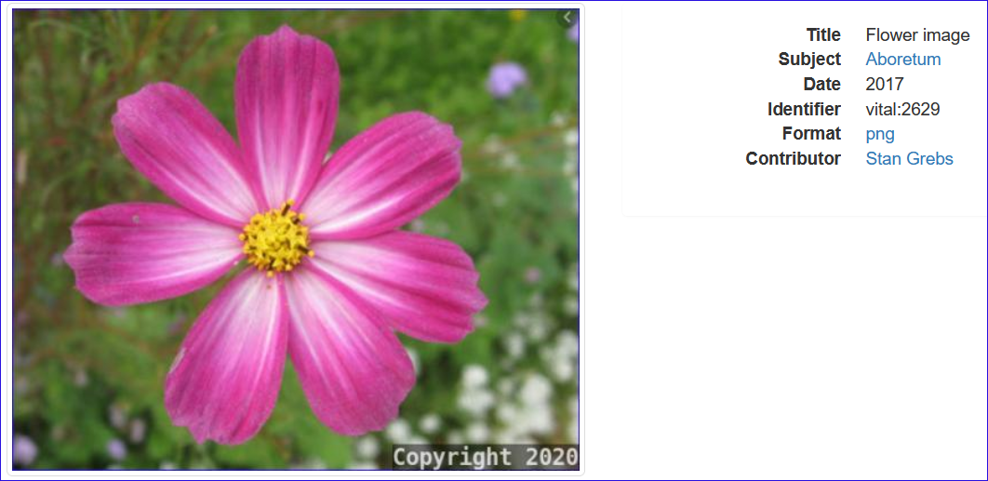

On the left side bar, select Properties.
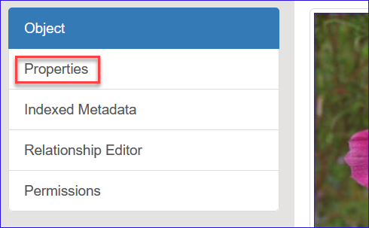

The first property that can be changed is the State. Active objects are publicly displayed. Changing the state to Inactive or Deleted will suppress the digital object in the public display.

The next property allows the editing of the name of the file attached to the digital object.

Also available for update are the choice to offer digital object in Global View, change the Site the digital object belongs, and if access to the digital object is restricted by IP addresses.

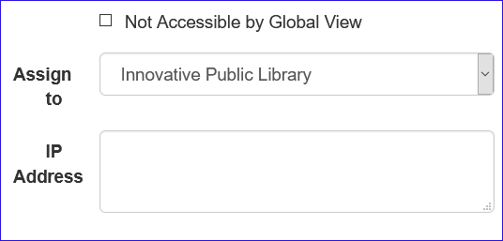

To the right is the option to change the collection a digital object belongs.

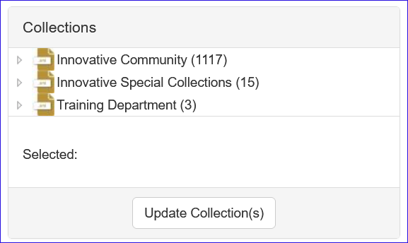

To add, update or remove the file attached to the digital object, select Object on the left side bar.

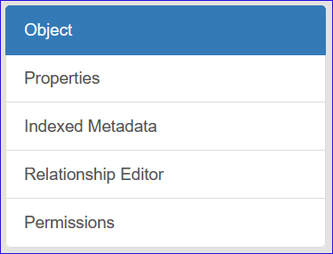

On the lower part of the page, are the datastreams which in combination make up the entirety of the digital object. To add a new file, click on +Add above the datastreams.

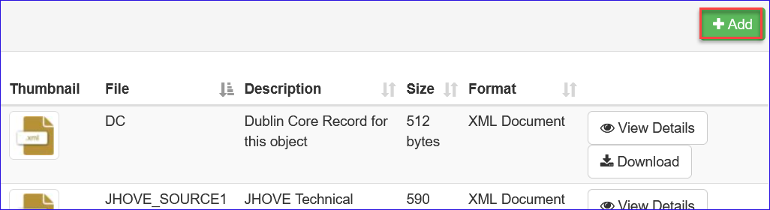

There are 3 methods to attach a new file to a digital object.
- Upload – This permits attaching a file from any drive accessible by your workstation.
- External Datastream – This permits attaching a file using a URL. The file is stored on the Vital server.
- Redirect Datastream – This also permits attaching a file using a URL. Only the link is stored in Vital with the file continuing to reside on the remote server.

Under the selections are the site assignment and the IP restrictions if needed.
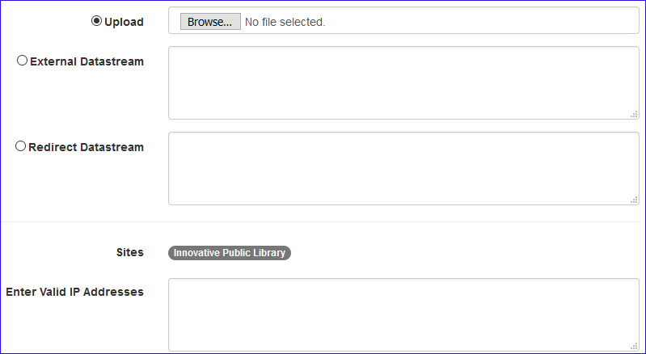

Select Continue on the bottom right of the screen to complete the transaction or select Cancel to exit without adding a new file. To remove or replace an existing file. Select the datastream for that file (typically called SOURCE1 for the first attached file, SOURCE2 for the second attached, etc) and select View Details.

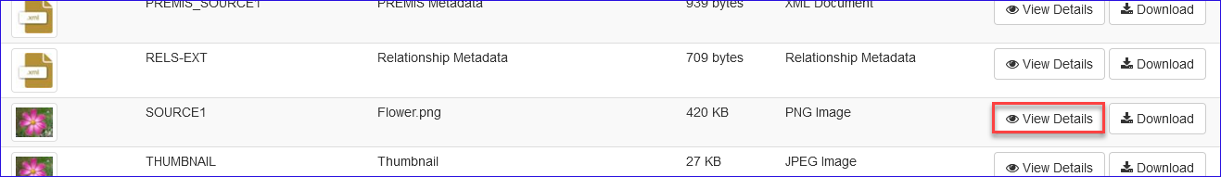

On the top right are options to Replace which will offer the option to upload a new file, Delete which will remove the file and Lock which will block additional changes to the file by other staff without authorization until unlocked.

On the right, Permissions determine the available functions for site specific users with regards to the datastream.

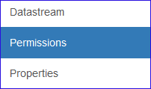

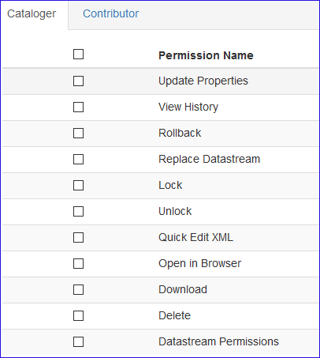

This publication is supplied for the exclusive use of customers of Innovative Interfaces with the understanding that it shall not be shown or distributed to anyone outside of the customer's organization without the prior written permission of Innovative Interfaces. This publication may be copied only if the copies are for the exclusive use of staff members of libraries that have purchased the Innovative system.
© 2022, Innovative Interfaces, Inc.

