vital Organization

Communities and Collections

Introduction to Communities and Collections
Communities and collections are a means for organizing digital objects within the repository. Vital can be configured to contain collections (sets of digital objects) and communities (groups of collections).

Note: Each community has one or more collections linked and each collection has one or more digital items linked.

This image provides an example of a single community containing multiple collections.

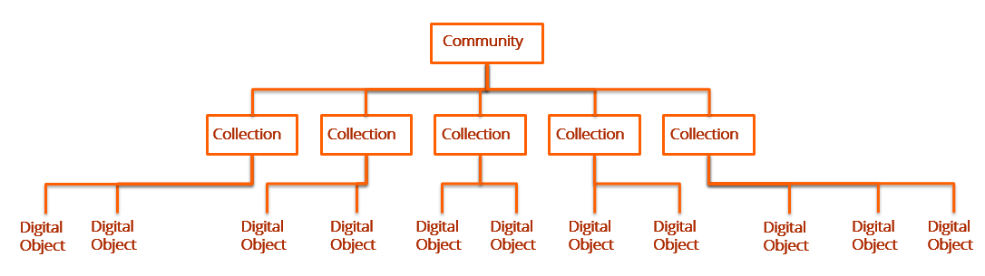

Basic Concepts:
- A community is used to group together collections.
- One or more communities belong to a site (consortia have multiple sites)
- A collection is used to group together digital objects.
- Digital objects are linked to collections, not communities
- In combination, digital objects are presented to the user with descriptive metadata and organized in collections and communities.
- The Communities & Collections browse allows you to view a hierarchical, nested list of communities and collections in the repository, and perform keyword or browse searches for objects within a selected collection. For a selected collection, you can choose to browse by Title, Creator, or Subject.

Sample Communities and Collections Hierarchy

The image below shows a hierarchy of communities and the collections under each community.

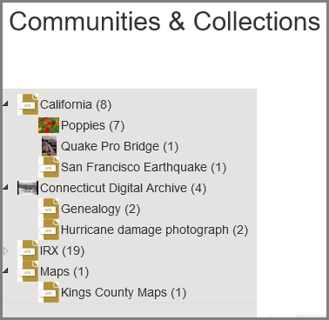

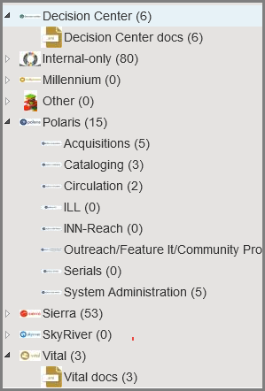

This publication is supplied for the exclusive use of customers of Innovative Interfaces with the understanding that it shall not be shown or distributed to anyone outside of the customer's organization without the prior written permission of Innovative Interfaces. This publication may be copied only if the copies are for the exclusive use of staff members of libraries that have purchased the Innovative system.
© 2022, Innovative Interfaces, Inc.

