vital Organization

How to Create a Community

Create a Community

To create a community, you need to be logged in to Vital.
- Once logged in, select a site (you cannot create communities in the Global View so it is necessary to choose a site).
- On the Administrative sidebar, click the Manage Communities link.

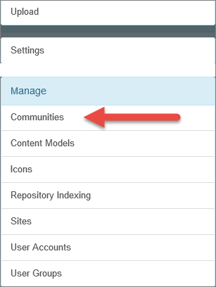

- On the Manage Communities screen, select + Add a Community.
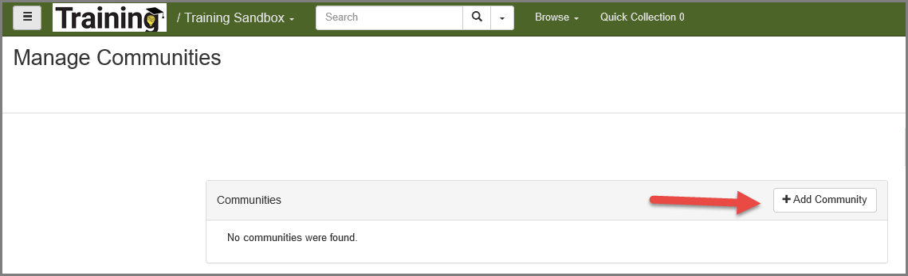
The workform to create a new community opens up.
- Complete the fields: add a unique name to the community, and a description. Check the box if the community should be accessible via Global View.
- Click Save.
Note: Fields marked with a red asterisk are required fields.

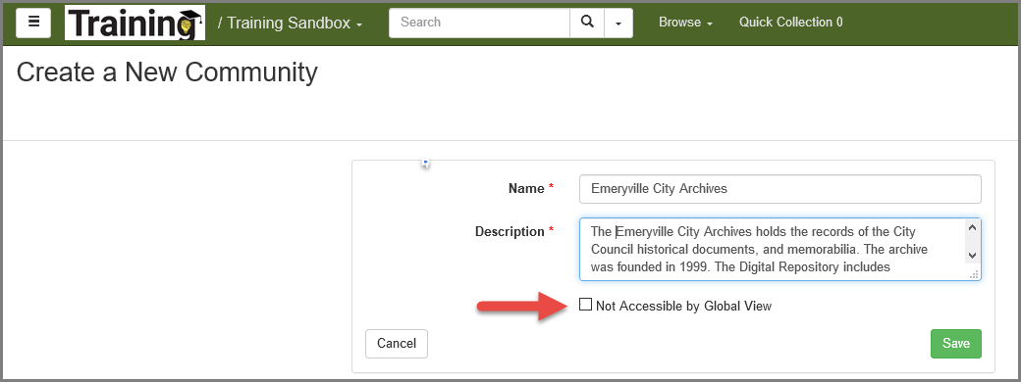

The new community is created and it displays under Manage Communities. A community is considered a digital object, each digital object in Vital is assigned a unique identifier named PID.
Click the edit button beside the new community to open its Object Properties page.
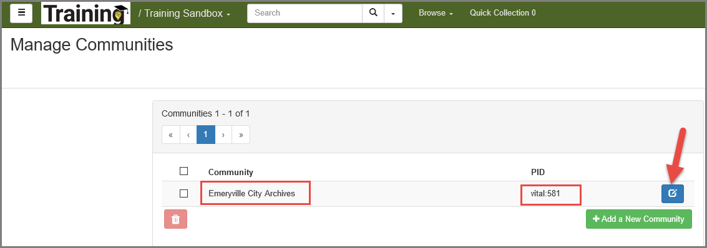

Note: You can add a thumbnail image for the community. The thumbnail image will be displayed on the Community Search and Permissions page in the Administrative interface, and on the Community page in the public access interface.

Edit a Community Object

To edit the title and/or description of a community:

- Display the object page of the community whose elements you want to edit.
- In the Administrative sidebar, click the Update Object Properties link.
The Object Properties page appears.

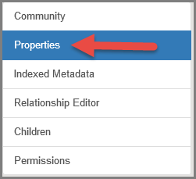

- In the Datastreams table, click DC in the Datastream ID column.
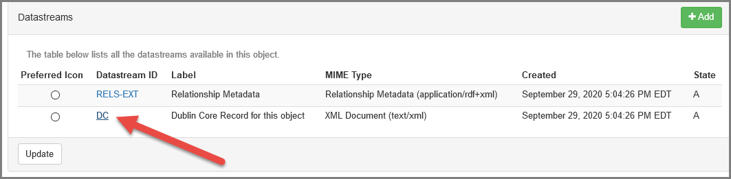
The Datastream Properties page appears.

- On the top menu, click the Edit button.
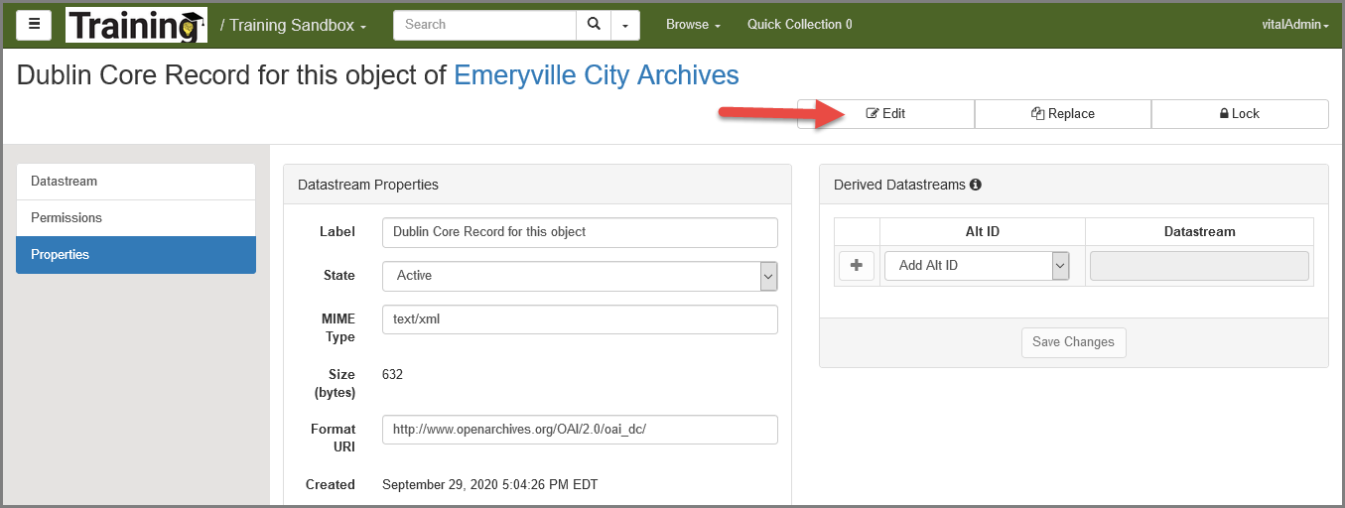
The Quick Edit XML page appears, displaying the Dublin Core metadata for the community object in HTML View. You can change title and description. Save the object after making changes.

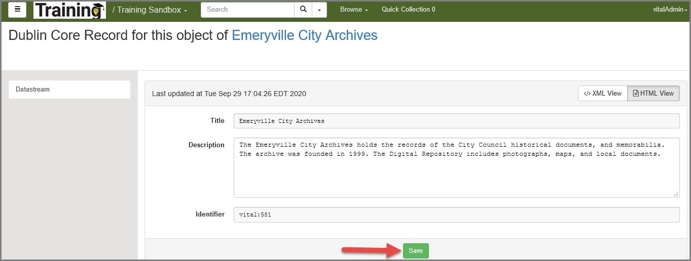

Add a Thumbnail Image for a Community

To add a thumbnail image to a Community, from the Manage Communities page, navigate to the Community page.

- Select Properties:

The Object Properties page for the community appears.
- Scroll down so that the Datastreams table is in view.
- On Datastreams table, click the Add button.
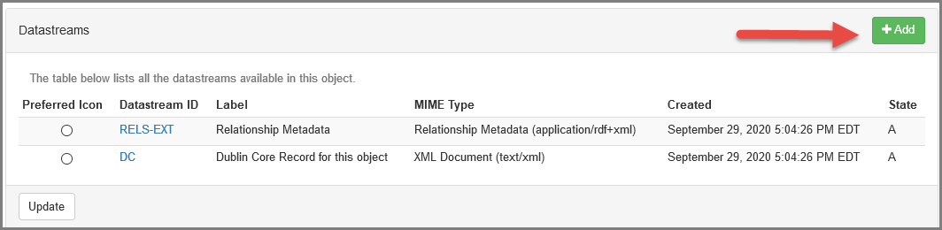

- The Add Datastream page appears.
- On the Add Datastream page, add an image file datastream to the community object. Select Upload to select an image from your local PC. Click Continue.

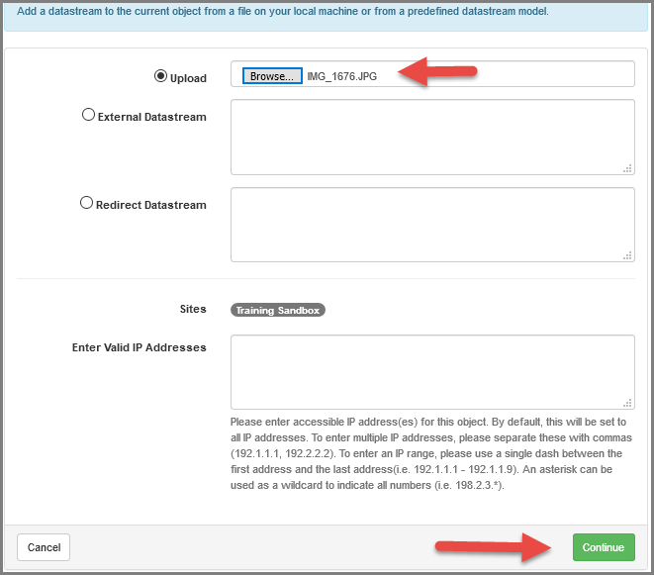

(To add an external datastream: Click the External Datastream radio button, and then type a URL to external content that will be referenced by Fedora. This URL will be recorded within the digital object, and each time the content is accessed, Fedora will request it from the host and send it to the client. To add a redirect datastream: Click the Redirect Datastream radio button, and then type a URL to external content that will be referenced by Fedora but handled via an HTTP redirect. Choose this type of datastream when the content contains relative hyperlinks or when the Internet site generates a media stream that must be accessed directly, without mediation by Fedora.)

- On the second Add Datastream page, edit the information as needed for the new datastream:
If possible, Vital will populate the Label field with a default label. This label will appear in the Datastream table on the Object Properties page.
If you want to mask the datastream, i.e., hide it from public view in the interface, select Inactive in the State drop-down list.
The software automatically detects the MIME type of the datastream and populates the MIME Type field on the Add Datastream page. The MIME Type field is required.
Leave the following two fields blank: Format URI and Alternate IDs. Once the datastream is created, the Alternate IDs field will be automatically populated.
If the source data for the datastream is an image-based file, the Add Datastream page will display a Watermarking Text field. If you enter text in the field, it will appear as a watermark in the lower right corner of the image being ingested as shown below.

- Click Continue.
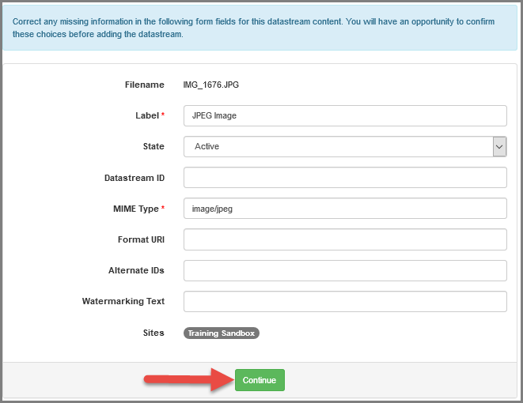

- Click Add.
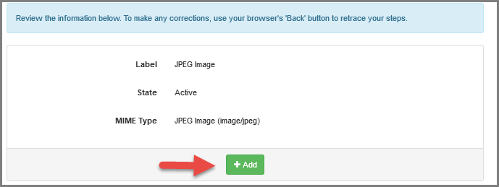

- Vital returns you to the Community page.
- Click the Reindex button. Vital reindex the community, and automatically creates a THUMBNAIL_SOURCE1 datastream for the new image datastream, and sets the THUMBNAIL_SOURCE1 datastream as the preferred icon image.

- The new thumbnail image appears on the Community page.

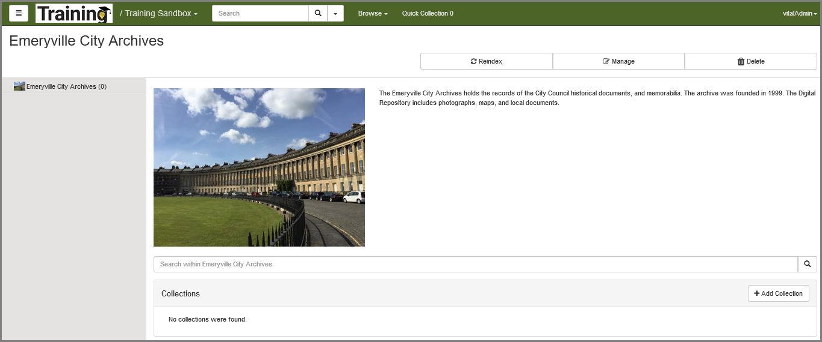

This publication is supplied for the exclusive use of customers of Innovative Interfaces with the understanding that it shall not be shown or distributed to anyone outside of the customer's organization without the prior written permission of Innovative Interfaces. This publication may be copied only if the copies are for the exclusive use of staff members of libraries that have purchased the Innovative system.
© 2022, Innovative Interfaces, Inc.

