SkyRiver

How to Spine and Pocket Label with SkyRiver

Spine and Pocket Label Printing with SkyRiver
Following is information for users setting up spine (and optionally pocket) label printing for SkyRiver.

Guide to Advanced Format Settings

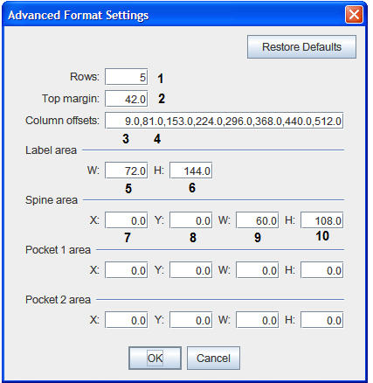

- Rows: For sheet fed only - number of rows of labels on sheet
- Top Margin: Points from top edge of sheet to top edge of label
- Column Offset: Offset from left edge of paper
- Additional column offsets: For sheet fed only - point where next label in row begins
- Label Area W: Width, in points, of label
- Label Area H: Height, in points, of label
- Spine area X: Number of points to left of column offset to start printing
- Spine Area Y: Number of points from top to start printing
- Spine Area W: Print area width, in points
- Spine Area H: Print area height, in points
- Pocket 1 Area X, Y, W, and H: Same as elements 7-10 for first pocket, if there is one.
- Pocket 2 Area X, Y, W, and H: Same as elements 7-10 for second pocket, if there is one.

Note: Points are a typographic unit of measurement. There are 72 points to an inch or 28.35 points to a centimeter.

Continuous Feed Label Stock
Occasionally, users of continuous feed labels have difficulty communicating the correct amount of form feed to the printer. Form feed normally is a setting within the printer driver or sometimes on the printer itself. In instances where none of these seem to work, there is a way for the client program to send information about page size to the printer. Innovative suggests that you try this only after working with the printer's own settings and failing to produce the desired output.

Open the ftr.properties file (located in the directory in which you installed the client, that is, C:\SkyRiver) in a text editor and add a line to the bottom of the file that delineates the "page" size of the label such as:

print.label.size = 324.0;216.0
Where element one [324.0] is the width, in points, and element two [216.0] is the height in points of the label "page."

In the example above, you are instructing the client to print labels to a 4.5" wide (324 = 4.5 * 72) by 3" high (216 = 3 * 72) page.

Restart the client after saving your changes. You must update the ftr.properties file on each PC that is printing labels to a printer of this type.

Zebra Printers and SkyRiver
A Zebra printer of any model has to include the word "ZDesigner" in the name of the printer (set in the Printer Driver settings) in order for the SkyRiver client to recognize it as a valid label printer. "ZDesigner" can be in any position, for example, "ZDesigner label printer," "Zebra ZDesigner" or "Zebra Zdesigner labels."

Print to File
The default print mode for SkyRiver labels is graphical. That means that the Java program captures an image and sends that to the printer to render as an image. Graphical printing provides you with the widest range of choices for font and text effects.

Some libraries, however, use label printers that cannot accept graphical images or use third-party text editing software that requires a text file in order to edit it before printing.

To create your labels in a text format, choose "Print to file" from the Select Label Printer menu page and then Browse for a file location. Note that selecting this option does not automatically send the labels to the printer. It sends the label(s) to the selected file, and then you must send the file to the printer as a separate step.

Printer Setting Examples
Below are some examples of printer settings that have worked for many SkyRiver users. Click the printer type to view the related settings.

Printer Type: Computype Mach4
- Label Type: continuous feed spine only
- Label Stock Number: Computype 1005542 1.125" x 1.125"

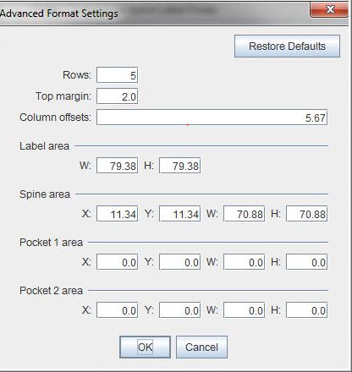

Printer Type: Dymo LabelWriter 400
- Label Type: continuous feed spine only
- Label Stock Number: Dymo label stock 30332 1"x1"

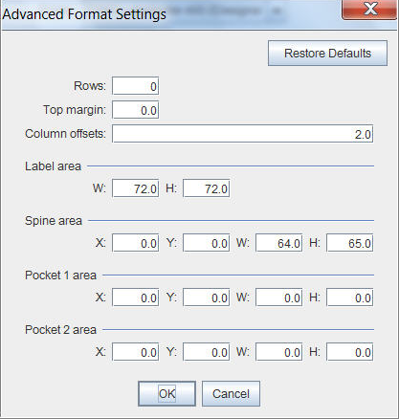

Printer Type: HP LaserJet 2420 PCL6
- Label Type: sheet spine only
- Label Stock Number: Demco 14916750 1.25" x .9"

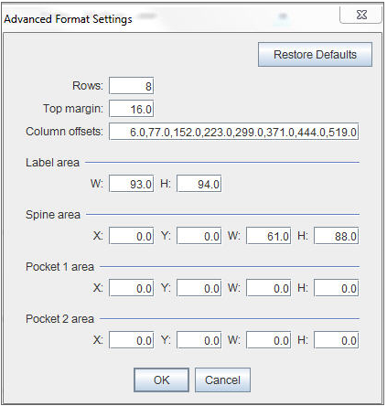

Printer Type: HP LaserJet P2035
- Label Type: sheet spine and label
- Label Stock Number: Brodart 55-395-021 (8 sets to a sheet)
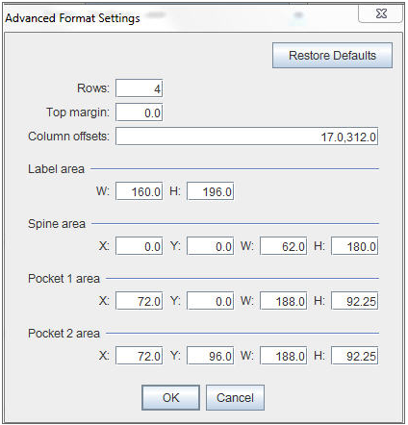
Printer Type: Oki Microline 420 - 9 pin
- Label Type: continuous feed spine and label
- Label Stock Number: Brodart SL4S

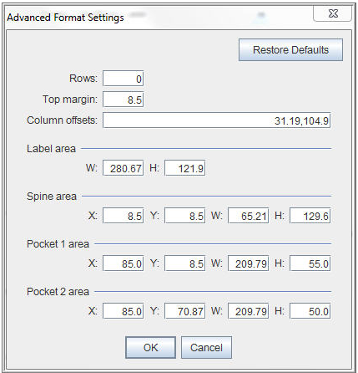

Printer Type: Oki Microline 420 - 9 pin
- Label Type: continuous feed spine and label
- Label Stock Number: Brodart SLB
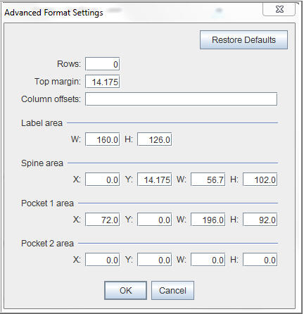

Printer Type: Zebra GX430t
- Label Type: continuous feed spine only
- Label Stock Number: Computype 14843901 1" x 1.5" (also known as 1005541-1)

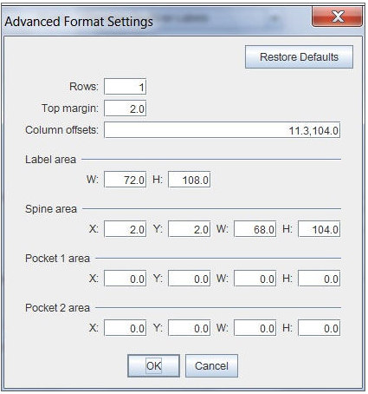
Printer Type: Zebra TLP 2824 Plus
- Label Type: continuous feed spine only
- Label Stock Number: Zebra Z-Select 400T, 1.2" x 0.85"
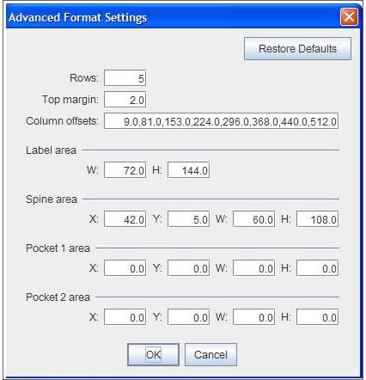

This publication is supplied for the exclusive use of customers of Innovative Interfaces with the understanding that it shall not be shown or distributed to anyone outside of the customer's organization without the prior written permission of Innovative Interfaces. This publication may be copied only if the copies are for the exclusive use of staff members of libraries that have purchased the Innovative system.
© 2022, Innovative Interfaces, Inc.

