sierra webpac

Tokens in Customizable HTML Forms

Tokens

Tokens are contextual placeholders in an HTML source document that outputs HTML and, in some cases, JavaScript, based on information in other parts of the system. Many elements of custom forms have been replaced with tokens to minimize the effort involved in maintaining these pages. Tokens also can be dynamic; they can read system files and respond according to library-defined settings so that HTML pages employing these tokens will not always have to be updated when changes are made to the Innovative system settings.

Custom forms also read the system, then react and output different HTML page elements dynamically. This makes the system more flexible. For example, a patron verification form must be able to output an error message if the patron's information is incorrect. Tokens allow for error messages to be coded into the forms conditionally, so that error messages will display only under certain circumstances.

The following example shows a list of locations used for limiting searches using the advanced keyword search page (https://yourlibraryIP/search/X). These locations are presented because the page invokes this token: <!--{branch}-->

When a token is placed in a page, WebPAC is directed to look somewhere else for the data or information and pulls it into the page when it is displayed by a client browser.

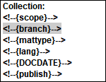

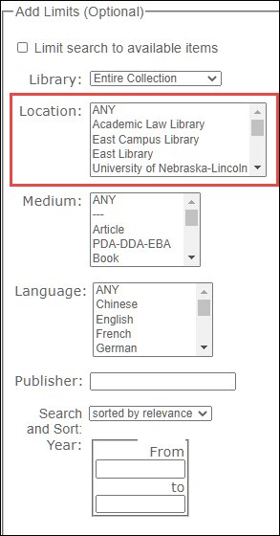

Note: Tokens cannot be seen by viewing code source in a client browser, unless you view the source by viewing the HTML directly. For example, https://yourlibraryIP/screens/srchhelp_X.html instead of https://yourlibraryIP/search/X . Otherwise what you see there is the result of the token and not the token itself.

Most tokens are not editable by the library. However, there are some tokens that act as placeholders for information that is under the library's control.

Note: Tokens are designed to work on only specific pages. A token will work on the page it was designed for, but will work in another. For this reason, Innovative does not provide a list of all possible tokens. When the use of a token, be sure to consult the Sierra Web Help page for the web page or form that you would like to edit. The valid tokens are listed for each customizable form.

Format of Tokens

Tokens are formatted like an HTML comment, but include specific text placed inside curly brackets, as in this example:
<!--{token}-->

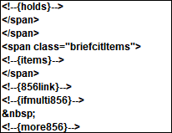

Note: When using tokens, they must be left-justified and on a line all by themselves. For this reason, it is important to turn off automatic indenting in your web editing software (if you are using a web editor rather than a text editor or Web Master).

Moving a token over towards the right, even by one space, will disable it. If you want to temporarily disable a token, to see how it works without deleting it from your file, you can simply move it over one space. However, if you move it far into the middle of the page will make it easier to see in order to move it back. It's easy to miss seeing a single space.

For example, look at the Advanced Search page (srchhelp_X.html). Note the limit by Material Type (re-named Medium in this example) drop down option there. It is controlled by the {mattype} token.

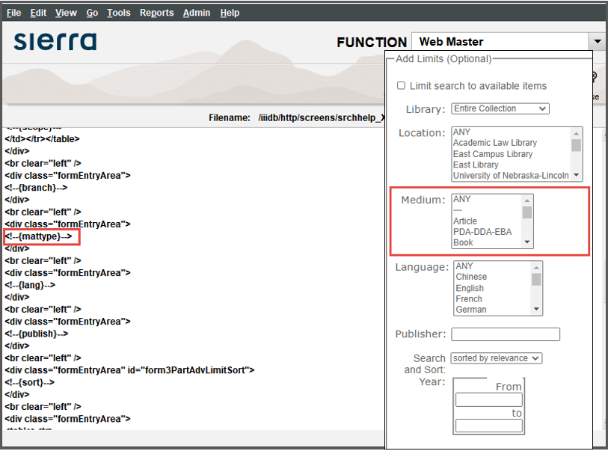

The <!--{mattype}--> token is moved to the right on the image below. This causes the limit by MATTYPE (locally named Media on the Sierra training server used for these images) to not display on the Advanced Search page.
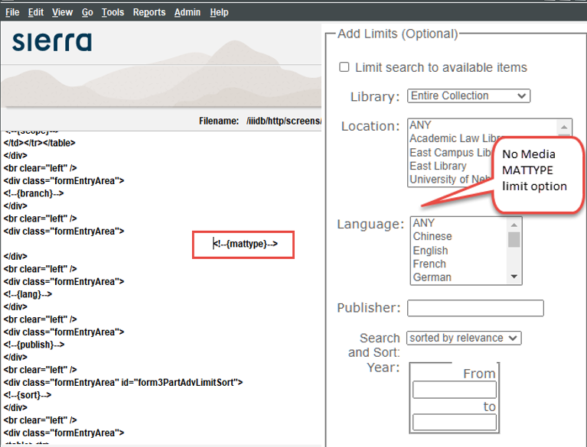

The {mattype} token is a placeholder for the information contained in the library's table of material type codes. If you want to change a label or add a new code, you only need to make that change in Sierra under Admin | Parameters | General | Fixed-length codes | Mat Type. This is a good example of how a token acts as a placeholder for information kept elsewhere that the library has control over.

The option is available to have only certain material types displaying for limiting. For instance, if you didn't want to have Maps as a limiting option, it could be removed. Innovative could create a separate file that would control which material types (codes and labels) to display. This would mean that you no longer control over the labels or codes displaying in WebPAC. The {mattype} token would still be a placeholder for information kept elsewhere, that information would just not be under the libraries control.

Token Examples
Added to static Web pages, the {toplogo} and {botlogo} tokens are placeholders for information that is kept in specific files in the screens directory. They work a little differently than the {mattype} token, in that they include the html from another file, rather than data.

These tokens work in conjunction with the TOPLOGO and BOTLOGO Web Options to allow the library to provide consistency, in look and feel, throughout WebPAC. These Web Options cause the above html pages to display on all system-generated screens.

Here's the {toplogo} token in the mainmenu.html page.

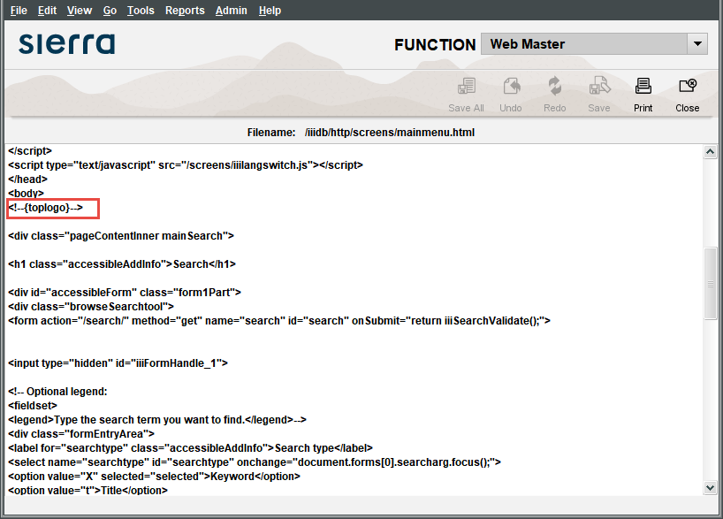

When we look in Web Master | Live Web Server Screens (or Staging Web Server Screens), we see the toplogo.html file listed there.

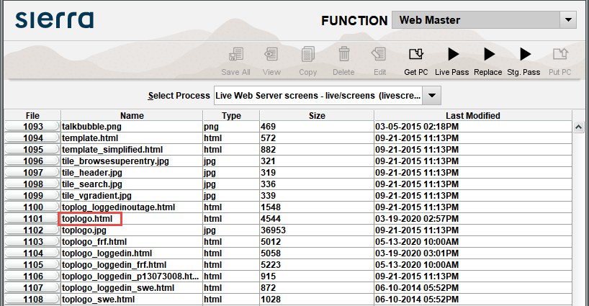

Note there is also a toplogo_loggedin.html page.

NOTE: Any file (html, gif or jpg) listed in the web server directory can be viewed in a browser by using the "direct link" approach. Here is an example:
http://LibraryIP/screens/toplogo.html

We can tell that this is toplogo.html by using the browser’s “View Source” functionality. When you view the page source, WebPAC displays the following information:
<!--this is customized <screens/toplogo.html>-->

In the image above, it displays on its own without the style sheet or other functioning elements of the WebPAC.

However, viewing the mainmenu.html page through a browser with all elements working together, we see this:

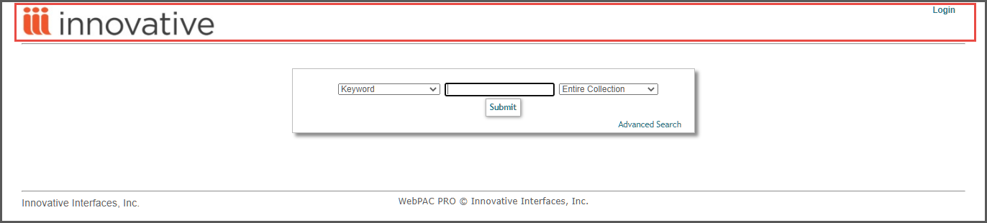

Another type of token is that which may only be enabled or disabled. An example of this is the {searchtool} token on a few forms, for example, bib_display.html and request_result.html. This token is used to add a drop down list of indexes and a search input box into the page. For libraries that have scopes, it also adds the scope drop down menu.

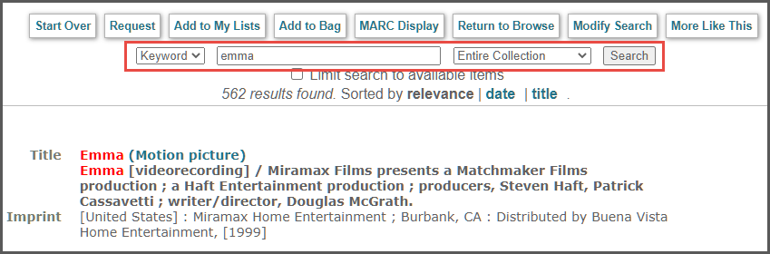

Disabling that token by moving it over results in not displaying the search tool on those pages.

Note: If the values of the token are customizable elsewhere in the system (for example, the fixed field table for Material Types), you should change them there. Otherwise your only course of action is to view the source and hardcode that HTML into your page instead of using the token, adjusting it as desired. This means that whenever you upgrade software, you will need to confirm that the token's behavior hasn't changed. And if you update the table, you will need to go back to update the hard coded HTML as well.

Many features require tokens to be added. For instance, if the library wants to allow requests (also referred to as holds) to be placed from the bibliographic record display, a {holds} token must be present in the bib_display.html page.

The Customizable Tokens

There are two tokens, that are somewhat “customizable”. These tokens control the display of variable and fixed length fields on the Brief Citation Form (briefcit.htm)

<!--{fieldspec:[fieldspec]}-->
Or
<!--{linkfieldspec:[fieldspec]}-->

Both versions of this token replace the [fieldspec] value with data located in the specified fields. The <!--{fieldspec:[fieldspec]}--> displays the fields as text, whereas the
<!--{linkfieldspec:[fieldspec]}--> displays fields as a HTML hyperlink to the full record display for the bibliographic record associated with the full citation.

The [fieldspec] can be specified with both fixed-length fields and variable-length fields. For example, if a library wants to display title hyperlinked, the linkfieldspec token tokens will be configured as follows:
<!--{linkfieldspec:VbT}-->

The fieldspec token is not hyperlinked and could be configured as follows
<!--{fieldspec:Vba}-->

To display publication data, the fieldspec could be configured in the following ways:
<!--{fieldspec:Vbp}--> will display all the data from MARC tag 264
<!--{fieldspec:Vbp:c}--> will display only the year of publication.

Note: If the year of publication display is repeated on brief citation results (briefcit.html), it is probably because both the <!--{year}--> token, and the <!--{fieldspec:Vbp:c}--> token are included in the file. You can delete or disable the <!--{year}--> token if you like.

The possible configurations of these two tokens is explained on the Sierra WebHelp Brief Citation Form page.

This publication is supplied for the exclusive use of customers of Innovative Interfaces with the understanding that it shall not be shown or distributed to anyone outside of the customer's organization without the prior written permission of Innovative Interfaces. This publication may be copied only if the copies are for the exclusive use of staff members of libraries that have purchased the Innovative system.
© 2022, Innovative Interfaces, Inc.

