sierra webpac

How to Customize Standard Pages: OPAC Menu and Main Menu

Main Menu Page

Your WebPAC comes with default HTML pages that are fully customizable. WebPAC is customizable using a combination of command links, style sheets, forms, and tokens.

It is important to know that WebPAC Pro requires the existence of the mainmenu.html page, this page can be redesigned, and many libraries use it as the entry web page for their library. You can use the Main Menu page to display your library's information, such as hours, services, programs, calendar of events, and link to other pages relevant to your organization. The only requirement of the Main Menu page is that it should exist.

When a user selects the link to your WebPAC the resulting URL is http://yourlibraryIP/

This mainmenu.html screenshot displays some of the elements of the page.

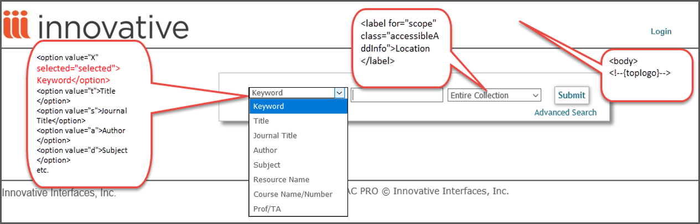

The Main Menu page comes with default HTML links that you can edit to reflect services provided by your library. You can add links to other functionality such as Course Reserves, Interlibrary Loan, you can also change the text of the indexes, etc. Furthermore, on this page you can add links to other resources such as Interlibrary Loan, Other Library Catalogs, etc. This example shows a Google search like page.

It is important to note that this page also supports other languages if your organization acquired this product. For example, to set up your WebPAC in French you must create another Main Menu page; the naming convention will include the three-character code for the language, for example, mainmenu_frf.html. The image below is the same WebPAC customized differently, with links to other functionality on the bottom.

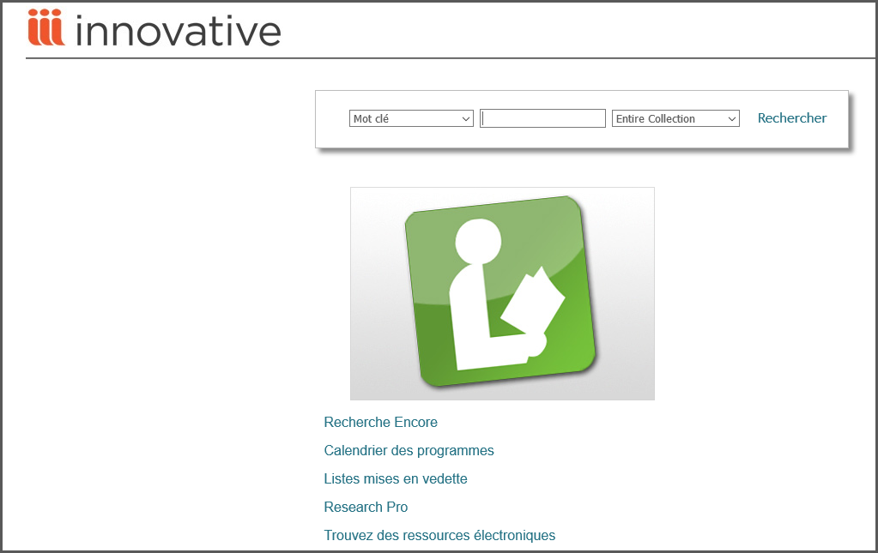

Important Note: WebPAC Pro requires the existence of the mainmenu.html page. You can redesign this page or make it an exact copy of opacmenu.html but you should not remove it.

For additional information see The Main Menu Page on Sierra WebHelp.

The OPAC Menu

The OPAC Menu is the page that offers search options to access the catalog, and it is designed to be the main search screen. The command link that invokes opacmenu.html is “/search”. The direct URL for the OPAC Menu page is http://yourlibraryIP/search. In the default setup of the WebPAC, this page is identical to the default Main Menu page. Both pages can be customized together and kept the same, or can be customized separately to have very different content and presentation.

If they are made to look different, a user would get an entry page each time they enter your catalog via mainmenu.html, and would get a page with different options each time they started a new search via opacmenu.html. If these pages are kept the same, then the entry page and search page will be seamlessly integrated and users will not be able to notice that they are being directed to different pages. The opacmenu.html supports both languages and scopes: opacmenu_lang.html ; opacmenu_s#.html (# is the number as given in the Scope Menu).

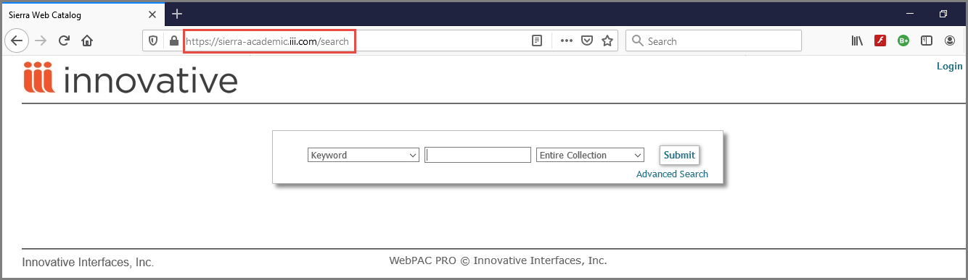

The OPAC Menu has been designed to be the main search screen. Therefore, by default the New Search link (Start Over) and the will take users to this page. However this behavior is customizable via the Web Options (STARTOVER).

The OPAC Menu is fully customizable to reflect the needs of your organization. Index search options are available from this screen and can be changed to reflect your library's choice of indexes to search. For example, if your library offers a search by journal title, a tab can be added to allow searching the journal title index. If your library does not offer one or more of the default index searches, you can deactivate them by commenting them out. You can also change the default sorting offerings to reflect your organization's preferences.

Other Searches can be customized removing unwanted features and adding other search options that you may want to offer to your library users.

For additional information see The OPAC Menu Page on Sierra WebHelp.

This publication is supplied for the exclusive use of customers of Innovative Interfaces with the understanding that it shall not be shown or distributed to anyone outside of the customer's organization without the prior written permission of Innovative Interfaces. This publication may be copied only if the copies are for the exclusive use of staff members of libraries that have purchased the Innovative system.
© 2022, Innovative Interfaces, Inc.

