sierra webpac

Customizable HTML Forms and Pages

Library-customizable forms and pages

WebPAC Pro includes default Customizable Forms that are HTML pages. These are static pages and will display the same information every time a library user requests them. Examples of static pages in WebPAC are the Main Menu and OPAC Menu pages and the Search Help Pages, which provide the library user with search hints and search instructions.

These customizable HTML static pages relate to other pages and include command links and tokens.

  - Command links are reserved words that tell the system to perform certain functions. They are always preceded by a slash "/" and they look similar to the following example:
http://yourlibraryIP/search/a

- Links to pages such as search help pages.

- HTML tokens are placeholders that define files such as:

<!--{toplogo}-->

<!--{botlogo}-->

<!--{nameprompt}-->

<!--{logout}-->

Your library can take advantage of the flexibility of these pages and change them as much or as little as it will fit the needs of your unique organization.

Customizable Forms can be edited in Web Master in Sierra Desktop or SierraWeb. The screen below illustrates an example of one of the Search Help Forms, srchhelp_a.html (http://yourlibraryIP/search/a) :

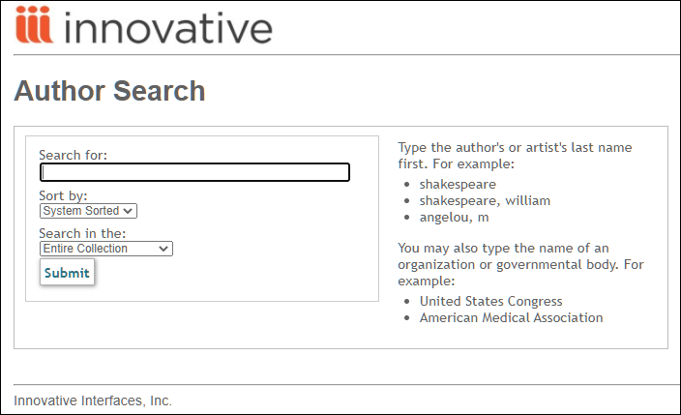
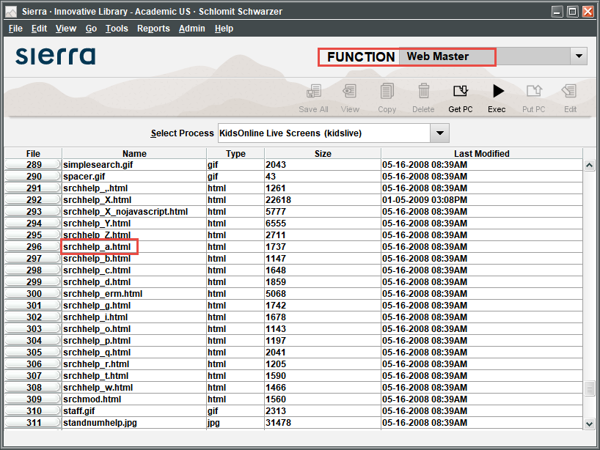

An excerpt part of the customized form with the tokens will look like:

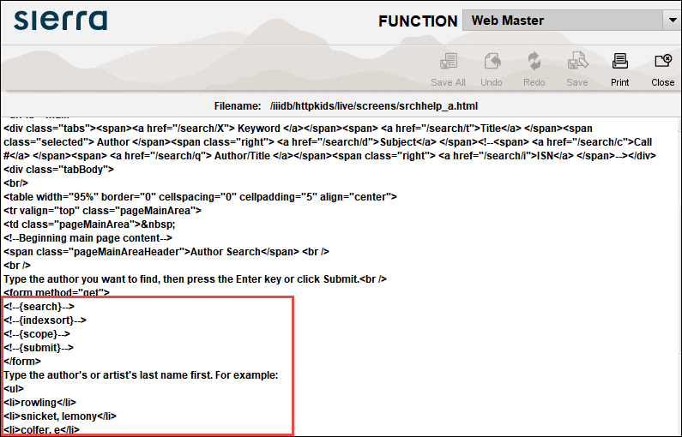

Other Customizable Forms can be seen throughout this tutorial, such as mainmenu.html, opacmenu.html, srchhelp_x.html, briefcit.html, bib_display.html, acquire_web.html, and more.

For a complete list of Customizable Forms and files, refer to the Sierra WebHelp Customizable Web Forms.

For current examples of customizable web forms, Web Options, and style sheets see the appropriate example set in WebPAC Example Sets and Photoshop Files on CSDirect.

For more information on customizing your WebPAC refer to the Innovative Guide & Reference:

Preparing the Content for Customizable Files
Editing Customizable Files and Options Using Innovative Programs
Editing Customizable Files Using non-Innovative Programs

Customizable Forms can be customized for language, scope, and PTYPE

Customizable Forms can be customized for language, scope, and PTYPE. You can create separate custom forms for each combination of language, scope, and patron type by using the following naming convention:

<form name>_LANG_s#_p#.html

LANG | The language code (spi for Spanish, frc for French, etc.).
s# | The number of the scope (s1, s2, s3, etc.).
p# | The patron type or PTYPE (p0 or p243, etc.).

Note: This convention applies to all Customizable Forms unless otherwise noted.

This publication is supplied for the exclusive use of customers of Innovative Interfaces with the understanding that it shall not be shown or distributed to anyone outside of the customer's organization without the prior written permission of Innovative Interfaces. This publication may be copied only if the copies are for the exclusive use of staff members of libraries that have purchased the Innovative system.
© 2022, Innovative Interfaces, Inc.

