sierra webpac

Command Links

Library-customizable forms and pages

Command links instruct WebPAC to access a certain function, such as searching on a specific index or changing the scope of a search. The most used Command Link is the search link. Other command links will invoke Custom Forms such as My Record, Help, or Suggest a Purchase.
For example, the command link “/search/a” instructs WebPAC to search for a specific index, in this case the author index. The command link “/patroninfo” will bring up the html page where patrons will fill out a form to login to their library record.

If no Command Link is added after the “/” WebPAC will bring you the Main Menu page. There are command links for all the searchable indexes in your library; for example: “search/X” is used for keyword searching, “search/a” is used for author searching, and “search/t” for title.

The screen bellow illustrates an example of the Command Link for author “search/a”.

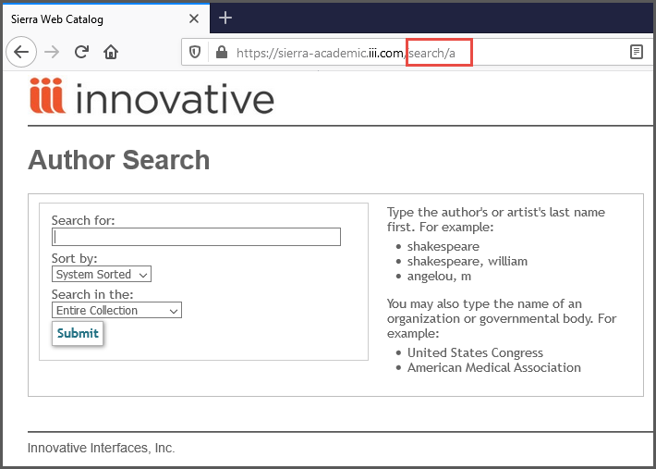
Below are some examples of how the HTML looks for some command links that search the author, title, and subject indexes and that are supported in the mainmenu.html and opacmenu.html pages:

<a href="/search/a ">Author</a>

<a href="/search/t ">Title</a>

<a href="/search/d ">Subject</a>

Below are examples of other command links used in WebPAC Pro, labels can be customized:

<a href="/acquire">Suggest a purchase</a> The /acquire Command Link will retrieve a form that a patron fills with his/her recommendation for purchasing library materials.

<a href="/suggest">Comments</a> The /suggest Command Link will retrieve a form that patrons can use to enter comments or suggestions for your library.

<a href="/screens/feeds_example.html">Feeds</a> The /feeds Command Link will link to a feeds file that you can create for your library. Please note, that this /feeds Command Link does not access files in the http/live/feeds directory.

A complete list of command links is available on the Sierra WebHelp command link page.

This publication is supplied for the exclusive use of customers of Innovative Interfaces with the understanding that it shall not be shown or distributed to anyone outside of the customer's organization without the prior written permission of Innovative Interfaces. This publication may be copied only if the copies are for the exclusive use of staff members of libraries that have purchased the Innovative system.
© 2022, Innovative Interfaces, Inc.

