sierra webpac

Integrated Login

Download

IPSSO HTML form
Also available in:
French
Spanish
Simplified Chinese
Traditional Chinese

Description

Libraries can customize IPSSO (Integrated Patron Single Sign On) with their own HTML form. This form allows complete customization, beyond what is available with the XML version.

If you do not yet use the HTML form, please request Support for the required initial setup using the Set up Integrated Login custom form (ipsso.html) .

If your library is already using the HTML form and you are replacing an existing ipsso.html file, you may proceed with the download. There is no need to resubmit the service commitment. This download includes a default HTML file and supporting CSS and GIF image files.

Customizations
- The logo image at the top is your existing screens/logo_sm.jpg. If you use a different file, change the image link accordingly.
- Depending on your setup, delete unused fields (external patron, patron alias) in ipsso.html.
- Enable the html version of the form in web options.

For additional instructions, see Implementing the Innovative Integrated Login.

Mobile Stylesheet
This version contains a mobile stylesheet so the same login form will work on the desktop and mobile phone. The mobile style occurs first, and contains styles that work on small screens. Next, the desktop stylesheet only gets linked if using a screen display with width over 480 pixels. This second stylesheet overrides some of the mobile styles to take advantage of the larger screen. There is a third and fourth conditional stylesheet to cover Internet Explorer and additional mobile browsers, but these also reference the same two stylesheets.

Samples

Desktop view using standard stylesheet
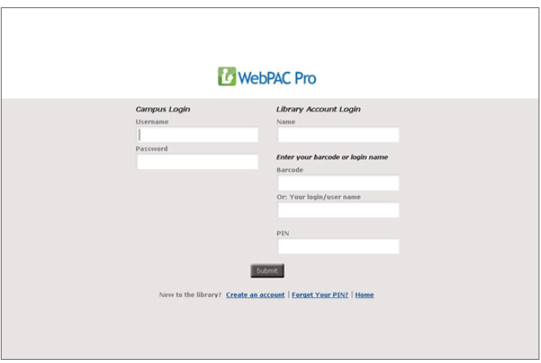

Mobile view, with mobile stylesheet
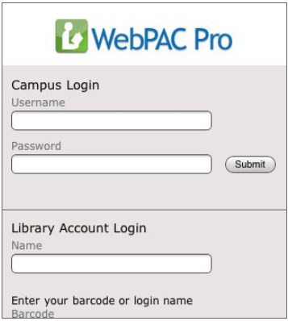
Note: IPSSO is also known as CAS-IPSSO.
This publication is supplied for the exclusive use of customers of Innovative Interfaces with the understanding that it shall not be shown or distributed to anyone outside of the customer's organization without the prior written permission of Innovative Interfaces. This publication may be copied only if the copies are for the exclusive use of staff members of libraries that have purchased the Innovative system.
© 2022, Innovative Interfaces, Inc.

