Sierra Harvester
How to Enable Access to Configuration for Encore Harvester

Enabling Access to Configuration for Encore Harvester

It is possible to enable or disable access to Encore Harvester Configuration tools in the Sierra Admin App for Sierra 3.2+.

To enable access to the Encore Harvester configuration tool:
- Log in to Sierra Admin App using a web browser such as Chrome or Firefox. By default, the URL is:
https://[your Sierra server]/sierra/admin
- Click on Authorizations and Authentication on the upper left-hand side of the screen
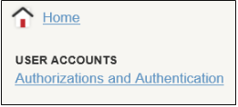
- Locate user for whom to grant or restrict access to the Encore Harvester configuration screen and click the + (plus sign) next to the user’s name.
- Click the EDIT button
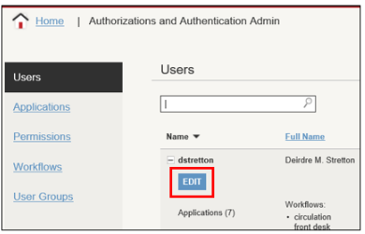
- Click on Applications to modify the permission and click Encore Harvester in the Available applications box to select it and drag to the Assigned applications box.
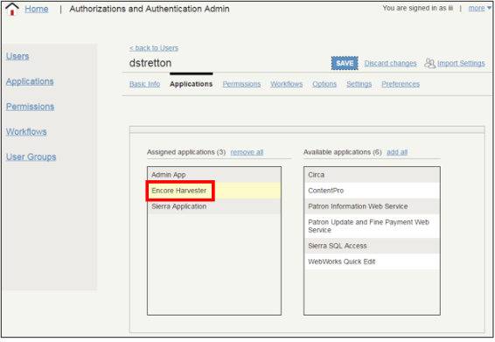
- Click the Save button to save the changes made to the user.
The next time the user logs in, a new link to the program will then appear for that user in the Other Web Applications section of the front page of the Admin App. This does not require a restart of the app.
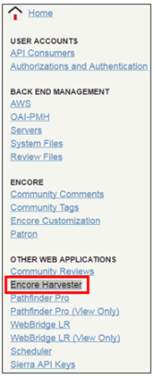

TIP: To remove access to this tool for a user, follow the steps above, instead moving the Encore Harvester from the Assigned applications column to the Available applications column for that user.

This publication is supplied for the exclusive use of customers of Innovative Interfaces with the understanding that it shall not be shown or distributed to anyone outside of the customer's organization without the prior written permission of Innovative Interfaces. This publication may be copied only if the copies are for the exclusive use of staff members of libraries that have purchased the Innovative system.
© 2022, Innovative Interfaces, Inc.

