Sierra Systems administration

How to Set up Access to a Z39.50 Servers File and Database

The following is a self-paced exercise intended for Sierra users who wish to practice setting up access to a Z39.50 server and database. For more information on the Z39.50 Servers File, see Z39.50 Server File in Sierra WebHelp.

Topics

Adding a Server to the Z39.50 Servers File

Adding a Database to the Z39.50 Servers File

Adding Search Options for a Database

Adding a Pre-search Limit to Your Database

Related References

Adding a Server to the Z39.50 Servers File
The example entry is for the Z39.50 server at the Library of Congress in the United States. All inputs from http://www.loc.gov/z3950/lcserver.html accessed August 20, 2020.

From Admin App, under "Back End Management" choose System Files | Admin Corner | Additional System Functions | Alter System Parameters | Login Names and Parameters | Z39.50 Server File | Add Server.

The system now provides data input prompts.

PROMPT: Give the new entry a unique code, local to your system, no more than 10 characters.
Response: ‘LC’

PROMPT: Enter a name your end users will see, no more than 50 characters.
Response: ‘Library of Congress’

PROMPT: Enter the address of the server. Hostnames work best, but a numeric IP address will work too.
Response: ‘lx2.loc.gov’

PROMPT: Enter the port. The standard port for Z39.50 traffic is 210, but an organization can choose any port on which to run its server.
Response: ‘210’

PROMPT: Enter ‘Authentication Method’
Response: Enter a login and password, if required. If the login is “searcher,” for example, and the password that goes with “searcher” is “z3950_123,” you key in “searcher/z3950_123” with the slash between the two elements. A maximum of 50 characters is allowed. LC does not require a password or authentication, so you can leave this field blank.

PROMPT: Enter a ‘character set’. Blank may work best, or if the administrators of the remote server have published what character set you should use, choose that one. Z39.50 servers often have a default behavior when a Z39.50 client does not specify which character set. That default behavior may be the best option.
Response: ‘LEAVE blank’

Note when you choose "6 > Character Set," if you key in?<Enter> or input something the system cannot offer, the system displays a list of valid Character Sets from which you can choose.

PROMPT: ‘Enable SCAN Facility?’
RESPONSE: ‘no’

For more information, Z39.50 Scan Feature and Adding Servers to the Z39.50 Server File.

Adding a Database to the Z39.50 Server File

Choose A > ADD database from the SERVER menu and enter the code for the database from the administrators of the Z39.50 server.

If the remote system is using Sierra or the Millennium ILS, enter "Innopac" (case insensitive) for the main, bibliographic database. Administrators at the remote organization should know the specific codes for any Sierra or Millennium reference databases – not their main, bibliographic records database -- available via Z39.50.

PROMPT: Enter a code.
RESPONSE: ‘LCDB’

PROMPT: Enter a display name.
RESPONSE: ‘Library of Congress Catalog’

PROMPT: Enter a type of query.
RESPONSE: The Sierra Z39.50 Client supports only type ‘1’, which comes up as a default.

PROMPT: ‘Do you want to input information to display on the search menu now? (y/n)’
RESPONSE: ‘no’

Note the system supplies two defaults.

- The default data format is MARC 21.
- The default 'type of updating' is NONE.
If you are adding an entry for OCLC to the Z39.50 Servers File and you plan to use Sierra Cataloging's Update Holdings function, set this option to 'OCLC'.

For more information, see Adding a Database to the Z39.50 Server File.

Adding Search Options for a Database
The following steps may be adapted to enter other types of searches.

- Select 'A > ADD new type of search' from the DATABASE menu.
- Enter 'a' for author. Press the <ENTER> key to accept the label 'AUTHOR'.
- Change search attributes. Change the attribute for '1 > Use Field' to '1003'. When you key '1', you'll be presented with a list. Choose the line number for '1003'. Change the attribute for '4 > Structure' to '1'.
- Select 'q' to quit and then select the ADD new type of search menu option.
5. Enter 't' for title. Press the <ENTER> key to accept the label 'TITLE'.
6. Change 'Use field' to '4'. Change 'Structure' to '1'. Select 'q' to quit.
7. Choose 'E > EDIT information on search menu' to enter customized search instructions. If you do not wish to enter instructions, the system will use system defaults.
8. Quit until prompted to save changes. Answer 'yes'.

Note that the search attributes listed above may not work for other databases. See Search Attributes for Selected Servers.

Note also sometimes the administrators of a Z39.50 server just give you the "Use" attribute or only a few of the possible attributes.

Part of the Z39.50 standard is negotiation. In fact, about our own Server, we say, "If it receives a search request that contains unsupported attribute(s), it attempts to perform the search by using its default values."

It is OK not to fill out all search attributes. See also Solution ID 200122133430733 at support.iii.com.

NOTE: Don't change any of the following tag + name combinations that the system supplies:

- Search tag: a Search name: AUTHOR
- Search tag: i Search name: ISSN
- Search tag: j Search name: ISBN
- Search tag: s Search name: SUBJECT
- Search tag: t Search name: TITLE
- Search tag: w Search name: WORD

Don't use numbers for Search Tags, except 1, 2, 3, and 4 for DATE AFT, DATE BEFOR, REC TYPE, and LANG (the "Limit" parameters).

Apart from the restrictions listed above, you may use any letter for the Search Tag, and any wording for the Search Name.

For more information, see Adding Search Options for a Database. Also see Solution ID 160713141152192 at support.iii.com.

Adding a Pre-search Limit to Your Database

Pre-search limits will only work on Z39.50 servers that support this type of limiting. Servers that support pre-search limiting include Sierra and Millennium, OCLC, and CURL (Consortium of University Research Libraries).

Continue as if adding a new search option (described above).

Select 'A > ADD new type of search'.

Enter the limit term at the 'search tag' prompt (e.g., 1,2,3, or 4).

NOTE: The limit terms MUST be defined according to this schema:
- Date on or after
- Date on or before
- Record type
- Language code

- The system will prompt with the appropriate search name, e.g., 'Search name: DATE IN/BEFORE'. Type <ENTER> at the prompt.
- The system will prompt you to change the search attributes for your search limit, e.g. "CHANGE SEARCH ATTRIBUTES FOR 'DATE IN/BEFORE(2)' SEARCH:"
- Key line # 1 to change the Use field, e.g., '1 > Use Field'. Search for the valid Use Attribute (listed below). If you do not see the actual number of the Use Attribute listed, key the line number for 'OTHER' and manually key in the Use Attribute number.

NOTE: There are four hard-coded limit terms available:
- Date on or after four-character string (Use Attribute 30 or 31)
- Date on or before four-character string (Use Attribute 30 or 31)
- Bibliographic format term unique to each server (Use Attribute 1001). OCLC uses terms such as "BKS" or "SER" as limit terms.
- Language MARC language code (Use Attribute 54)

4. Input other attributes (2-6). The Use Attribute used for limiting by date varies depending on the server. Use 31 for OCLC. Use 30 for CURL.

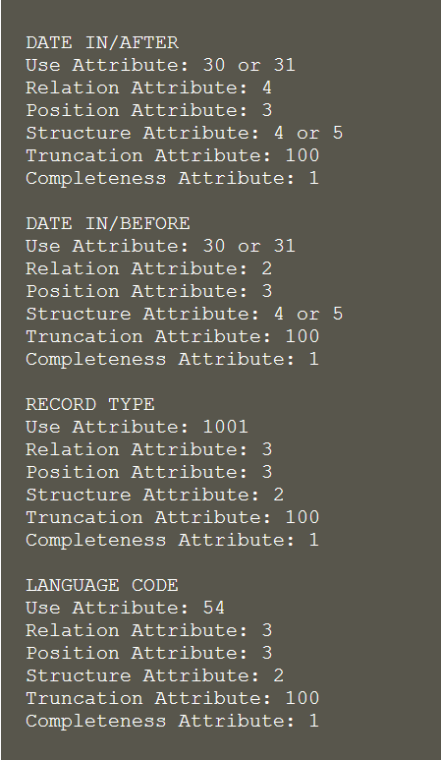

5. Add all desired limits for that database. Then, 'Quit' until prompted to save changes. Answer 'yes'.

Innovative has successfully tested all four limit terms against the OCLC ZCAT server. A successful "limit" depends upon a site's having its records set up in the accepted standard format.

The Sierra Z39.50 server uses the following pre-search limit attributes:

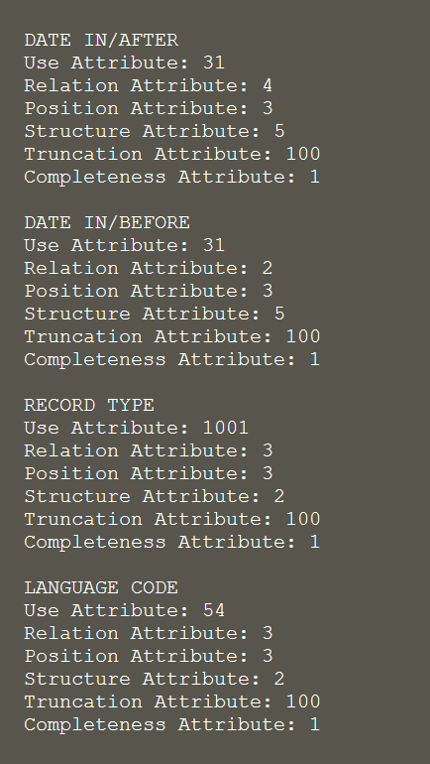

Related References
What do other libraries need to know to search your catalog or reference database via Z39.50? See Server Information Needed by Remote Z39.50 Clients and Search Attributes for the Z39.50 Server.

See also Z39.50 Options for a discussion of web options relating to Z39.50.

This publication is supplied for the exclusive use of customers of Innovative Interfaces with the understanding that it shall not be shown or distributed to anyone outside of the customer's organization without the prior written permission of Innovative Interfaces. This publication may be copied only if the copies are for the exclusive use of staff members of libraries that have purchased the Innovative system.
© 2022, Innovative Interfaces, Inc.

