Sierra System Administration

How to Design Effective User Groups (Contention Groups)

Introduction

A User Group is a library defined category to which Sierra users can be assigned (e.g., "staff", “circulation”, administration”, “library” “library b” etc.). The User Group is an administrative tool for controlling access to the system. The system limits the number of simultaneous login connections for each User Group to a maximum number that you specify using this function.

User Groups are set up in the Sierra Admin App, under User Accounts| Authorizations and Authentication| User Groups. For information on maintaining User Groups, see Administering Global User Groups.

1. Login to your Sierra Admin website https://<Sierra Hostname>/sierra/admin

2. Navigate to the Authorizations and Authentication Admin section of the Admin controls

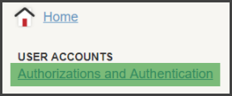

3. Choose the User Groups section on the left

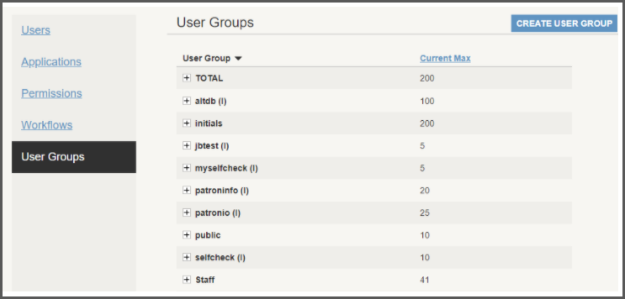

The TOTAL Current Max value is how many licenses your library must distribute.

4. Open the User Group(s) you would like to alter and edit the Concurrent Max value(s) as needed, then save your changes.

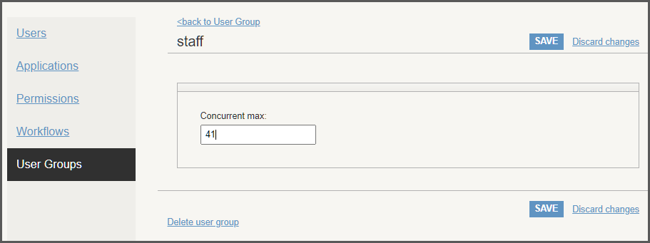

Note: The TOTAL group sets the total number of simultaneous (concurrent) logins allowed for all groups combined.
Groups can be created to contain the number of licenses a user group can utilize to access Sierra.

Note: Messages such as ‘no user licenses available’ or 'maximum number of users reached' indicate that the login with which the user is connecting to the system belongs to a group which has no more licenses available or that all licenses are in use. If some users are receiving this type of message consistently while other users remain able to access the system, the Concurrent max setting may need to be adjusted.

In the example below, there is no contention. The '1' assigned to each of the web groups does not represent a license that will be used, because the library has unlimited WebPAC users. The total of licenses assigned for staff use add up to the total licenses available. In this scenario, if bstaff, mstaff, and rstaff represent three institutions, these libraries will always have access to the total licenses allocated to their group, and no more or less. One license is reserved for an administrator.

Note that if a user that is assigned to group 'admin' has Sierra Statistics Settings of "Accumulate in the background", the user will need more than one license assigned to this group to run reports (each simultaneously running report will require an additional license)., see Sierra Statistics Settings.

GLOBAL USER GROUPS
Total | 60
GROUP NAME | MAXIMUM USERS
admin | 1
bstaff | 19
mstaff | 25
rstaff | 15
bweb | 1
nweb | 1
rweb | 1

Administering User Groups

A User Group sets the total number of simultaneous (concurrent) users allowed to login to Sierra Desktop or SierraWeb for all that group.
A Sierra user belonging to one of these User Groups contends with the logins in its own and all other groups in the User Group pool. When a Sierra user belonging to one of these User groups is granted a connection to Sierra Desktop or SierraWeb, the number of available users (licenses) decreases by one.

Note: Add one or more groups for web logins even if your library has unlimited WebPAC logins, because the group(s) will be used in Unlimited WebPAC Login Statistics. Libraries assigning WebPAC logins by IP in the HTTP Network Access table may wish to create a group for each separate pool of users to be tracked in this statistical report.

The example below demonstrates no contention, because the total licenses allocated to the User Groups add up to the total licenses available to the library. If anyone User Group is not using all the licenses available to it, another User Group cannot take advantage of the available licenses. This institution does not have unlimited WebPAC licenses.

No Contention
GLOBAL USER GROUPS
Total | 150
GROUP NAME | MAXIMUM USERS
bstaff | 15
dstaff | 20
mstaff | 25
rstaff | 15
bweb | 15
dweb | 20
nweb | 25
rweb | 15

The example below demonstrates partial contention, because the total of the licenses allocated to the User Groups is 166, although there are only 150 licenses available. Users assigned to a User Group have no guarantee that they will be able to use the full number of licenses allocated to their group, because all the User Groups are contending for more licenses than exist. The contention is set up so that no group will ever be completely unable to get a license, although it would be possible for a group to be left with only one available license.

For example, if the first seven groups used all the licenses allocated to their groups simultaneously, the eighth group (rweb) would be left with only two available licenses. However, since many of the groups are for WebPAC users, the licenses will usually quickly become available again as users finish searching at the OPAC.

Partial Contention
GLOBAL USER GROUPS
Total | 150
GROUP NAME | MAXIMUM USERS
bstaff | 17
dstaff | 22
mstaff | 27
rstaff | 17
bweb | 17
dweb | 22
nweb | 27
rweb | 17

The example below demonstrates full contention, because the total of the licenses allocated to the user groups is 300, although there are only 150 licenses available. Users assigned to a group have no guarantee that they will have any licenses available at all. It would be possible for staff to find themselves unable to log in if 150 OPAC users were on the system simultaneously. What would be more likely is that staff assigned to some user groups find that not enough free licenses are available for all the users assigned to the group who need to work at the same time.

Full contention works well at some libraries but would not be practical at others. A library with unlimited OPAC users is more likely to be able to use full contention without experiencing problems with staff license availability.

Full Contention
GLOBAL USER GROUPS
Total | 150
GROUP NAME | MAXIMUM USERS
bstaff | 30
dstaff | 40
mstaff | 50
rstaff | 30
bweb | 30
dweb | 40
nweb | 50
rweb | 30

Contention Group Tips

- Login Statistics display the average number of login requests which were denied each hour during the last ten days. If the user views the statistics for one day, the actual number of denials is displayed. A high number of denials for a group suggests that the group may need more user licenses allocated. For more information on Login Statistics, see Login Statistics.
- Managers may need to set guidelines for running statistical reports during the workday if licenses are at a premium. Statistical reports may be scheduled to run on off-hours. Sierra Statistics processes may be run without using a separate license by adjusting the user’s settings.
- Messages such as ‘no user licenses available' or 'maximum number of users reached' indicate that the login with which the user is connecting to the system belongs to a group which has no more licenses available or (if using partial or full contention) that no user licenses are available. If some users are receiving this type of message consistently while other users remain able to access the system, the contention groups may need to be adjusted.
- Creating a contention group with one license assigned (for example, a group called 'admin' with one license) only guarantees access if the site is using the 'no contention' model. If a user is logging in with a license assigned to such a group, remind the user that Sierra Statistics processes must be run in the foreground.

This publication is supplied for the exclusive use of customers of Innovative Interfaces with the understanding that it shall not be shown or distributed to anyone outside of the customer's organization without the prior written permission of Innovative Interfaces. This publication may be copied only if the copies are for the exclusive use of staff members of libraries that have purchased the Innovative system.
© 2022, Innovative Interfaces, Inc.

