Sierra System Administration

How to Customize Facet Display in Sierra

Introduction
Facets help refine Sierra searches by limiting the results according to the characteristics the Sierra user choose. Facets appear in the left column in catalog browse results.
The facets that display depend on the results of the search and the library's system configuration.

Sierra offer the following facets

Available at Library
Limits the search results to resources that currently are available.

Call Number
Limits the search results to resources with a specific LC call number prefix.

Collections
Keyword Searches Only: Limits the search results to resources from a specific collection of materials. Collections can include physical locations as well as digital collections of harvested records. The collections available depend on your library's system configuration.

Course
Limits the search results to resources on reserve for a specific course. (Appears only if your library has the Course Reserves product.)

Format
Limits the search results to resources of a specific material type. For example, choose the Book facet value to remove music, videos, and so on, from the results and see only the books that matched your search.

Found In
Keyword Searches Only: Limits searches for a search term to the Author, Subject, or Title keyword search indexes. For example, if one searches for Jane Austen, choose the Author facet value to limit the results to items authored by Jane Austen: books about Jane Austen (by other authors) no longer appear in the list.

Language
Limits the search results to resources in a specific language, based on the LANG bibliographic fixed-length field. The languages available depend on your library's collection of materials.

Locations
Limits the search results to resources from a specific bibliographic location. The locations available depend on the library's system configuration.

Phrase
Limits the search results to a specific phrase related to the search term. For example, if one searched for Mozart Wolfgang Amadeus 1756 1791 biography, the search is limited to results in the subject index that match the phrase search.

Professor
Limits the search results to resources on reserve for a specific professor. (Appears only if the library has the Course Reserves product.)

Publish Date
Keyword Searches Only: Limits the search results to resources published in a specific year.

Note: Sierra does not display the Phrase facet in the compact browse display

How to Customize Facets Display in Sierra?
There are two places to adjust the facet display settings, Admin app and in the Sierra SDA:
- Sierra SDA and Sierra Web
- Sierra Admin

Sierra SDA or Sierra Web
To change facet display settings the user must have permission 1255 (Customize Facet Display).
To change the facet display, log into Sierra Desktop Application or Sierra Web and adjust the facet display settings by going to the Admin pull down menu, select Settings and choose the Sierra Facets tab.

There are two customization options, default display and custom display.

Default display
If you select this option, Sierra displays the facets in the expanded format

Custom display
In this option, Sierra enables the custom display settings:

Facets Custom Display Settings
These settings allow you to define which facets you want to appear and the order in which you want them to appear. Note that facets in the Displayed Facets list appear in your Sierra system in the order in which they appear in the list. The Available Facets list displays all facets available on your system.

Expanded Facets Custom Display Settings
These settings allow you to determine how you want your facets to appear by default. Facets in the Expanded Facets list appear in the expanded format by default; all other facets enabled on your system display in the collapsed format by default.

To move a facet into or out of the Displayed Facets list, highlight the facet, and click the right or left arrow. To change the facet display order, highlight the facet, and click the up or down arrow.

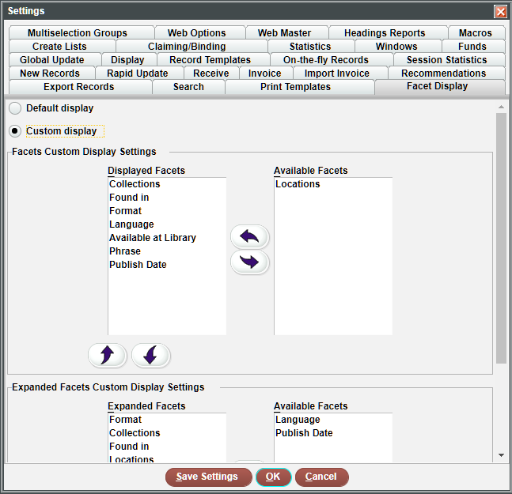

Sierra Admin
To change facet display settings the user must have permission 1255 (Customize Facet Display).
Defining which facets appear in the Sierra Desktop Application, the order in which they appear, and whether each facet appears in the expanded or collapsed format by default.
Note: these settings control the display of facets for all users of your system.

To change the facet display from Sierra Admin, log into Sierra Admin, Under the Back End Management menu select Sierra Facets.
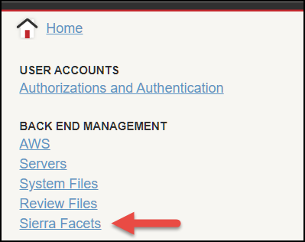

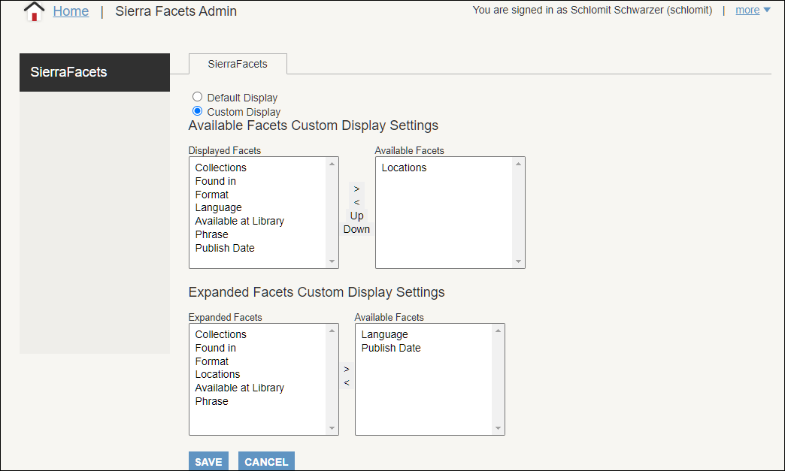

This publication is supplied for the exclusive use of customers of Innovative Interfaces with the understanding that it shall not be shown or distributed to anyone outside of the customer's organization without the prior written permission of Innovative Interfaces. This publication may be copied only if the copies are for the exclusive use of staff members of libraries that have purchased the Innovative system.
© 2022, Innovative Interfaces, Inc.

