Sierra create lists

Create Lists Anatomy - Searching

Permissions
018 To create, view & maintain review files
186 Review File List Administrator

In addition, the user must be authorized to:

View the record types within the review files.

Edit the record type in the file if you want to edit the records in a file.

To save login Settings permanently you will need authorization 176 (Save settings).

Click “Search Records”
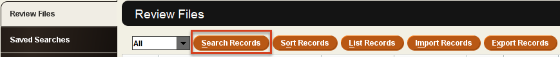

NOTE: Search Records: to start a search. If a review file that already contains records is selected, in Release 5.1 and later, a warning dialog will offer options. The user can Start a new query, which will overwrite the existing file, Re-run the existing query (the query used to find the records currently in the review file), Edit the existing query or Cancel.

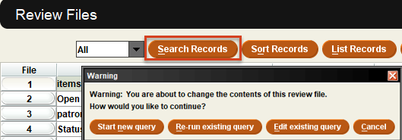

Enter a Review File Name.
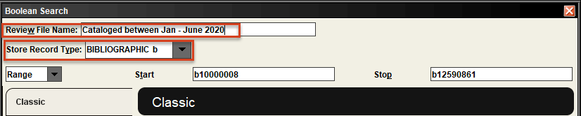
Select the “Store Record Type.” Note that the record type that is chosen will allow the user to search in the data in records linked to this type of record. Store Record Type BIBLIOGRAPHIC b means the user can search for data in the bibliographic records as well as in item, order and holding records.

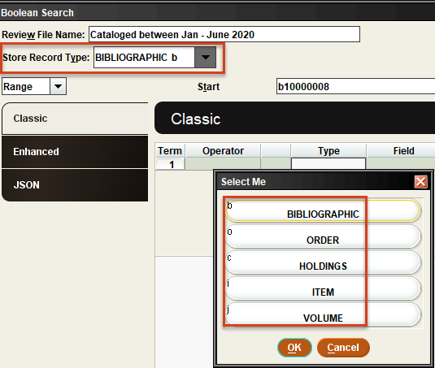

The “Range” dropdown will offer different access to which records to search.
- Range: Search the entire database or a set of record numbers you specify.
- Review: Search in the records in an existing review file.
- Index: Select an index. Indexes offered are based on the record type was selected in “Store Record Type.”
- Advanced: Keyword searching in data in the “Store Record Type” record type.
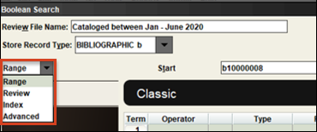

NOTE: To select the value in any box, double click in the box to see the options or type in the code.
Type will offer all the linked records to the “Stored Record Type.” If bibliographic were selected: 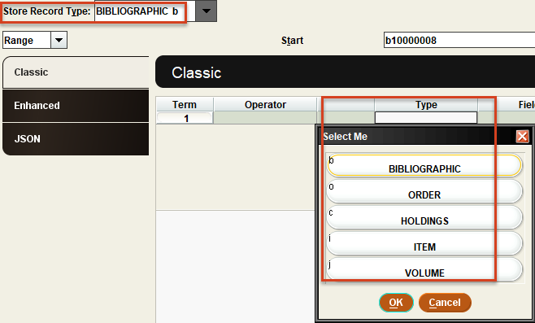
If item were selected:
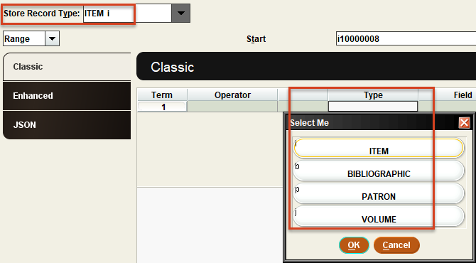
If order were selected:
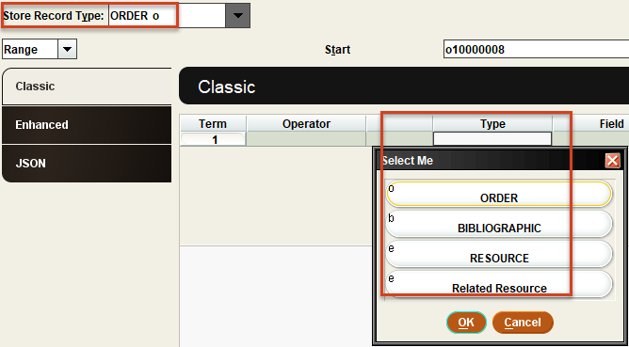

If HOLDINGS AND CARDS is selected, the elements of the boxes in the checkin card can be searched.
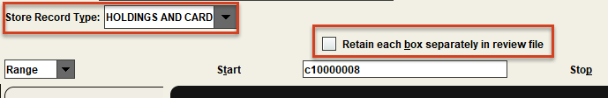

Select “type”. In this example bibliographic record. Click “Fields.”
The first tab is “Data Fields” displaying the Fixed Fields followed by the Variable Fields.
Select the field you want to search by double clicking or select and click “OK.”
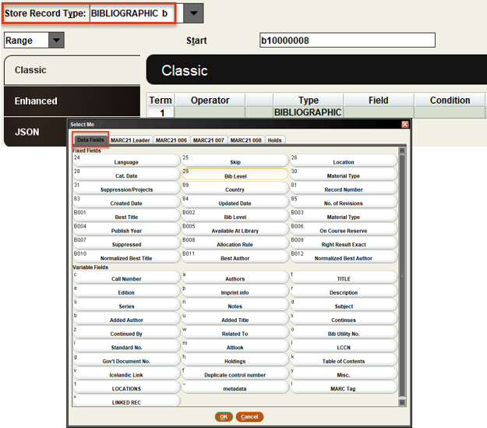

The other Tabs allow you to search fields within the Leader, the 006, 007 and 008 fields as well as in bib level holds.
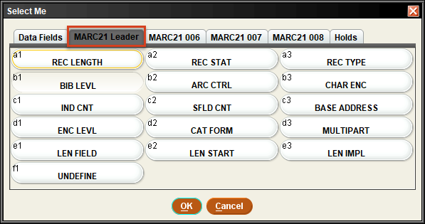
NOTE: You must know the value you are looking for.

Based on the Field you have selected, a set of conditions are available.
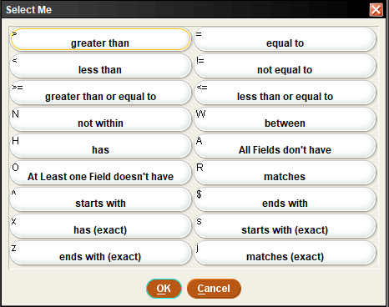

If you select a date field, there will be more date options such as relative dates.
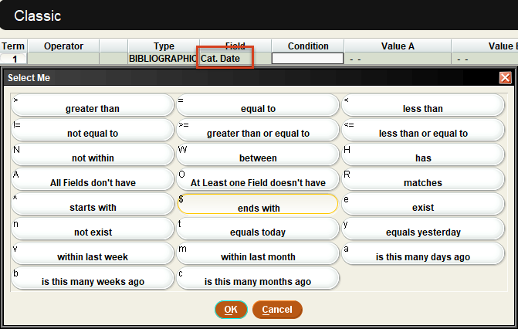

You can “Use Existing Search” or “Retrieve Saved Query”.
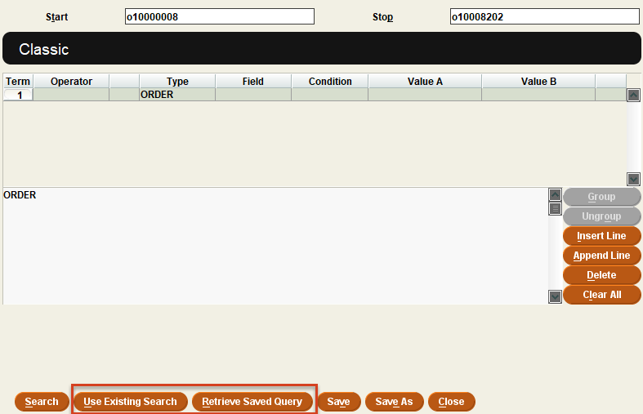

Existing Search will allow you to select the strategy from any existing review file.
Retrieve Saved Query will let you select from Saved Searches.

Options to add another line:
- Insert will insert a line above the selected line.
- Append will append the line below the selected line.
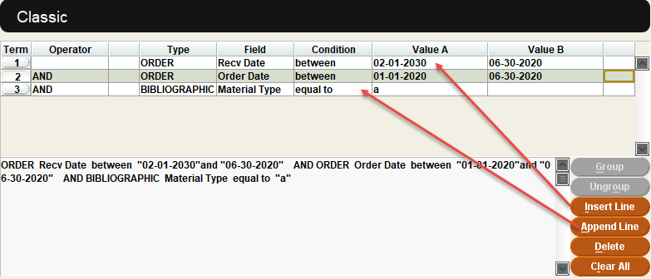

To nest a set of criteria, select the line, hold Shift key, and select other lines. The option for Group becomes available.
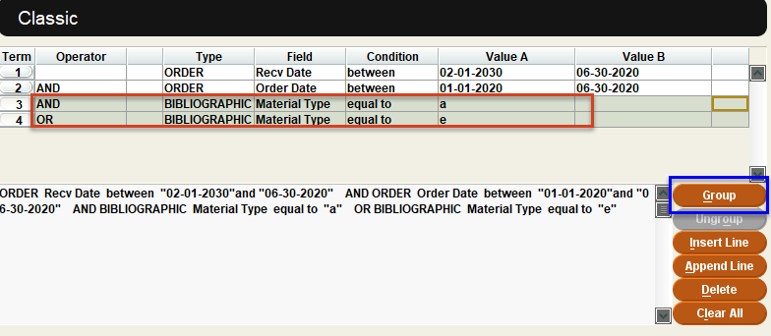

Click Group:
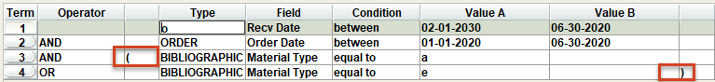

In this example the order records the conditions of received dates between February and June AND order date between Jan and June of 2020 must be present for material types of “a” OR “e”.

See Logical Operator Precedence and Grouping in the Sierra Web Help.

This publication is supplied for the exclusive use of customers of Innovative Interfaces with the understanding that it shall not be shown or distributed to anyone outside of the customer's organization without the prior written permission of Innovative Interfaces. This publication may be copied only if the copies are for the exclusive use of staff members of libraries that have purchased the Innovative system.
© 2022, Innovative Interfaces, Inc.

