Sierra Digital Collections
Title Priority Paging on Mobile Worklists

Title Priority Paging is available on the Mobile Worklists product for libraries that have Title Priority Paging in Sierra. Library must be on Sierra Release 5.1 or later and have Mobile Worklists Release 3.1 or later. Some features are available in later Releases, so always upgrading to the latest Release is recommended. Title Priority Paging must be separately activated for Mobile Worklists. Contact Support to activate if necessary.

After signing into Mobile Worklists with your Sierra username and password, Title Priority Paging is available on the home screen.

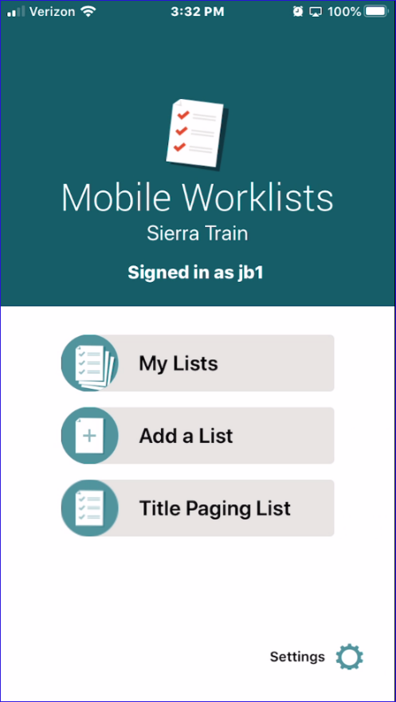
Figure 1

Selecting Title Paging List displays the items that are to be paged at the library. Note that a background process that typically runs at 7:00AM, 10:00AM and 2:00PM updates the list. New holds placed resulting in paging will not appear in the list until the process runs.

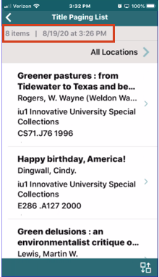

At the top, there is a summary of the number of items to page and the date/time of last update. The default is to include all locations in the branch. To restrict to one or more locations, select All Locations and then choose the locations. Only items matching the select locations will display.
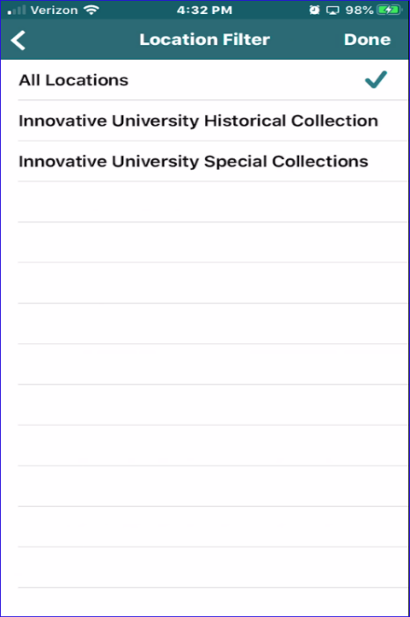

Select an item to view details.
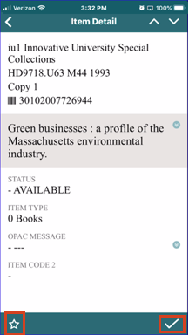

Swipe up or down to view the details of the item immediately above or below respectively on the summary screen. Select the star on the bottom left to mark the item without checking it in. Select the checkmark on the bottom right to display the check in option.

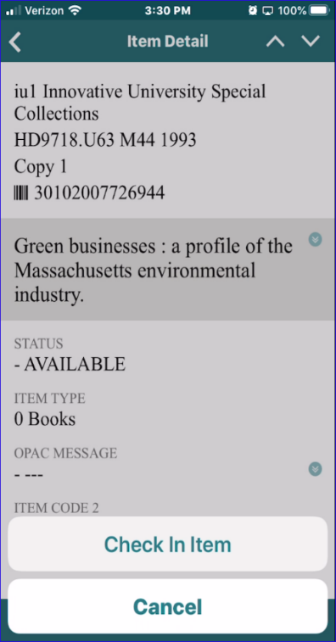

Select Check In Item to check the item in. With the device camera, you can check in the item by scanning the barcode.

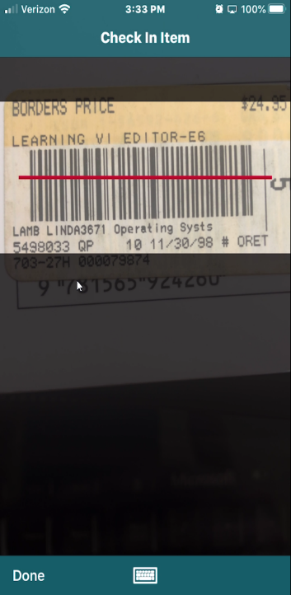

If the camera is unavailable or the barcode is not scannable, select the keyboard at the bottom of the screen to type in the barcode number.

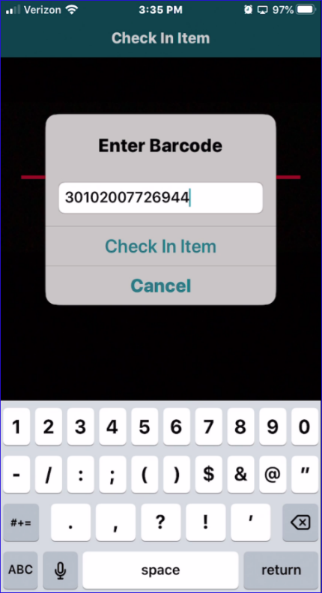
Checking in the item would place the item on the holdshelf if the locations served of the Sierra username matches the pickup location.

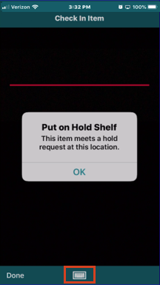

If the item it to be picked up at a different location based on the above criteria, it will be set in transit.
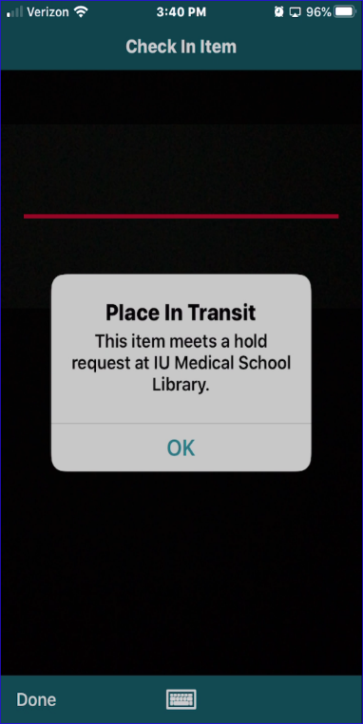
NOTE: Neither holdslips nor transit slips are produced when checking items in via Mobile Worklists.

On the summary screen, the list can be sorted by one or more conditions. Select the symbol on the bottom left.

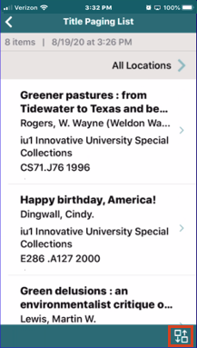

If choosing multiple sort conditions, choose from the “hamburger” menu on the right to determine primary sort, secondary sort, etc.
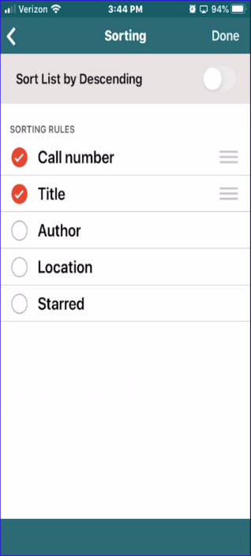

In this example, the list is sorted in Call Number order. If more than one entry shares the same call number, then sub sort by Title.
On the summary screen swipe right to mark or star an entry.

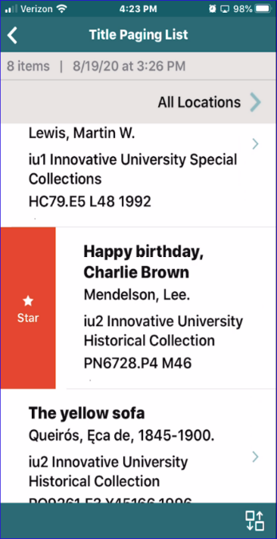

And swipe left to check the item in from the summary screen.

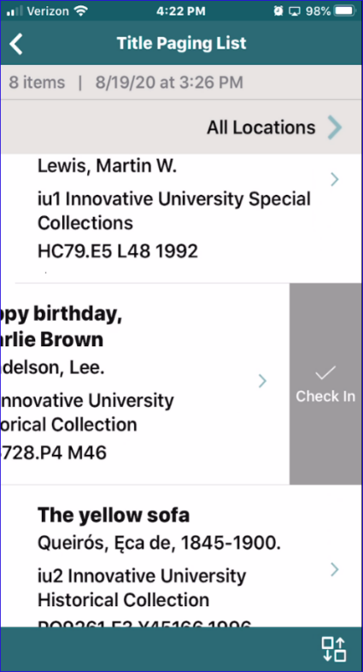

This publication is supplied for the exclusive use of customers of Innovative Interfaces with the understanding that it shall not be shown or distributed to anyone outside of the customer's organization without the prior written permission of Innovative Interfaces. This publication may be copied only if the copies are for the exclusive use of staff members of libraries that have purchased the Innovative system.
© 2022, Innovative Interfaces, Inc.

