Sierra Print templates

Adding or editing elements for Print Templates in Jaspersoft Studio

A large part of customization on a Print Template is determining which data elements will appear in the output. For information about getting started with Jaspersoft Studio, the environment within which customizations are applied, review the document Setting Dimensions for Print Templates in Jaspersoft Studio.

Each output type has a data dictionary defined in the Sierra WebHelp. And each default template has the complete set of elements embedded within. Using a default template to get started makes that set accessible. For example, using the _Prenotices default template for courtesy notices, we see all the elements available for use in the Outline panel.

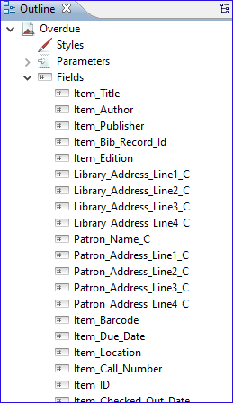

If the Outline panel does not display, activate via Windows | Show View | Outline.

Elements all share the format $F{<element_name>}. For example, the Material Type field is represented as $F{Item_Material_Type}. To use the elements, drag the element from the Outline panel using the left mouse button and drop it onto the workspace.

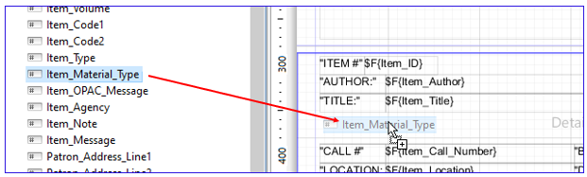

NOTE: Elements ending in “_C” are applied in the Title and Footer bands. The elements not ending in “_C” are used in the Detail 1 band.

Once the element has been dropped in the workspace, you can move it around via the mouse or arrow keys on the keyboard. You can also use the properties to precisely place the element using the Location settings. The x value is the amount of space from the left side of the page and y value is the space from the top of the band. Note that the default unit of measure is the pixel (1 inch = 72 pixels), but that can be changed in the page properties discussed in Setting Dimensions for Print Templates in Jaspersoft Studio. You can also update other properties of the elements such as the dimensions (height and width) of the element and the font and font properties.

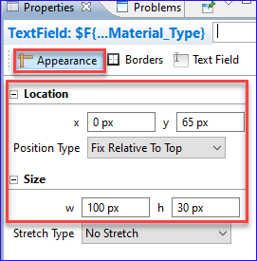

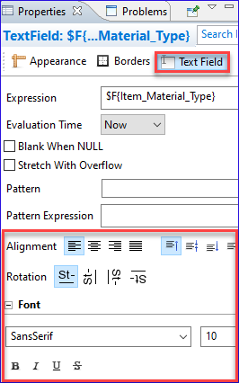

In addition to the placeholder elements, you can add static text to provide description. For example, if we added the Material Type element, we might want to precede it with a static text element with the text “FORMAT:”. Drag and drop the element into the workspace from the Palette panel. If the Palette panel does not display, activate via Windows | Show View | Palette.

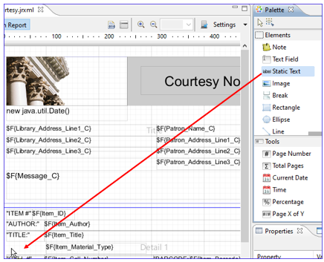

Customize the Static Text field with the content and properties like those applying to the elements. Double-click within the Static Text field to update the content.

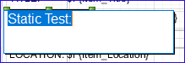

Now the Material Type field is preceded with the “FORMAT:” text.

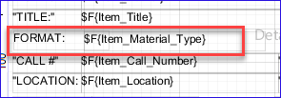

To change an existing element or static text, double-click on the element and update the properties.

There are several methods to check for errors. In Studio, click on the Preview tab. Errors will be called out. In the following example, the height of the MESSAGE_C element crosses over a band boundary causing the outline to display in red, and the element Item_Title_Example is not valid.

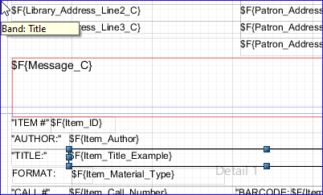

Selecting Preview calls out the two errors:

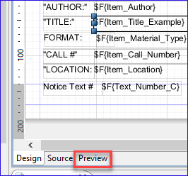

Errors display in the Report State panel. If the Report State panel does not display, activate via Windows | Show View | Report State.

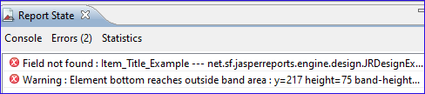

Selecting the Design tab will allow you to continue editing. Correcting the errors will display a clear report when selecting Preview again.

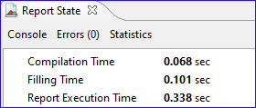

This publication is supplied for the exclusive use of customers of Innovative Interfaces with the understanding that it shall not be shown or distributed to anyone outside of the customer's organization without the prior written permission of Innovative Interfaces. This publication may be copied only if the copies are for the exclusive use of staff members of libraries that have purchased the Innovative system.
© 2022, Innovative Interfaces, Inc.

