sierra Print templates

Setting Dimensions for Print Templates in Jaspersoft Studio

After a Print Template has been exported from Sierra to your workstation, customization of that template takes place in Jaspersoft Studio. Jaspersoft Studio is a third-party report generation program that allows for several levels of customization to Sierra output. If you have not already done so, download the program here.

Before using Studio, you will need a file to customize. Review the document Getting Started with Print Templates to learn how to export a file from Sierra to your workstation.

After launching Studio, open the jrxml (Jasper Reports XML) exported from Sierra. You will need to navigate to the same folder on your workstation that the file was originally saved.

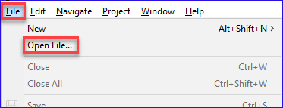

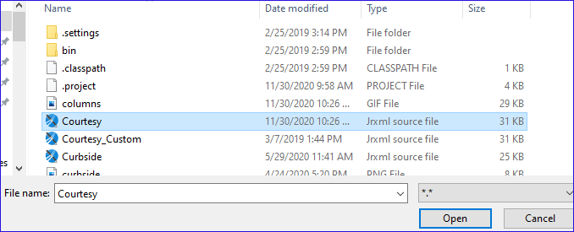

When the file is active on Studio, it is ready to be customized.

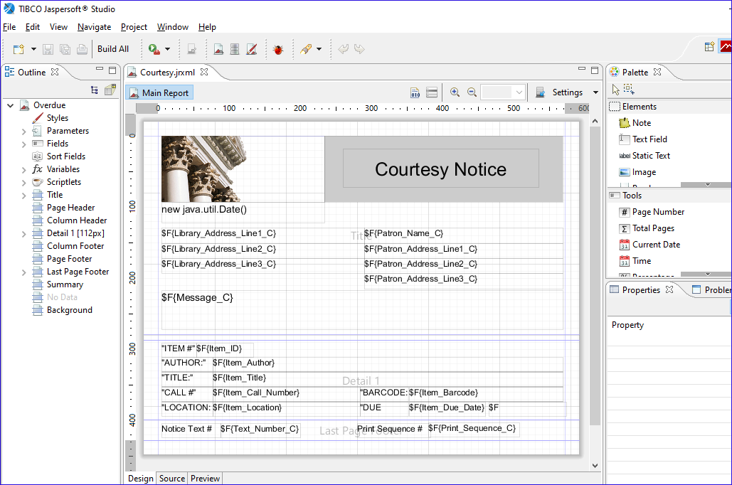

There are several changes that can be applied to a Print Template. This first is the page dimensions. The unit of measure in Studio is the pixel. One inch is equal to 72 pixels which allows for granular changes to be applied. If we want to send out output with dimensions 8.5 inches in width and 11 inches in height, that is represented as 612 x 792 pixels. If the output is to be emailed, you may want to use a longer page length to allow for more items to appear on the “page”.

To view and/or update the page dimensions, click on the grey space outside of the work form and then in Properties panel, select Report.

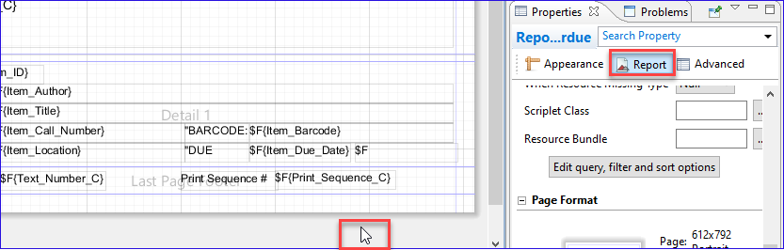

If Properties panel is not displayed, it may need to be activated via Window | Show View | Properties.

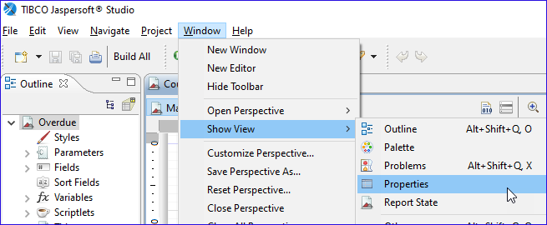

At the bottom of the Report section, select Edit Page Format.

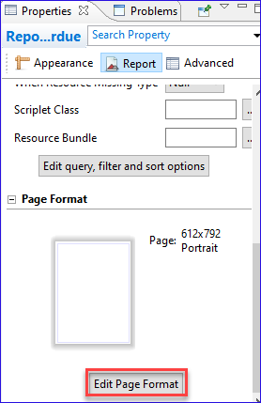

Here we can see the page dimensions in pixel units. We can update the dimensions, change the unit of measure, indicate if the page is to be Portrait (8.5” x 11”) or Landscape (11” x 8.5”), define the margins and indicate the number of columns. The last one is useful for designing monographic spine labels if the sheet contains multiple labels in one row.
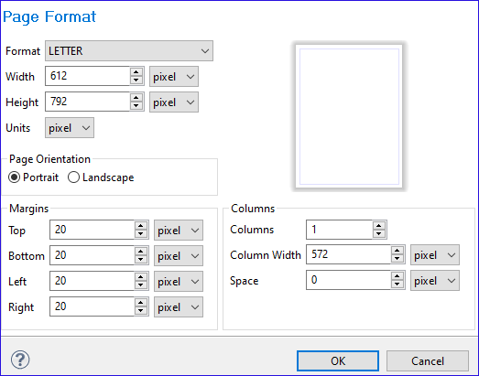

As changes are applied, the blank rectangle will reflect those changes.

Studio divides the page vertically into zones called bands. Each band has a height and a particular purpose. The bands are displayed in the Outline panel. If the Outline panel does not display, activate via Windows | Show View | Outline.

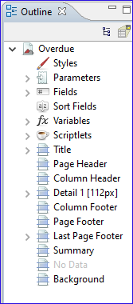

To view/adjust the height value of a band, click on the band (ex: Title) and then in Properties, select Appearance. The height is listed and can be updated.

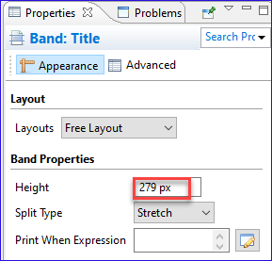

Print Templates use all or some of the following bands:

Title: The top of the report. All the data is printed one time at the beginning of the output will go here.
Column Header: This could be used if the data that follows is in columns
Detail 1: This is where the repeatable data goes. For example, if this is an overdue notice, we will define the output for one item (barcode, title, author, call number, etc.) and that information will be used for each overdue item that appears on the notice.
Page Footer: Details that appear at the bottom of each page.
Last Page Footer: Details that appear at the bottom of the final page of output.

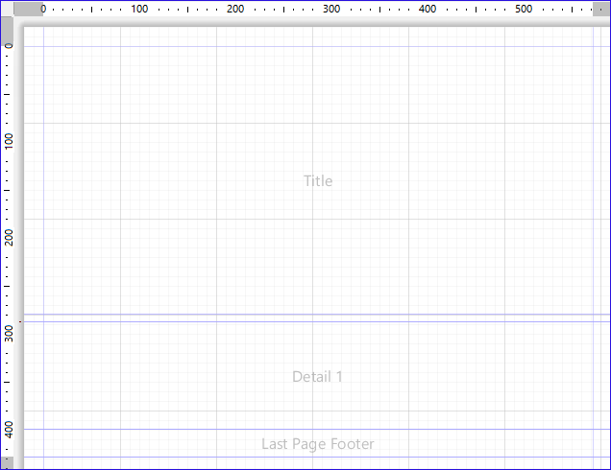

Each band that is used is assigned a height to define the space available for that portion of the page. Because Detail 1 is repeatable, the total amount of space available for that band is the height of the page minus the space used by the other bands. As an example, let’s use a page height = 11 inches and only two bands: Title = 3.5 inches and Detail 1 (one item) = 1 inch. On the first page, Detail 1 has 7.5 inches (11 minus 3.5) which means it can include up to 7 items as a half inch is not enough for the 8th item. The rest of the items will continue on the next page. Since the title only appears on the first page, any page after will allow for 11 items to appear.

Within each band is the information needed in that part of the page. For example, on a Courtesy Notice, common elements stored in the title band are the library name and address, the patron name and address, the date of the notice and the notice message. If there is a logo to include, it would also be placed here.

Many of the elements are placeholders for the actual data that will be used at the time the notice is produced. For example, an element for patron name $F{Patron_Name_C} will be replaced with the name of the patron receiving the notice at the time of output. For more information, review the document Adding or editing elements for Print Templates in Jaspersoft Studio.

In addition to including placeholder elements in bands, you can add static text, images, shapes and more.

This publication is supplied for the exclusive use of customers of Innovative Interfaces with the understanding that it shall not be shown or distributed to anyone outside of the customer's organization without the prior written permission of Innovative Interfaces. This publication may be copied only if the copies are for the exclusive use of staff members of libraries that have purchased the Innovative system.
© 2022, Innovative Interfaces, Inc.

