Sierra Electronic resource management

How to Guide to Matching Coverage

What is Coverage Data?

Coverage data store information about your library's resource providers, titles, EISSNs, holdings for titles, access restrictions, etc. Several Innovative products can use the coverage data stored in the system. Coverage data are stored in the coverage table.

Load coverage data into the coverage table by using Coverage Load.
Edit the coverage data in the coverage table by using Coverage Edit.

When processing coverage data into the coverage table, the Innovative system performs several checks to determine how the data should be handled.

What is the Matching Algorithm when the Data is Loaded?

When you use Coverage Load mode to load coverage data, you choose to update either your catalog, your coverage table, or, as Innovative recommends, both simultaneously. There are different algorithms for matching records in your catalog and coverage data in your coverage table. For a description of Sierra Coverage Load's default matching algorithms, see Alternate Lookup: The Catalog Option in Coverage Load and Alternate Lookup: The Coverage Option in Coverage Load.
Check this page for a description on Matching Existing Coverage Data during Coverage Load.

For a description of the algorithm used for coverage updates if alternate lookups are disabled on your system, see Additional Matchpoints.

For a description of the algorithm used for catalog updates if alternate lookups are disabled on your system, see Processing Coverage Data with the Catalog Option section of How the Catalog and Coverage Options Work.

The following diagram illustrates the way resource, holdings, and coverage table data are matched by following linked Resource ID and PROVIDER fields.

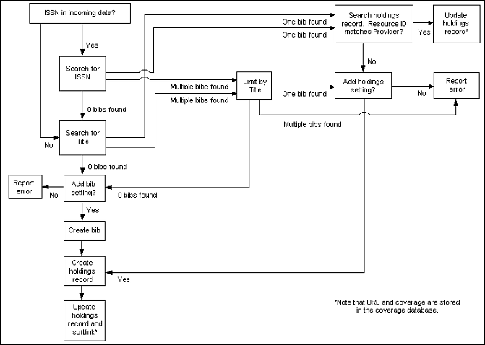

Does my library have to do any setup for matching to work?

Typically no setup is required. Your library must index the bibliographic record's ISSN variable-length field, because Sierra Coverage Load searches for matches against the ISSN index rather than each individual record. Alternate lookups are used by default; if you do not want to use alternate lookups, contact Innovative. For more information about Coverage Load's search against the ISSN index and its use of alternate lookups, see Matching Existing Coverage Data with Alternate Lookups.

Bibliographic Records for Print and Electronic Journals

If I have a bibliographic record for a print journal, would the data load from my vendor attach the holdings statement to the print bibliographic record or would it create a new bibliographic record for the ejournal?

The system creates a new holdings record attached to the existing bibliographic record if the following conditions are true:

- The bibliographic record for the print journal matches either:
- the ISSN
- the title
- (optionally) the alternate matchpoint in the file you are loading
- You have set up ERM parameters for your login to create new holdings records.
- You have checked Catalog before you loaded the coverage file.

The system creates a new bibliographic record and attaches to it a new holdings record if the following conditions are true:

- The system fails to match an existing bibliographic record on either:
- the ISSN
- the title
- (optionally) the alternate matchpoint in the file you are loading
- You have set up ERM parameters for your login to create new bibliographic records.
- You have set up ERM parameters for your login to create new holdings records.
- You have checked Catalog before you loaded the coverage file.

For updating coverage data, your system will match on the following:

- ISSN/EISSN/ISBN
- the title
- (optionally) the alternate matchpoint in the file you are loading

See Electronic Holdings Administration (for more information on setting your login's parameters for creating records during a coverage load.

Can ALTLOOKUP be inserted into a MARC tag other than 001 during ERM Coverage Load?

When creating brief bibliographic records during a coverage load, the system inserts the ALTLOOKUP into a field with MARC tag 001. If you wish to have it inserted into a different MARC tag, add to the bib template used for loading coverage a field with 'o' as the field group tag and the preferred MARC tag, 035 for instance.

This solution is applicable when your ALTLOOKUP is set to be an o-tagged field indexed in the 'o' index.

Example of a bibliographic record template used for brief bibliographic records created with coverage load.
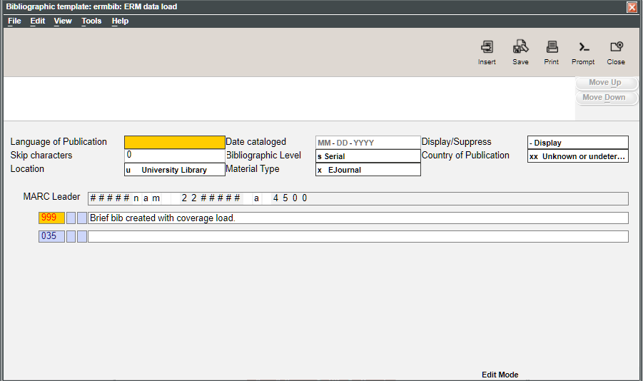

To match a different index in Catalog updates in ERM, contact Innovative Help Desk.
NOTE: the field used for matching ALTLOOKUP must in indexed.

This publication is supplied for the exclusive use of customers of Innovative Interfaces with the understanding that it shall not be shown or distributed to anyone outside of the customer's organization without the prior written permission of Innovative Interfaces. This publication may be copied only if the copies are for the exclusive use of staff members of libraries that have purchased the Innovative system.
© 2022, Innovative Interfaces, Inc.

