Sierra ERM
Enhanced Tickler Notifications

Enhanced Tickler Notifications
Your library's staff can add a Resource or License fixed-length field and its value as optional elements to a Tickler rule.

Example: Send email 30 days before Contract End Date only if a license indicates that it is not set up for automatic renewal

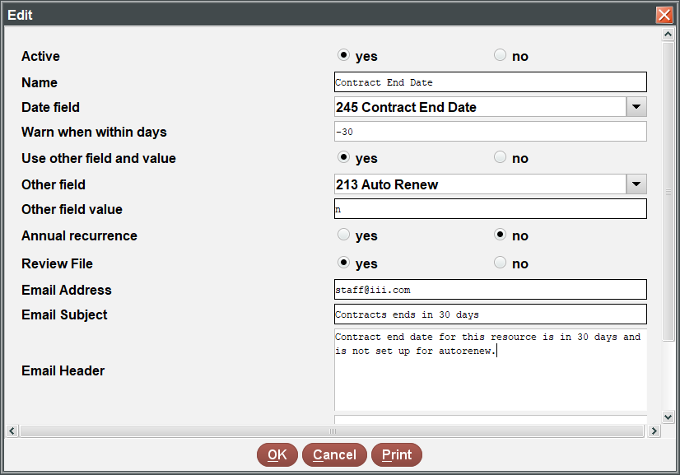

Use Cases
USE CASE | WARN WHEN WITHIN DAYS | DATE FIELD | OTHER FIELD | OTHER FIELD VALUES
Send email 30 days before Contract End Date only if a license indicates that it is not set up for automatic renewal | - 30 | Contract End Date | Auto Renew | n (No)
Send email 1 day after the Registration Date only if a resource indicates its display is still suppressed in WebPAC Pro/Encore | 1 | Registration Date | Suppress | n (Suppress in OPAC)
Send email 1 day after the Trial Begin Date only if a resource record indicates its status is still inactive | 1 | Trial Begin Date | Status | i (Inactive)

Annual Recurrence
ERM's Tickler notification feature also has an Annual Recurrence option that allows notifications to be generated only from Month-Day elements in a Resource or License fixed-length date field. This means that you do not have to update the Year element in your date fields in order to receive a Tickler notification on an annual basis.

This publication is supplied for the exclusive use of customers of Innovative Interfaces with the understanding that it shall not be shown or distributed to anyone outside of the customer's organization without the prior written permission of Innovative Interfaces. This publication may be copied only if the copies are for the exclusive use of staff members of libraries that have purchased the Innovative system.
© 2022, Innovative Interfaces, Inc.

