Sierra Circulation
Offline Circulation Operation

Offline Circulation saves checkout, check in and patron registration transactions on the workstation while disconnected from the Sierra server. For instructions on installing and setting up Offline Circulation, see Offline Circulation Installation and Setup. When a network link is available between Offline Circulation and the Sierra server, the transactions can be uploaded. This is discussed in the Offline Circulation Upload and Processing document.

Offline Circulation offers four operations:
Check-Out
Check-In
Renew
Patron Registration

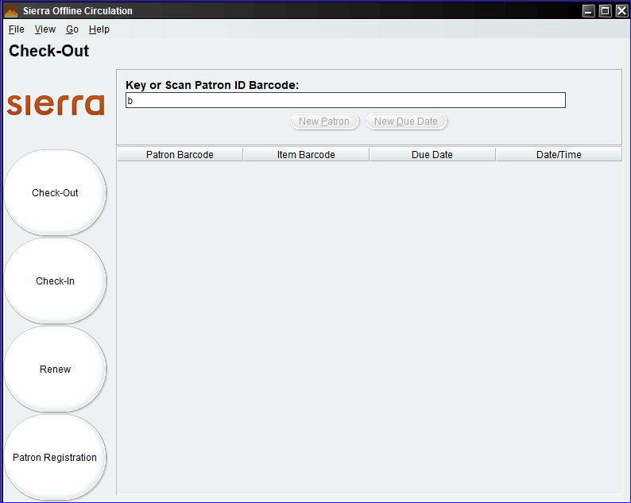

Check-Out
Check out allows circulation of items to patrons using barcodes. Because the client is offline, it does not have access to any details beyond the supplied barcode. It also has no access to circulation rules. Therefore, when checking out, the operator will need to decide if the material is appropriate for check out to the patron and supply the due date and possibly the due hour.

First select the Check Out icon and key or scan the patron barcode.

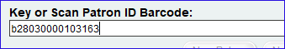

Next, supply the date and possibly the time. The date is in the format MM-DD-YYYY unless altered in the Preferences.

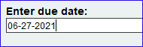

Answer Y(es) or N(o) to Hourly?

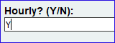

If answered Y, then there is an additional prompt for hour using the 24-hour clock. For example, 15 represents 3PM.

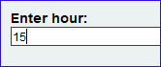

Minutes are not entered as Sierra Offline Circulation will record the item due at the top of the hour (e.g., 15:00/ 3:00PM). Now scan item barcodes for all the items that are to be checked out to this patron and due on the date/time supplied. If an item is to be due on a different date/time, click on New Due Date to enter the new due date or New Patron to complete the checkout for the patron.

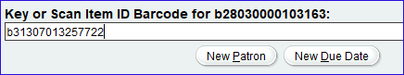

As items are checked out, a summary is provided.

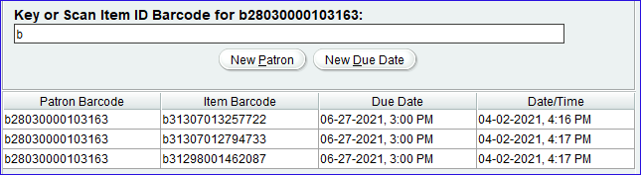

When done, click on New Patron to output the Due Slip if designated in Preferences.

Check-In

Check-In records the return of items that have been checked out. Again, because it is not connected to the Sierra server, Offline Circulation does not know if checked in materials need additional processing. For example, if the item is overdue, there could be a fine assessed or an item with a hold could be checked in at the hold pickup location. When the transactions are uploaded to Sierra and processed, these actions may or may not be enacted at that time depending on selections made.

Checking in items only requires keying or scanning the item barcode. As items are checked in, a summary is supplied.

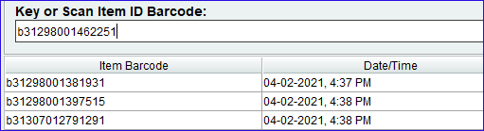

When done, select another function or end the session with File | Exit.

Renew
Renew is identical to Check-Out. In both functions, if an item barcode is supplied that is already checked out to the supplied patron barcode, then it will ultimately result as a renewal similar to checking out an item to a patron that is already charged to that patron in the Sierra Desktop Application. Likewise, a new checkout can be recorded in either function.

Patron Registration
Patron Registration is used to generate new patron records. The prompts for patron data are defined in Preferences, discussed in Offline Circulation Installation and Setup.

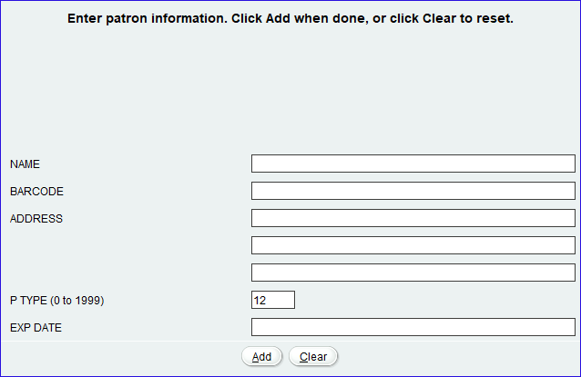

If designated in Preferences, fields might be prepopulated such as P TYPE = 12 in the above example. Fill in all the available prompts for which there is data and click on Add to save the new patron record. When the data is uploaded and processed in Sierra, a patron record containing the supplied information will be generated.

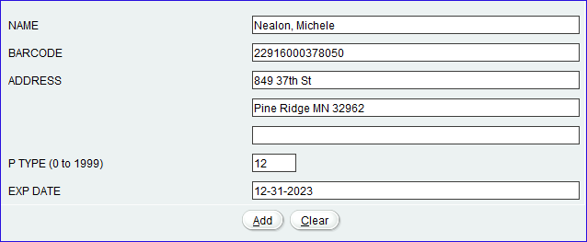

This publication is supplied for the exclusive use of customers of Innovative Interfaces with the understanding that it shall not be shown or distributed to anyone outside of the customer's organization without the prior written permission of Innovative Interfaces. This publication may be copied only if the copies are for the exclusive use of staff members of libraries that have purchased the Innovative system.
© 2022, Innovative Interfaces, Inc.

