sierra circulation
How to Resolve Duplicate Patron Accounts

After identifying a duplicate patron record, how does it get resolved? It is possible to merge the two records so the data is contained in a single record and the unnecessary record is deleted.

Permission # 36 (merge patrons) is required to be able to perform this task. See Merging Duplicate Patron Records in the Sierra WebHelp for additional information.

From the function list select: Merge Duplicate Patron Records
The next screen prompts to search duplicate patron records to merge by patron record number.
Under source record number, type the patron record number to discard.
Under destination record number, type the patron record number to keep.

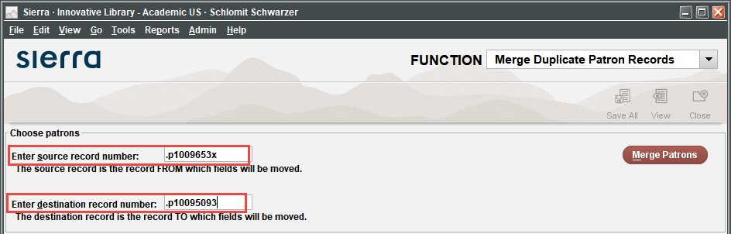

Click the Merge Patrons button. That will bring up a window with patrons to merge. You can compare records data to make a final decision. The destination record is selected by default.

Click the Merge Patrons button to complete the merge.
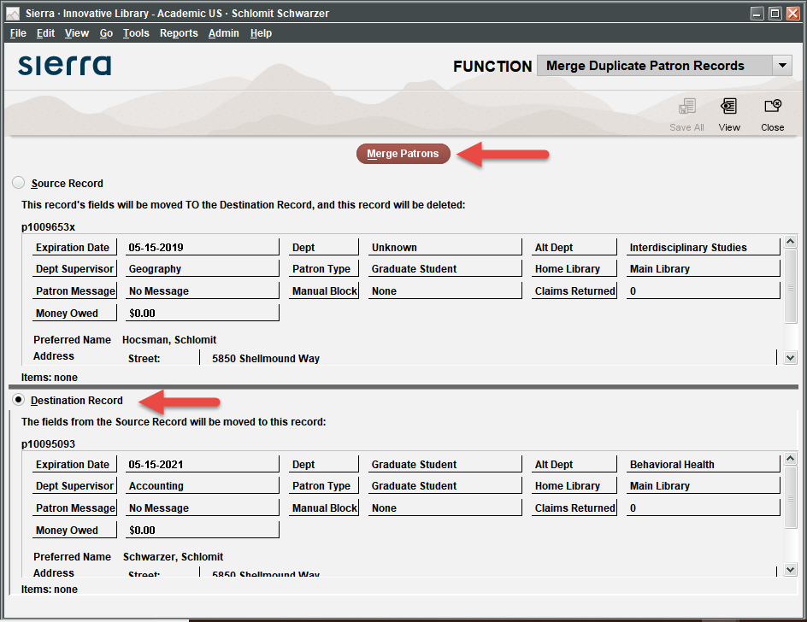

It is also possible to simply delete one of the duplicate patron records. While selecting which one to delete, compare the two records and look for:
- Created date (is one record much older than the other?)
- Last updated date (have either record been updated recently, indicating it has been used?)
- Expiration date (is one account already expired?)
- Usage (data in current checkout field, total check out field, money owed field)
- Incomplete variable length fields (barcode is missing, address or phone number is missing)

Make your decision based on your findings. An incomplete record that has never been used would be the one to delete rather than one with more complete information or that has been used.

To delete a patron account, open the record in EDIT mode. Click on FILE in the upper left corner of the record. Select DELETE PATRON RECORD. Choose YES to delete the account.

Patron accounts with items checked out or which have money owed can’t be deleted. The “merge” process can move that data to the other patron account.

This publication is supplied for the exclusive use of customers of Innovative Interfaces with the understanding that it shall not be shown or distributed to anyone outside of the customer's organization without the prior written permission of Innovative Interfaces. This publication may be copied only if the copies are for the exclusive use of staff members of libraries that have purchased the Innovative system.
© 2022, Innovative Interfaces, Inc.

