sierra circulation
How to Change the Record View Properties, Holds/Bookings View Vs. Item View

If the screen choices look different for one login versus another login, you can adjust this type of screen view. There are record view properties that can be set for each login. There is information about this in the User Guide in the link below:
Sierra User Guide: Record View Properties

From pull down menu (top left side of the screen, select View| Record View Properties

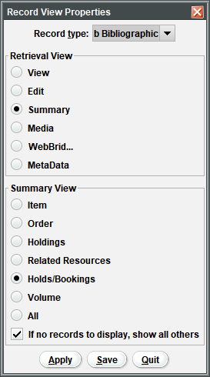

When you get in, you choose the record type, and then there should be options for which view you would like to be the default.

After making a selection, choose the appropriate button:
Apply - Applies your choices to the current session only. The next time you log in, the existing default settings apply.
Save - Applies your choices to the current session and saves them as the new default for your login. (The Login can edit preferences Setup option must be enabled for your login.)
Quit - Discards your choices and closes the dialog box.

The Record View Properties menu option appears only when you are in a Sierra function that enables you to search the database and retrieve records, including Catalog, Search/Holds, or Program Management.

Note: if you change this setting, Sierra cannot restore the default system behavior.

This publication is supplied for the exclusive use of customers of Innovative Interfaces with the understanding that it shall not be shown or distributed to anyone outside of the customer's organization without the prior written permission of Innovative Interfaces. This publication may be copied only if the copies are for the exclusive use of staff members of libraries that have purchased the Innovative system.
© 2022, Innovative Interfaces, Inc.

