sierra circulation
How Can I Print a List of Items on the Hold Shelf That Includes Patron and Hold Information?
- Go | Circulation | View Outstanding Holds
- Limit Display: keep the default date (i.e. today's date) for Holds Placed Before; input "on holdshelf" (without double quotes) for Hold Status
- Pickup Location: select the option "select location" and select the target hold pickup location
- Click on View Outstanding Holds button
- Click on Print icon at the upper right corner to print the table

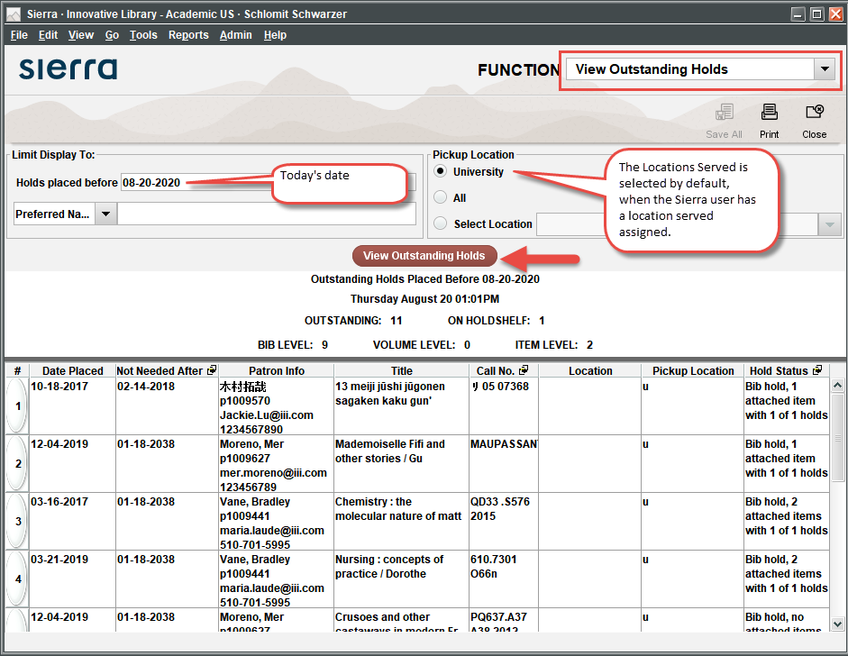

For more information, see Viewing Outstanding Holds in the Sierra WebHelp.

This publication is supplied for the exclusive use of customers of Innovative Interfaces with the understanding that it shall not be shown or distributed to anyone outside of the customer's organization without the prior written permission of Innovative Interfaces. This publication may be copied only if the copies are for the exclusive use of staff members of libraries that have purchased the Innovative system.
© 2022, Innovative Interfaces, Inc.

