sierra circulation

Checkout Criteria Flowchart

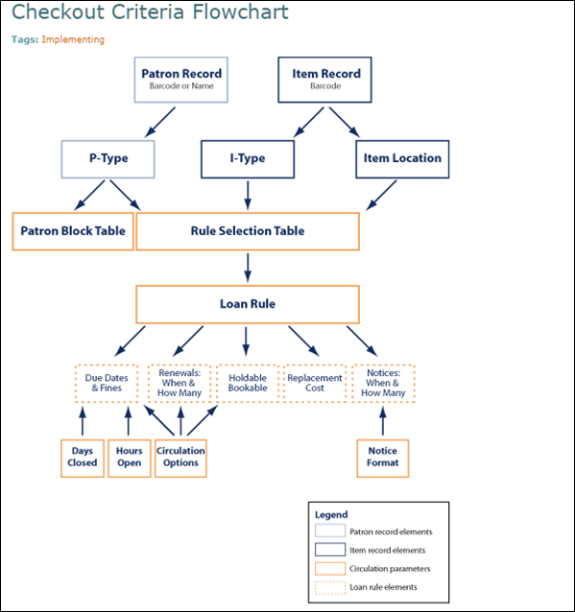

This publication is supplied for the exclusive use of customers of Innovative Interfaces with the understanding that it shall not be shown or distributed to anyone outside of the customer's organization without the prior written permission of Innovative Interfaces. This publication may be copied only if the copies are for the exclusive use of staff members of libraries that have purchased the Innovative system.
© 2022, Innovative Interfaces, Inc.

