Sierra circulation

Batch Checkin: Managing Long Billed Items FAQ

FAQ

We have a lot of items that have been billed for quite some time. Is there a way to remove these from our database without losing the bill?
Yes. Batch Checkin is designed for library staff to manage long billed items. This function is used to check in an item while leaving the bill on the patron's record. Library staff most frequently use this function to check in long overdue items that they do not expect to be returned. See Batch Checkin process.

When an item is checked in using the batch checkin method, how do fines and fines paid information display in the patron's record?
The patron record fines display includes information on the item charge, processing fee (if any), and billing fee (if any). For example:

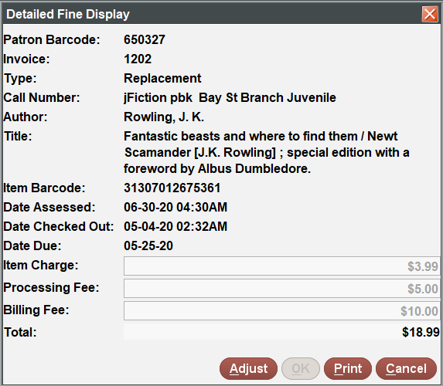

Once the fine is paid, the Fines Paid file display includes the invoice number, charge type, description, amount due, amount paid, and date paid for each line item. For example:
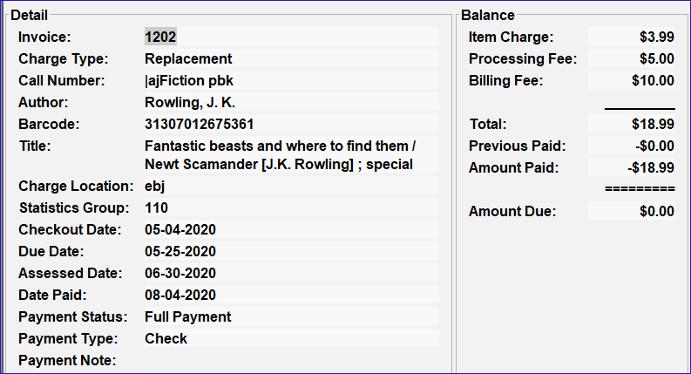

What happens if we delete the batch checked in item?
When an item is deleted from the system after using batch checkin (before payment is accepted), the barcode is removed from the fines and fines paid displays and replaced with an informational message. For example:

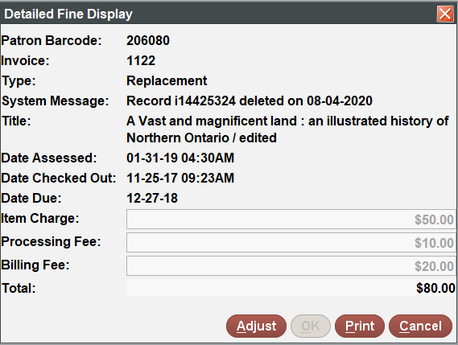
Additionally, when an item is deleted from the system after using batch checkin, the following fields are not retained in the full view of fines and fines paid displays on the patron's record: Author, Item Location, Call number (including volume and copy number); however, the summary display of fines and fines paid information includes the item location for unpaid or partially paid fines.

For further information review the following: Fines Tab and Viewing Fines Paid.

When I use Batch Checkin to check in a "long billed" item, it shows on the shelf. How do I check in a long billed item and not have it show "on the shelf"?

Batch Checkin performs an actual checkin on a batch of item records, causing these items to appear to be "on the shelf" upon completion. To handle long billed items, many libraries create a special suppression value. Run rapid update on these items prior to running Batch Checkin to insert the special suppression value.

You can request the setup of additional suppression values by contacting the Help Desk.

A typical Batch Checkin work flow is:

- As often as needed, a staff member creates a review file of items billed more than a certain amount of time. For example:
item status = n and due date within 01/01/2019 and 12/31/2019

- The staff member inserts a suppression value into the items via rapid update.
- If your library will need to reference information later about the batch checked in items, Innovative recommends outputting information about the item, patron, and bibliographic records from the records in the review file. Some suggested fields include item barcode, item out date, item due date, item call number (if used), patron name, patron record number, bibliographic title, and bibliographic call number (if used). Your library should include all useful fields. Output the file and import into a third party software product, such as a spreadsheet. Your library then will be able to locate information about the items even after they have been deleted, in the event that a long billed item is located and returned to the library.
- The staff member checks in the items using Batch Checkin.
- As often as needed, a staff member creates a review file of items with an LCHKIN date within a specific date range and the special suppression value. For example:
suppression value = r and LCHKIN date within 01/01/2020 and 12/31/2020
- Staff run a statistical report on the items and then delete items or items with bibs (last copies) in DELETE RECORDS OF ANY TYPE.

Your work flow may vary, depending upon circumstances.

We want to delete some old and inactive patron records, some of which have long billed items. How do we do that?
To delete patron records with long billed items, complete the following steps:

- Create a review file of any long billed items still checked out to these patrons.
- Batch check in the long-billed items. The bills will be added to the patrons' records.
- Create a review file of the old and inactive patron records, all of which should now have no items checked out to them.
- Globally purge the fines owed in these patron records. For more information, see GLOBALLY purge fines.
- Verify that the specified patron records have no more checked out items, holds, fines, nor any other outstanding transactions.
- Delete the patron records. See Deleting Records.

This publication is supplied for the exclusive use of customers of Innovative Interfaces with the understanding that it shall not be shown or distributed to anyone outside of the customer's organization without the prior written permission of Innovative Interfaces. This publication may be copied only if the copies are for the exclusive use of staff members of libraries that have purchased the Innovative system.
© 2022, Innovative Interfaces, Inc.

