sierra cataloging
How to Use Advanced Limiting in Global Update

Topics:
- Create a review file of records to be globally updated.

Open the file in the Global Update Function.

For more information check Advanced limiting in Global Update.

What follows is the process to delete unwanted barcodes from patron accounts which contain multiple barcode fields.

Open the file of patron records in global update. Before starting this process, it is helpful to toggle the display to patron barcode so you can see the variety of digits at the beginning of the barcodes.

Click Tools

Click limit – this opens a search window like what is seen in create lists. Choose the append command and build the query. In this example, the barcodes starting with 0 and 1 will be changing:

type = patron field = barcode condition = starts with value a = 0

OR type = patron field = barcode condition = starts with value a = 1

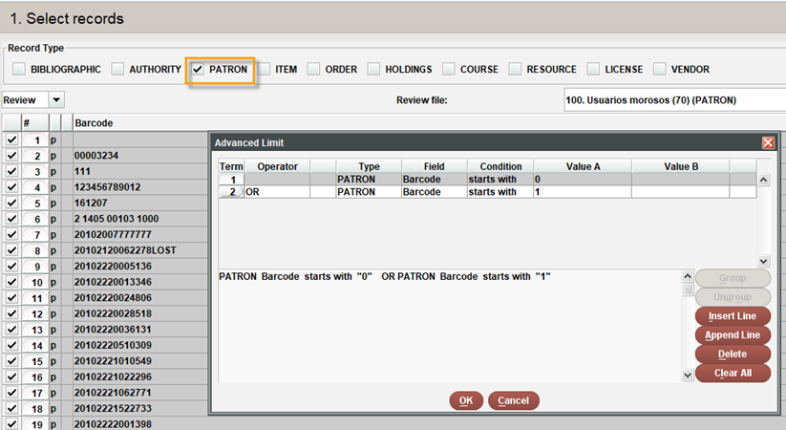

Click OK | Click search.

A subset that matches the search criteria will display.

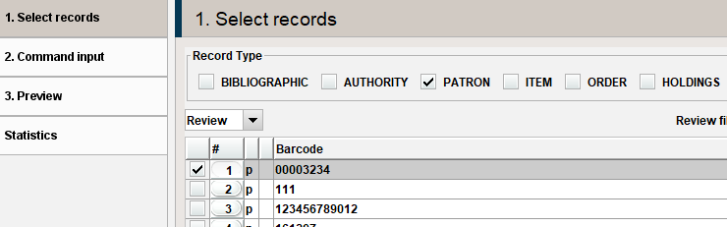

Select the records to delete

Click command input

Click add

Select delete variable length field

Click ok

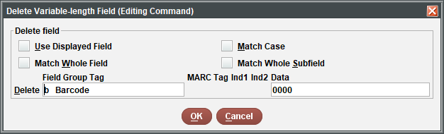

Uncheck “use displayed field.”

In the field group tag window, select barcode, add data

Click ok

Click Preview tab

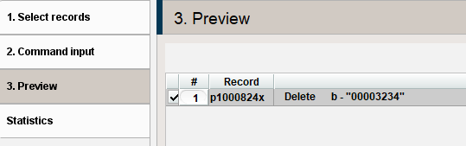

The selections will display and show the barcodes that will be deleted. Some of the entries may include multiple barcodes.

Click process and yes, if this accomplishes your goal.

Now, to repeat the process for the next grouping….

Click select records, then on Tools | Limit

Change value a to different digits to retrieve another subset of records

Click ok and then on search

To clear the limits to view the entire list, click Tools |limit. In the bottom right corner click “clear all” | click OK.

This publication is supplied for the exclusive use of customers of Innovative Interfaces with the understanding that it shall not be shown or distributed to anyone outside of the customer's organization without the prior written permission of Innovative Interfaces. This publication may be copied only if the copies are for the exclusive use of staff members of libraries that have purchased the Innovative system.

© 2022, Innovative Interfaces, Inc.

