sierra cataloging

How to View Record History

Sierra allows users to view the history of changes that are made to Bibliographic record. Changes made to the data are not documented. The system tracks the username and date when changes were made, but not the actual edits.

Creation of records and changes made by staff can be tracked for these functions: Editor, Data Exchange, Scheduler, Global Update, Rapid Update (in Sierra Cataloging only), MetaData Builder (tracked as Sierra Cataloging), URL Checker, Media Management (tracked as Sierra Cataloging), and Web Works Quick Edit.

The following considerations apply to tracking data:

Only programs enabled for tracking appear in the record history. These programs are chosen by the library when the feature is enabled by Innovative. Follow the link at the bottom of this article to learn more about contacting Innovative to enable this feature.

Some activities might not appear in the record edit history. It is also possible that the last update date in the record might be more recent than the most recent change tracked.

The changes tracked in record history may include users who cannot edit that type of records. For instance, if a user can add or modify a bib-level hold, that action can count as a change on the system and be recorded in the record history, making it appear as though the bibliographic record was edited -- by a user who otherwise is not permitted to update bibs.

Alternate or reference database data is tracked separately. Each reference database has its own tracking setup and record change tracking can be enabled separately for each database.

To view record history, permission 606 (View Bibliographic Record History) is required.

To view the change history of a record:
- Open the record in Edit or View-Only Mode
- Click REPORTS
- Select RECORD HISTORY
- The record history report appears.
- Choose Print to print the report or click on Close to close the report.

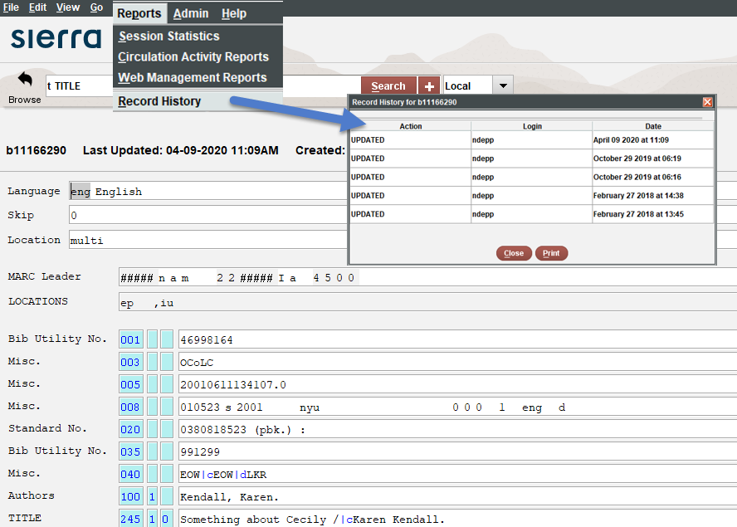

If a record was created before the record history feature was turned on and there have been no recent changes to it, a notice will display stating there is no history for this record.

Note the user can only see the change history for a given record one-by-one from within that record; there is no report about multiple records.

Here is the link to a relevant article about contacting Innovative to enable this feature: How to have Viewing Record History enabled.

This publication is supplied for the exclusive use of customers of Innovative Interfaces with the understanding that it shall not be shown or distributed to anyone outside of the customer's organization without the prior written permission of Innovative Interfaces. This publication may be copied only if the copies are for the exclusive use of staff members of libraries that have purchased the Innovative system.

© 2022, Innovative Interfaces, Inc.

