Sierra cataloging

How to Edit an Item Record

To edit Item records in Catalog, you must be assigned permission 124 (Edit item records).

Retrieve the item record to modify.

The fixed-length fields are often referred to as Statistical category fields. The data in these fields display in the Filed Statistics Reports in the Statistics Function, Web Management Reports and Decision Center.
Most of these fields validate against the Fixed-length Codes file which is defined by the library.

Item records in addition to the system defined fixed-length fields have two specific fixed-length fields, ICode1 (Item code1) and ICode2 (Item code2), so the libraries can use to collect special data. ICode1 is the only fixed-length field that the code is used in Sierra, but the code label is not. i.e., the codes are added to the item records in Sierra but, the library needs to maintain a ledger of the code labels outside Sierra to know the meaning of each code.

Review all Fixed-Length Fields in Item Records.

Edit Fixed-Length Fields

To change a fixed-length field, type in the value or double click in the box. The list will sort either by the code or the code label depending on your starting click. The values in each field are defined and maintained by the library.

The labels for all fixed-length fields can be changed to reflect the data being collected.
Double click on the code to select the value:
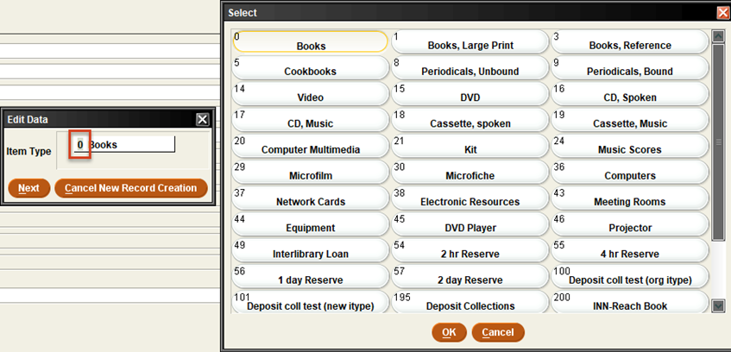

Double click on the code label to select the value:
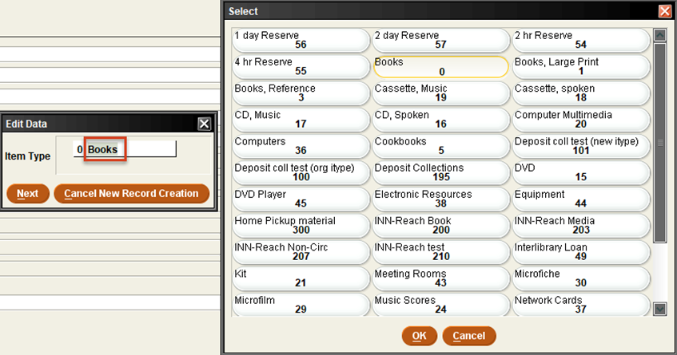

There are two sets of fixed-length fields in the item records. The editable fields and the fields that Sierra automatically inserts data.

The editable fields:
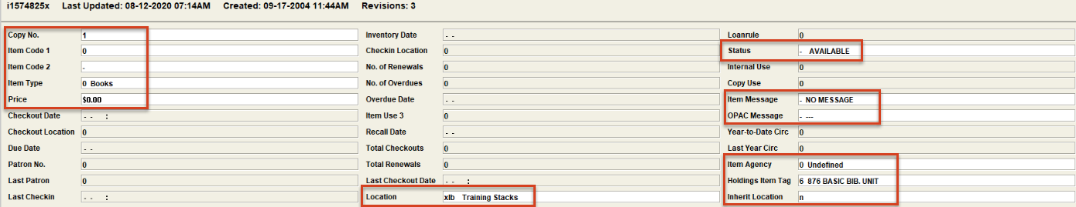

Copy NO., Item Code1, Eprice: the data is inputted, and they are not linked to a predefined table.
Item Type: types of items to determine different circulation periods.
Location: item shelf location.
Status: item status.
Item Message: a code corresponding to a library-defined item message.
OPAC Message: the library defines the messages in the fixed-length code file and the definition will display in the OPAC.

Sierra automatically inserts data in the grayed-out fields. These data are used in the Web Management Reports, Statistics and Decision Center.
Year to Date Circ: the number of times the item has circulated until it is manually copied to the Last Year Circ Filed.
Inherent Location: the item record should refer to the location of the parent record, if no location is specified for the item record.

Fixed-length fields specific to other products:
Inventory date: Inventory Control Product
Item Agency: Consortia Management Product
Holdings Item Tag: Monographic Holding Product

Edit Variable Length Fields

To edit a variable length-field type in the field, right click or click Edit from the menu bar and select or use the following keyboard shortcuts:
• “Ctrl e” or type changes in the field
• “Ctrl j” to paste field
• “Ctrl o” to copy field
• “Ctrl i” to insert field or hit enter and type in MARC tag. Sierra recognizes the correct Field Group Tag for each MARC filed.
• “Ctrl d” to delete field
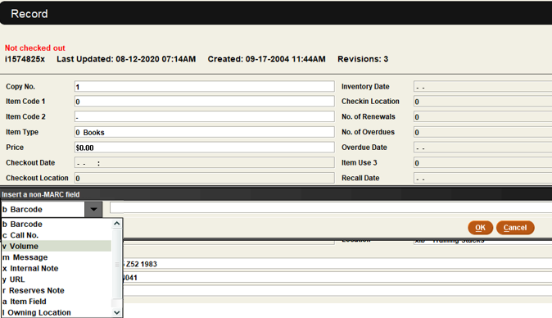

The “m Message” variable length field is a pop-up field.
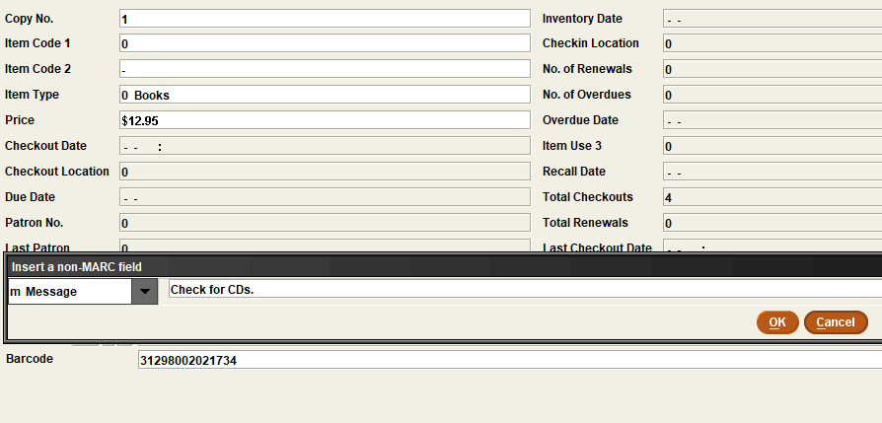

The message pops up when the item is checked out or checked in.
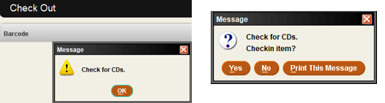

This publication is supplied for the exclusive use of customers of Innovative Interfaces with the understanding that it shall not be shown or distributed to anyone outside of the customer's organization without the prior written permission of Innovative Interfaces. This publication may be copied only if the copies are for the exclusive use of staff members of libraries that have purchased the Innovative system.
© 2022, Innovative Interfaces, Inc.

