Sierra cataloging

How to Create a Single Item Record

To create Item records in Catalog, you must be assigned permission 122 (Create item records).

Item records are attached to a bibliographic record. You can create single or multiple items. This document provides instruction for creating a single item record.

Sierra defaults to creating a single item unless the Prompt for Multiple Items check box is selected in the Admin | Settings | New Records tab.
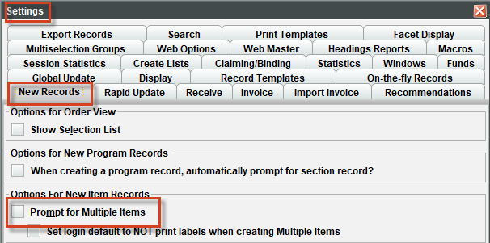

To create a single item record:

- Retrieve the bibliographic,
- Select Item from the View drop-down list in the Summary tab
- Click Attach New Item button
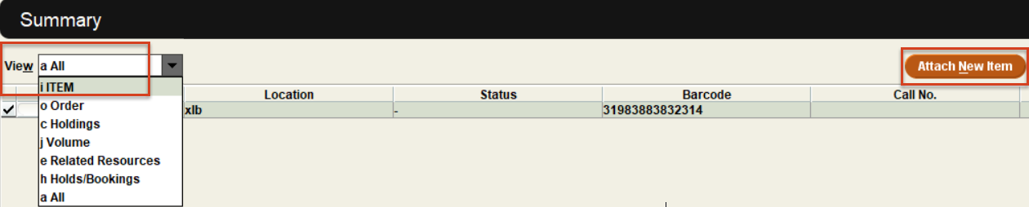
Select the appropriate Item Template
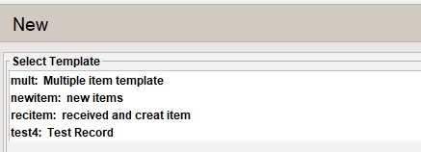

The template maybe using a dialog box also known as the Wizard
- The fields maybe empty or pre-populated.
- Click Next if the pre-populated value is correct
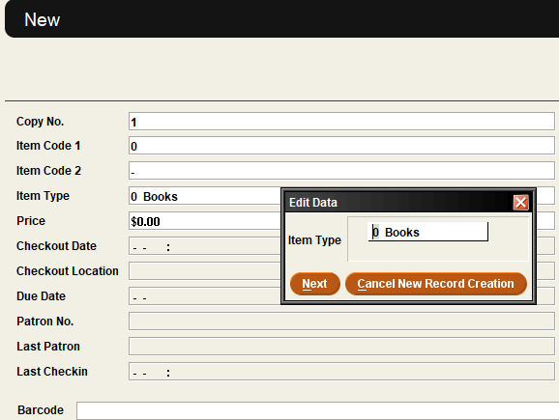

- Otherwise, type in the valid value or double click to see values. The list will sort either by the code or the code label depending on your starting click.

Double click on the code to select the value:
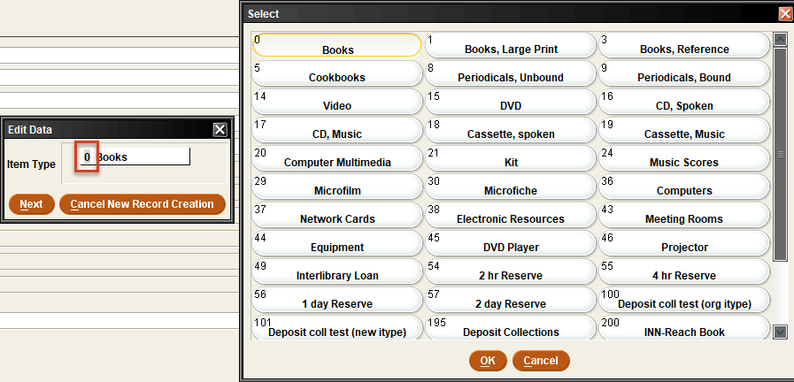

Double click on the code label to select the value:
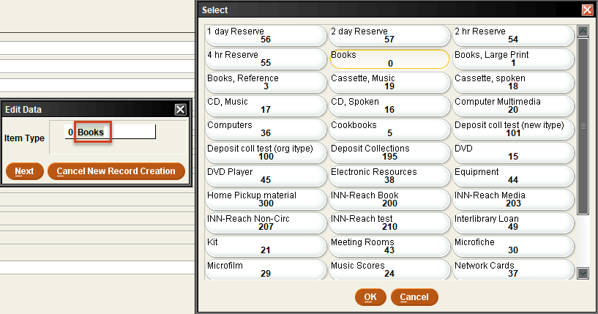
- Click Next to finish adding data for each prompt

Double click in any Fixed length field box that needs to be updated after the dialog box is finished.

NOTE: Make sure to select a valid value for each fixed length field. Blank is not a valid value.
To insert additional variable length fields, click Insert:

To insert additional variable length fields, click Insert:
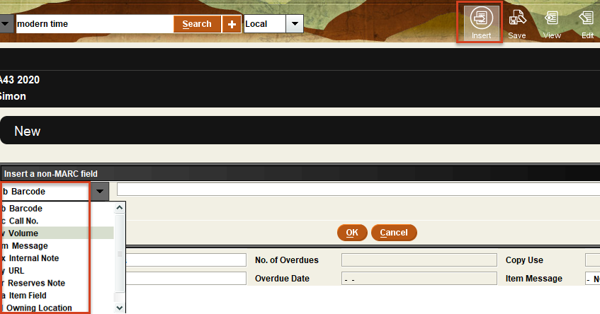

Once the appropriate data has been added, click Save:
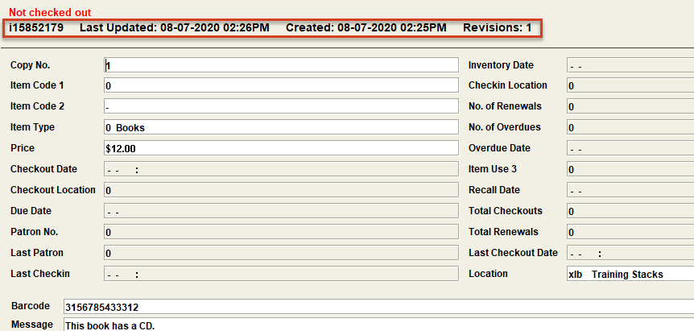

The saved record has the record number, Last Updated, Created date and revisions.

This publication is supplied for the exclusive use of customers of Innovative Interfaces with the understanding that it shall not be shown or distributed to anyone outside of the customer's organization without the prior written permission of Innovative Interfaces. This publication may be copied only if the copies are for the exclusive use of staff members of libraries that have purchased the Innovative system.
© 2022, Innovative Interfaces, Inc.

