sierra Cataloging
Global Update Tips

Introduction
This document discusses common problems that new users have and suggests tips for effective use of Global Update. Before using Sierra Cataloging Global Update, Innovative recommends that you review Globally Updating Records.

Having trouble? Repeat your Global Update steps using the checklists below. Verify that you aren't making any of the common mistakes discussed in the checklists.

Selecting Records Checklist

If a record type cannot be selected (is grayed out), is the user passworded to edit the selected record type? (e.g., 161 'view patron records' and 164 'edit patron records' in addition to 184 'global update' in order to update patrons)

Click 'search' to load and display the records to be edited.

After globally updating records, click 'search' again to re-queue records to review the changes and perform another update on the same records.

NOTE: If you don't see a browse display of records to be edited in the "Select Records" tab, you can't globally update the records. Click 'search'!

For more information, see Selecting Records to Globally Update.

Creating Commands Checklist

Don't check "Use Displayed Field" if the fields displaying in the "Select Records" tab are not the fields you plan to edit.

If "Use Displayed Field" is checked, changes are only applied to the displayed (and 'selected') fields on Select records tab. For example, the title field displays for a set of bibliographic records in Select records tab, but the command is set up to change a call number field. In this case "Use Displayed Field" will cause no changes to be found because the displayed field is not the call number field.

The four conditions "Use Displayed Field", "Match Whole Field", "Match Case", or "Match Whole Subfield" are exclusionary conditions. These four conditions are necessary only when multiple fields exist to which a command could be applied and where the user wishes to further exclude specific fields.

If no changes are found in the Preview tab, examine the command to see if all results were excluded by too narrow a command.

To specify a blank cat date value for the CAT DATE fixed field in Global Update

Enter "<SPACE><SPACE><HYPHEN><SPACE><SPACE><HYPHEN><SPACE><SPACE>" to specify a blank cat date (e.g., " - - ").

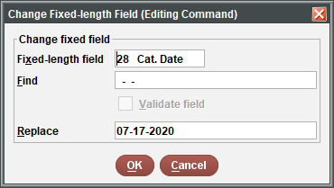

Resulting Preview display:
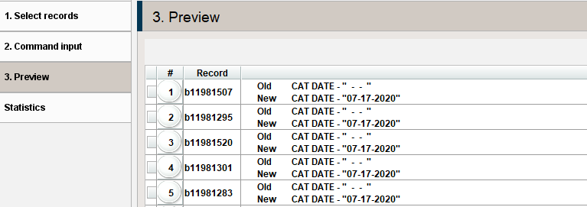

Default Display Field by Record Type

When an index search is done, Global Update returns a list of records and displays the fields that match your search. When a review file or keyword search is used, Global Update cannot predict what field you are interested in viewing, so it defaults to showing the fields displayed in the table below. Change the displayed field by using the toggle symbol. (This feature is only available with Review File and Advanced Keyword Searches, not with Index searches.

RECORD TYPE | FIELD DISPLAYED
Bibliographic | Title
Authority | Uniform title
Order | Acquisition type
Item | Barcode
Patron | Name
Course | Course
Checkin | Location

More Information:

For information on the Global Update process from start to finish, see Sample Global Update. The sample update includes a step-by-step description of a global update and tips on these topics:

Case Sensitivity of Search Statements

Case Sensitivity of Find Data

Case Sensitivity of Replace Data

How to Order Multiple Change Commands

For information on data clean-up projects with Global Update, see Data Clean-up with Global Update.

This publication is supplied for the exclusive use of customers of Innovative Interfaces with the understanding that it shall not be shown or distributed to anyone outside of the customer's organization without the prior written permission of Innovative Interfaces. This publication may be copied only if the copies are for the exclusive use of staff members of libraries that have purchased the Innovative system.

© 2022, Innovative Interfaces, Inc.

