sierra cataloging

Fix Bad Codes FAQ

What are bad codes and how do they get into my records?

Bad codes are entries that appear in statistical reports under a heading labelled "Bad Code" or "No Code." Bad codes are not searchable in the Create Lists function and lead to inaccurate search results and report results. Some types of bad codes can lead to functionality issues, such as funds out of balance or WebPAC display problems.

Bad codes are created in several ways:
- A code value is deleted from a fixed-length field code table while there are database records that contain that code.
- Bad code can be inserted into new records via a template containing a zero-length code value string (e.g., no valid value) in one or more fixed-length fields. This commonly happens when a new template is created, and the user does not input a valid code from a table into every alphanumeric fixed-length field. Thus, records created with these templates have no valid value in these alphanumeric fixed-length fields.

Tip: To avoid creating templates with bad codes, specify in your Sierra Preferences (Editor Colors Tab) that the background color for invalid text be something other than white. Zero length code value strings cannot be viewed normally, so for the template creator to see that a valid value has not been added to each template field, the background color for the invalid text must be something other than white.

For example, in the display below, a user created a new template but did not insert a valid value into each fixed-length field. Invalid values display on a yellow background because this is what the user specified in the Sierra Preferences Editor Colors Tab.

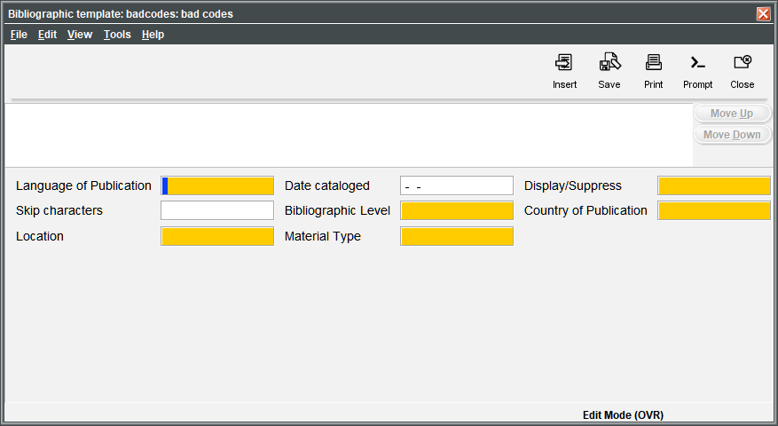

- Bad codes also result when a user removes a value from a fixed-length code table but does not remove it from the appropriate templates. The value will continue to be inserted into new records created from those templates and will display in reports under the "Bad Code" label.
- Similarly, bad codes result when a user removes a value from the fixed-length code table 'Status' (item status), and the value removed is one that the system inputs into items automatically as the result of a circulation process. See Fixed-length Fields in Item Records for a list of item statuses that should never be removed.

What is the difference between the labels "Bad Code" and "No Code"?

The following bad code errors display under the "Bad Code" heading:

- An alphanumeric single-character fixed-length code that is present in records but is not a valid code in a code table.
- A vendor, fund, location, language, country or other multi-character fixed-length code that appears in record data but not in the corresponding table.

Note: The "Space Code" label displays when a fixed-length field has a valid code value of <space character> (displayed as ' ') and the code is present in the fixed-length field's table without a corresponding description (for example, NO MESSAGE or NO BLOCK).
Entries under the "No Code" heading display for records with a fixed-length field set with a zero length code value—that is, no valid value is assigned to the field.

How do I know if my system has bad codes?

Run a statistical report on your records. All record types potentially contain bad codes. Innovative suggests that your staff annually examine your entire database to seek out and clean up bad codes.

In Sierra Statistics, create a Field Statistics report for the entire range of records in the database for a given record type. For example, run a Field Statistics report on all the items in the database. When generating a report on record types which can have 'multi' as a valid fixed-length field value, choose Split multi.

When the report has completed, examine the report results for each field and look for bad codes.
Following are statistical reports:

Example 1: Bad Code in Order Record CLAIM Field
Code | Meaning | Record Count
“ | No Code | 7
- | --- | 1023
a | CL 1 DEC MD | 32
b | CL 2 DEC MD | 19

In Example 1, one or more templates were created with no valid value selected for CLAIM. The seven records created with this template display the "No Code" invalid code label. The '---' label for the '-' (hyphen) value is not an error, but is the informational message for the valid null designated in the CLAIM code table. The valid null is generally assigned to a record when there is no other applicable value currently assigned.

Example2: Bad Code in Course Record CCODE1 (SEMESTER) Field
Code | Meaning | Record Count
‘ ‘ | Bad Code | 3
- | UNASSIGNED | 23
f | FALL TERM | 200
j | Bad Code | 10
w | WINTER TERM | 150
s | SUMMER TERM | 35

In Example 2, the 'space character' and 'j' codes were removed from the fixed-length code table CCODE1 ("SEMESTER") before removing the values from all records that contained them.

This library does have a valid null for this table (note the hyphen value, to be used where no other value in the table applies to a given record or where the library staff has not yet made the correct value assignment). Normally when creating a template, if the value cannot be determined in advance or is to be prompted for, staff should input the appropriate null value from the code table, such as a '-'.

Example 3: Bad Code in Location Fields
Code | Meaning | Record Count
a | Arrow Branch | 2253
ap | Bad Code | 11

In Example 3, the location code 'ap' (Arrow Phono Collection) was removed from the branch codes file before it was removed from all records that contained it.

Example 4: Bad Code in Fund Fields

Code | Meaning | Record Count
1aaf | Arrow Adult Fiction | 323
1aal | Bad Code | 2

In Example 4, the fund code '1aal' (Arrow Adult LPS) was removed from the fund codes file before it was removed from all records that contained it.

What happens if I try to edit a record that contains a bad code?

In Sierra, if you double-click on a fixed-length field that contains a bad code, the system displays a list of valid values from the fixed-length field table from which to choose. If you choose "Cancel," the bad code remains in the record. You can also key a valid value into the field. You can save changes to a record in Sierra even if the record contains a bad code.

Below is an example of a record which has bad code. Invalid values display on a red background because the user has specified this color as the background for invalid text in Sierra Preferences (Editor Colors tab).

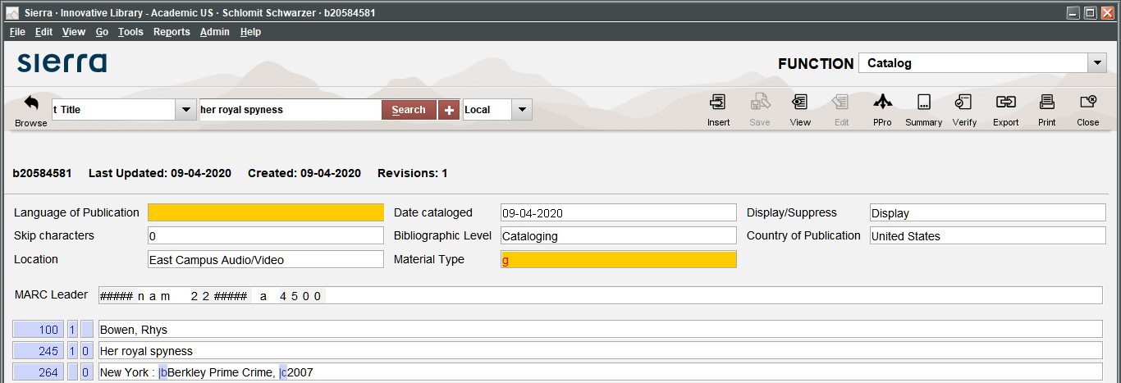

I can see that my library has records with bad codes, but the statistical report doesn't tell me which records those are. How can I find the records and fix the problems?

Identify the problem from the list below and execute the corresponding solution.

Problem:
An alphanumeric fixed-length field code (but not fund, vendor, or location) has been removed from a table before being removed from all records.
Solution:
- Add the alphanumeric fixed-length field code back to the table.
- Create a review file of records containing the code.
- Change the code value in the records.
- Ensure that no records retain the old value by running another statistical report on the changed records. Inspect the default templates to verify that no templates retain the old value.
- Remove the old code from the table.

Problem:
The fixed-length field code table contains a space character as the valid null value but what appear to be space characters are being reported as No Code in statistical reports.
Solution:
In Create Lists, create a list specifying that the target code is not equal to all valid codes in the table, including the valid space character. All records with zero length code value strings (i.e., no valid value in the field) should be found.

Statistical Report on IMESSAGE Code Values
Code | Meaning | Record Count
“ | No Code | 3789
‘ ‘ | NO MESSAGE | 208001
c | CHECK PARTS | 202

In this example, a statistical report is run for the code IMESSAGE. The report shows 208001 records where the space character equals NO MESSAGE, a valid code for that library's code table. 3789 records with zero length code value strings (i.e., no valid value in the field) display in the report as having No Code.

To correct the bad ("No Code") codes, the library should create a list where IMESSAGE is not equal to 'c' AND IMESSAGE is not equal to the space character and so on, until all valid codes in the library's IMESSAGE table have been specified in the list. The resulting list of items should include only those with no valid value in the IMESSAGE field. Run rapid update on the IMESSAGE field of the list of items to insert a valid value.

Problem:
A fund code is deleted before being removed from all records, including fully paid and cancelled orders.
Solution:
Enter a valid fund code into any record that contained the deleted fund code. If appropriate, post.

Note about Funds in Order Records: an invalid fund code present in orders is converted to 'none. Invalid funds result when fund codes are deleted from Sierra but still remain assigned on order records.

What are some common problems caused by bad codes in records?

Some common problems caused by bad codes in records include:

- Patron records with bad codes in the MBLOCK field can be blocked from checking out.
- Sorting on records with a bad code in a fixed-length field can result in an improperly sorted review file.
- Statistical reports will not contain accurate report totals for valid code values if some records have bad codes.
- Create Lists searches can yield inaccurate results when records have bad codes in a given fixed-length field and a search is executed on that fixed-length field value.

What are the best practices for effective use of codes?

- Only delete a fixed-length code from a table after you have removed it from all records, all templates, tables, and system options in which it occurs.
- Only delete a location code after removing it from all records, templates, tables, and system options in which it occurs. Note that Innovative will have to remove the code from certain tables, such as the scoping tables. See:
  - Deleting Location Codes

Follow these procedures when deleting a fund or vendor code:
- Deleting Fund Records
- Deleting Vendor Records

- Never delete system-generated codes or codes used by the software as part of a process, for example, item status 'n', which the system inputs automatically as part of the billing process. See below for a list of codes or code values that should not be altered.
- When creating a new template, input a valid code from a table into every alphanumeric fixed-length field.

What Fixed-Length Field Code Values should not be altered?

Do not alter the following fixed-length field code values:
Fixed Length Field Value Code | Note
STATUS (item) | 3789Do not delete any of the following statuses, which are reserved for specific system functions: m $ n z o - t !  Never add these values as item statuses: @ # % & ( ) _ [space character]
OPACMSG (item) | Value 'r' is hardcoded to cause the system to charge rental fees at checkout. Do not use for non-rental items. Changing the label does not change the software's action.
MBLOCK (patron) | Do not remove the '-' "No Block" value or you will not be able to unblock patrons.
IMESSAGE (item) | Do not remove the "No Message" values of either '-' or "space character" or you will not be able to remove IMESSAGE values.
PMESSAGE (patron) | Do not remove the "No Message" values of either '-' or "space character" or you will not be able to remove PMESSAGE values.
CLAIM (order) | Do not change or delete labels.
ORDNOTE (order) | Do not remove the 'r' code. Changing the label will not change system behavior. Do not remove the '-' valid null value for "No Ord Note."
RACTION (order) | Do not remove the '-' "No Raction" value.
STATUS (order) | Do not alter, delete, or add to these values.

This publication is supplied for the exclusive use of customers of Innovative Interfaces with the understanding that it shall not be shown or distributed to anyone outside of the customer's organization without the prior written permission of Innovative Interfaces. This publication may be copied only if the copies are for the exclusive use of staff members of libraries that have purchased the Innovative system.
© 2022, Innovative Interfaces, Inc.

