Sierra cataloging

How to Edit a Bibliographic Record

To update bibliographic records in Catalog, you must be assigned permission 104 (update bibliographic records).

Retrieve the bibliographic record to be edited.

Modify a Fixed-Length Field

To edit any of the fixed-length field, double click in the box. The list will sort either by the code or the code label depending on your starting click.

Click Code to select the value:
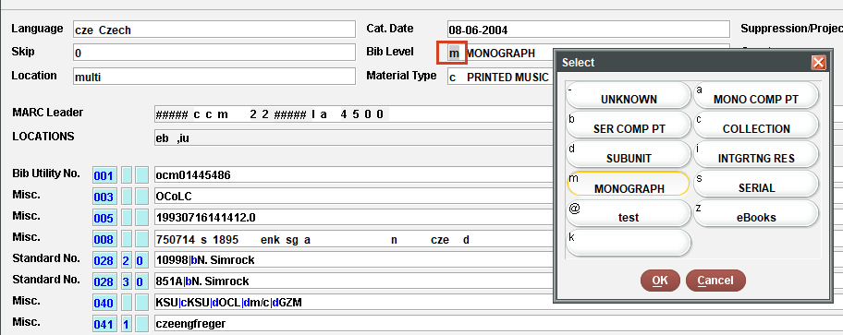

Click code label to select the value:
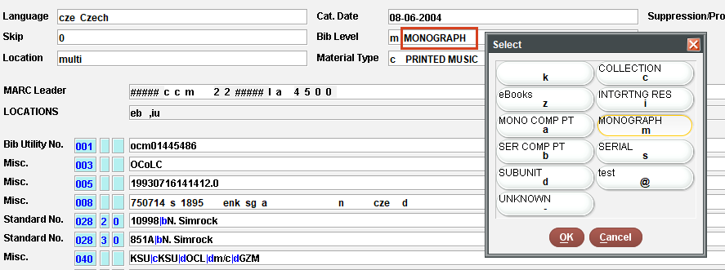

To Add a date, click a date box, there are three ways to add the date:
- type in the date
- Type “c” or double click in the field to see the calendar
- Type “t” for today’s date
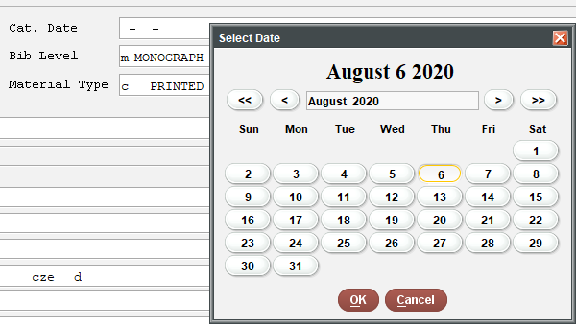

Modify a Variable-Length Field

Edit Special fields (Leader, 006, 007, 008)

To edit these fields, right click | Expand field
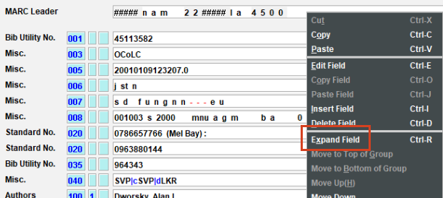

Double click in a field to select a value. Each list contains the standard MARC21 values.
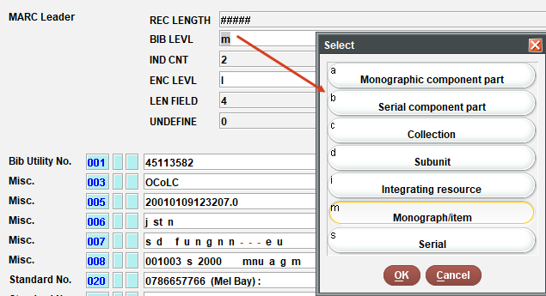

To edit a variable length-field type in the field, right click or click Edit from the menu bar and select or use the following keyboard shortcuts:
- “Ctrl e” or type changes in the field
- “Ctrl j” to paste field
- “Ctrl o” to copy field
- “Ctrl i” to insert field or hit enter and type in MARC tag. Sierra recognizes the correct Field Group Tag for each MARC filed.
- “Ctrl d” to delete field
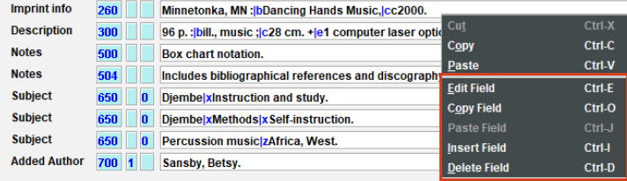

Entering Diacritics and Special Characters

To display the Unicode values of special characters in a record, open the record, choose View | Show Codes from the menu bar.
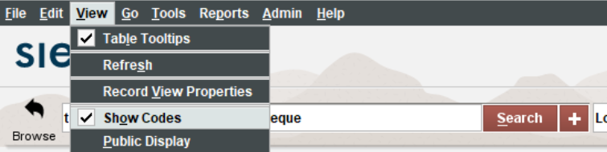

Clicking Show Codes displays the special characters in a record as Unicode values.

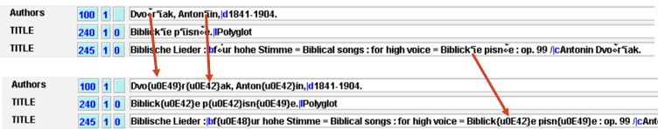

Moving (re-ordering) variable length fields

Place the cursor in the field, right click. There are options to move the field up or down or move it to the top or bottom of the group.

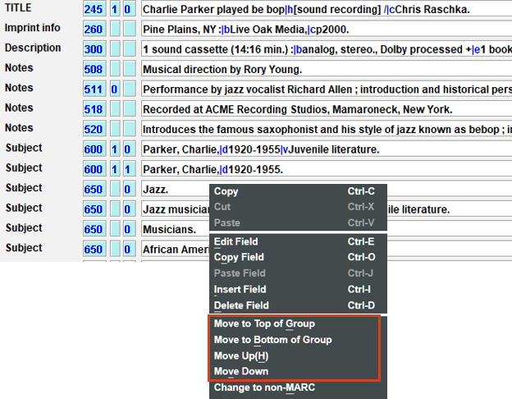

This publication is supplied for the exclusive use of customers of Innovative Interfaces with the understanding that it shall not be shown or distributed to anyone outside of the customer's organization without the prior written permission of Innovative Interfaces. This publication may be copied only if the copies are for the exclusive use of staff members of libraries that have purchased the Innovative system.
© 2022, Innovative Interfaces, Inc.

