sierra cataloging
How to Use “save change” Commands in Global Update

After retrieving the records that you want to globally update, select the “command input” button and set up the changes you want to make. Before previewing and processing the changes, follow the steps below. After the “change commands” are saved, you can continue with the preview and processing of the records being updated.

To save change commands to your local computer or a Server:
- From the Command Input tab, select the File menu (upper left corner)
- You can choose Save (Local) or Save (Server)
- Save (Server) would allow other users to use the same command
- Save (Local) would be useful for busy records when you only need to re-use the command once

Save (Local):

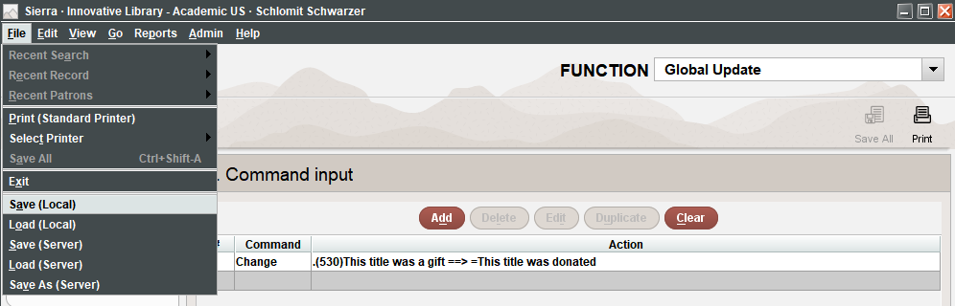

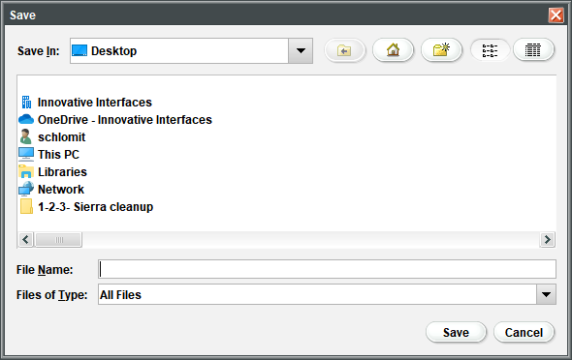

Save (server)

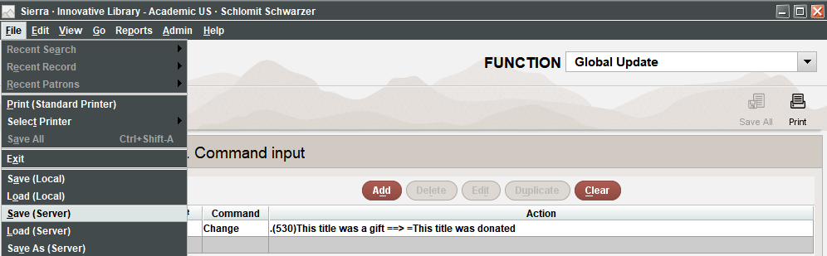

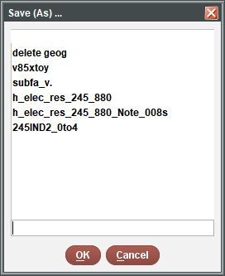

Follow these steps to load saved change commands from your local computer:

Click Command input tab. If the Choose Command Type dialog box appears, click Cancel to close it.

File | Load (Local).

Find the file name.

Select the desired file and click Open.

Preview and process as usual.

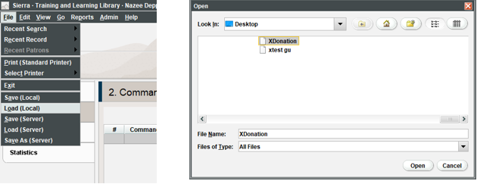

To load saved change commands from the server:

If you choose Load (Server) select the command from the Load Macro popup window. Then click OK

Click the Command input tab. If the Choose Command Type dialog box appears, choose the Cancel button to close it.

File | Load (Server).

In the Load Macro dialog box, find the file.

Select the desired file and click OK.

Preview and process as usual.

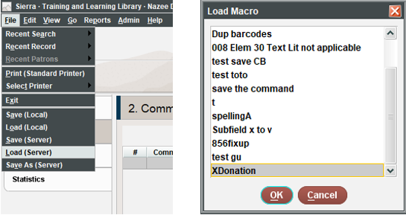

To remove saved change commands, please contact Innovative Customer Support.

This publication is supplied for the exclusive use of customers of Innovative Interfaces with the understanding that it shall not be shown or distributed to anyone outside of the customer's organization without the prior written permission of Innovative Interfaces. This publication may be copied only if the copies are for the exclusive use of staff members of libraries that have purchased the Innovative system.
© 2022, Innovative Interfaces, Inc.

