sierra acquisitions

How to use Inventory Express

Inventory Express is an optional product that allows the user to search a title’s ISBN simultaneously on selected book vendor websites and the local Sierra system. The user can check vendor inventory and pricing information and can create a new bibliographic order record using the book vendor’s bibliographic data. Purchase orders can be generated to transmit the order to the vendor if desired. This is an acquisitions workflow that originates in Sierra as opposed to workflows that originate on a vendor’s site. For more information see Ordering Using Inventory Express. If your library does not have Inventory Express and you are interested in purchasing or to set up a demo, contact your library account representative.

Typical library workflow

After the product has been installed and configured, create a bibliographic template that prompts for the ISBN as the first variable length field. Other fields can be added to the template in the event no results are found, and you are continuing with keying the bibliographic record. Typical steps:

- At the ISBN prompt, key in the ISBN for the title.
- Instead of clicking on Next to move to the next template prompt, click on the Go option next to the checked vendors in the Search by Inventory Express.
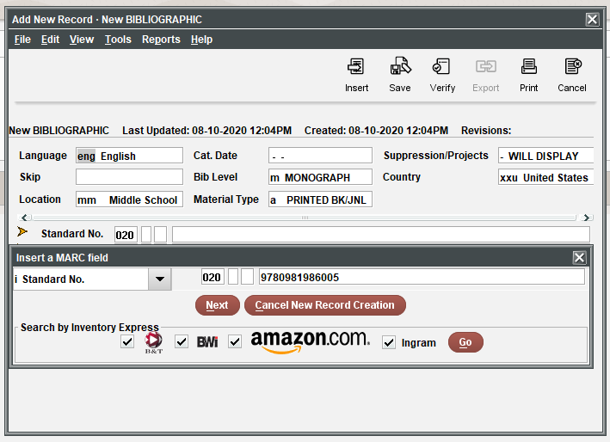
- Sierra will transmit the ISBN to the checked vendors and display the results. If there is at least one result, the results will be integrated in one summary display. If there are no results, then Sierra moves to the next prompted field in the template.
- To view a record in the results, highlight it and click the View button. Use the Browse button to go back to the list

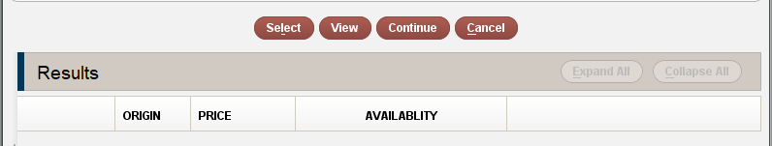

- If you do not wish to use any of the listed records, click the Continue button to go back to keying the bibliographic record using the template.
- To use a record, highlight it and click on Select. Sierra will import bibliographic information as provided by the vendor which can be edited as needed.
- After finishing the bibliographic record, move to adding the Order record. It is recommended that the order record template include a prompt to confirm the correct vendor although it is not a requirement that you use the vendor you selected from the initial list in the actual order. Some libraries find that one vendor provides better MARC data than a vendor that has the lowest price. A prompt for vendor will help ensure that you are ordering from the correct vendor. The price suppled from the vendor will be copied into the order record’s EPRICE fixed field.
- Finish keying the order.
- Follow your library’s steps to send the order to the vendor.

Which vendors support Inventory Express?

The listed vendors (Amazon, Baker & Taylor, BWI, and Ingram) currently support Inventory Express however this information is subject to change. When the product is installed the current vendors will be prepopulated requiring the addition of a vendor supplied username and password. These links are what the client uses to determine the vendor’s Web service location and technical details. Information on the data elements can be found in the Inventory Express Table.

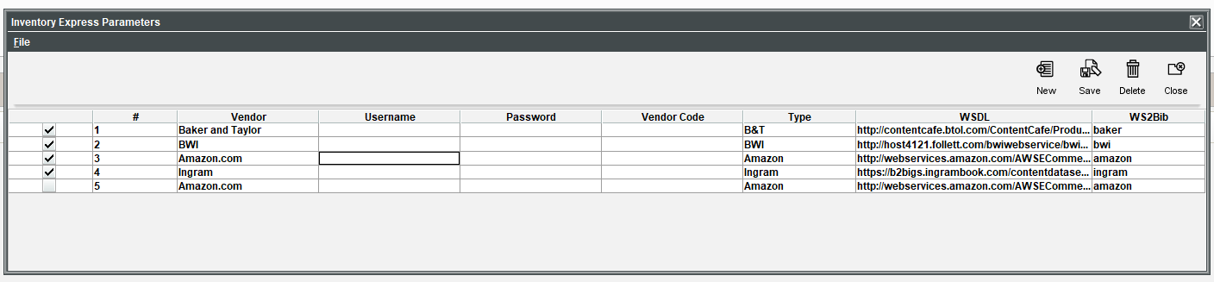

What to do if my vendor is not listed.

Ask your vendor to contact to contact Innovative to discuss the technical requirements for Inventory Express. The vendor will have to implement a Web service that allows Innovative libraries who have purchased Inventory Express to search their publicly accessible inventory database. Innovative will provide the necessary technical documentation for our interface. Information on supported operations can be found on vendordocs.iii.com. For additional information email us at vendordocs.iii.com. Contact the vendor for the required username and password for their system.

This publication is supplied for the exclusive use of customers of Innovative Interfaces with the understanding that it shall not be shown or distributed to anyone outside of the customer's organization without the prior written permission of Innovative Interfaces. This publication may be copied only if the copies are for the exclusive use of staff members of libraries that have purchased the Innovative system.
© 2022, Innovative Interfaces, Inc.

