sierra acquisitions

Change Eprice Function

The change estimated price (Eprice) is an acquisitions tool used by libraries to change status ‘d’ serial fully paid back to status ‘c’ serial on order which re-encumbers the fund. In addition, Sierra compares past payments to predict a new Eprice. That way the library starts the new fiscal year with serial fund encumbrances better reflecting projected actual costs for the upcoming year.

Typical Workflow

- At fiscal year-end, gather all status ‘d’ orders into a review file. The function can also be run on status ‘f’ serial no encumbering if the library is switching from this method.
- Examine the order records in your review file and determine the two date ranges for comparison.
  - Each order must have at least one payment fields during two different time periods.
  - The time periods are typically are payments in two fiscal years.
- Navigate to the Change Eprice function in Sierra Acquisitions
- Select the review file produced in step 1.
- For Time Period 1 - enter the date range reflecting the oldest time period in your order records that you wish Sierra to use.
- For Time Period 2 - enter the date range of the most recent time period to review.
- Click Start
- The result will be the orders with payments that fall within the two-time periods.
  - Note an order must have at least one payment in each time period to be included so the number of listed records may be less than the number of records in the review file.
- Review the listed records and to accept the Eprice calculation and change the order status to ‘c’ click on Process.

The first tab will show a review of the price projections by each order record.

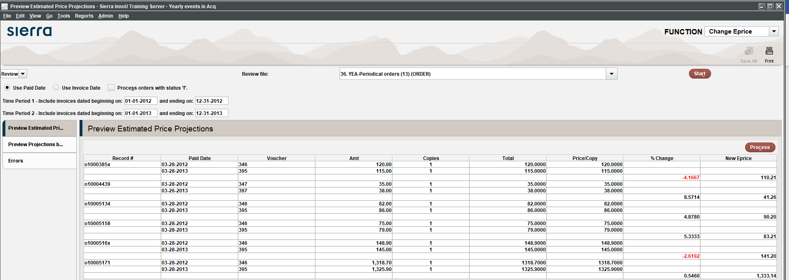

The second tab shows the projected impact on each fund.

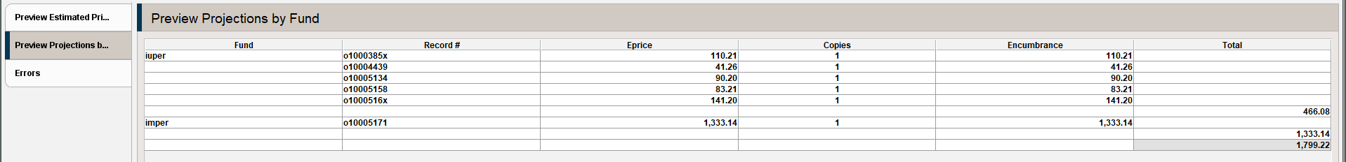

The third tab shows order records that cannot be updated. For example, an order status that is not ‘d’ or ‘f’ if that option was included. This might be because the order is already status ‘c’.

How is the new Eprice calculated?

Sierra compares the total payments in each time period and determines a price per copy. It then calculates the percent change between the two time periods and multiplies that percentage against the most recent price per copy to calculate the new Eprice. The price could be lower or higher or the same.

What if the new Eprice is not correct?

- Continue to process the file which changes the order status. Note the order record numbers which need adjusting. Using your original review file, find those orders and manually edit the Eprice field. Remember to post when completed.
- Note the orders. Using the review file make the changes which would be the new Eprice and changing the order status to ‘c’. Remove the orders from the review file and use the Change Eprice option to process the remaining orders. Remember to post for to finalize the changes.

Libraries new to acquisitions

Change Eprice requires two years of payment data in each order record. During the first two years gather your status ‘d’ into a review file and manually update the Eprice and change the status to ‘c’.

This publication is supplied for the exclusive use of customers of Innovative Interfaces with the understanding that it shall not be shown or distributed to anyone outside of the customer's organization without the prior written permission of Innovative Interfaces. This publication may be copied only if the copies are for the exclusive use of staff members of libraries that have purchased the Innovative system.
© 2022, Innovative Interfaces, Inc.

