sierra Acquisitions

Guide to Receiving

Receiving in Sierra is the process by which the rdate field in the order record is updated. What can be confusing for libraries is the concept of receiving often is more involved on the library side. Physical work involves: 1. Boxes are opened and 2. items are checked off a packing slip. Then, purchase orders are reconciled etc.

For Sierra an order is received when a date is entered into this (rdate) field. An unreceived order is one without the date. The order status is not a factor. An unpaid order could be received even though that might not be library procedure or practice.

Where is the rdate field?

Here is an unreceived order. There is no date in the rdate (Recv Date) field.

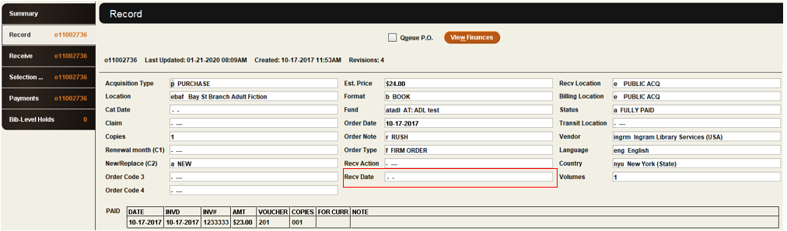

What does the rdate do?

- Combined with the setting of the SHOWREC weboption (wwwoptions) it determines the display of the order record for the public in Encore and the WebPAC.
  - Unsuppressed orders display the x copies on order for library location on this date
1 copy on order for bay St Branch Adult Fiction on 12-17-2018
1 copy on order for bay Emeryville Public Adult Fiction on 12-17-2018

  - Depending on the SHOWREC setting this message can disappear upon receiving or be updated to In Process. The In Process message is cleared via a separate step
  - See the description of SHOWOREC at the end of this how to guide.
- The date is used as part of the calculation for delivery time in vendor statistics. The clock starts with the order date and stops with the receive date.
- It determines when orders appear in the claiming function, which is not based on order status. A fully paid but not received order can appear in the claiming report.

What are the typical methods of receiving?
- Manually enter a date in the order date field. Either type in the date in or key the letter c for the calendar interface and select a date from the calendar. In this order record, it would be adding a date to the highlighted fixed field.

- Combine receiving with invoicing. Under the Admin | Settings | Invoice check the box next to Use Paid Date as Date Received
  - Note if you are using Import Invoices, check the setting under the Import Invoice tab and the rdate options as well.
  - This can have an impact on vendor statistics as the Paid Date is usually the date on the invoice and the received date is usually the date the material arrived at the library. Delays in shipping can produce inaccurate results in vendor statistics.

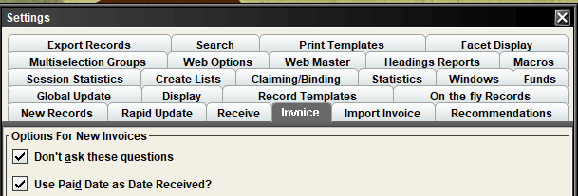

- Combine creating the item with receiving.
  - In the order record click on the Receive tab
  - Receive date defaults to today’s date and can be changed if needed.
    - For accurate vendor statistics change the date to the day the material arrived at the library instead of the date staff are working on the order
  - Copy EPRICE to item is an optional feature to take the order record Est. Price (eprice fixed field) and copy it into the item Price fixed field.
    - Essentially this option is based on the determination that the estimated price is potentially the correct price to bill or charge a patron for lost or never returned item.
  - Scan or key the item barcode
  - Click Receive
    - Sierra uses the item record template selected in Receive Settings or the Prompt for Template or Always Prompt sequence.

- Use rapid update to insert a receive date in a group of orders
  - Use Create Lists to identify and add records to the review file
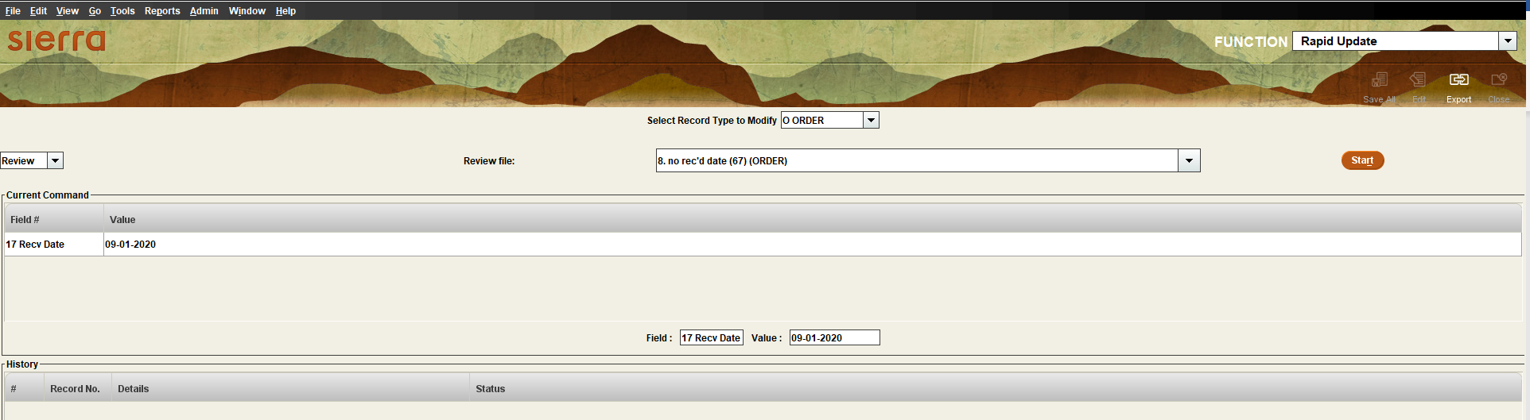

We have not received all our materials on an order. Is there a partial receive option?

No, an order is either received or not based on the presence or absence of the rdate. Wait to update the date when all materials have arrived. This way the order can still show up in the claiming report as a reminder you are waiting on missing items.

Can we still use receive and create items workflow for partial receipts?

Yes, by unchecking the specific records you have not received. When you receive those items, you can process those, and Sierra will add the rdate field. Here is an example of an incomplete order

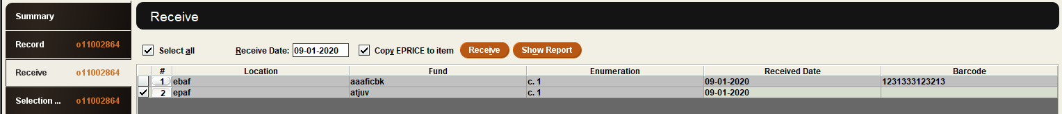

How does the SHOWOREC in web options (wwwoptions) work?

There are four possible configurations for this web option. However only one configuration can be set so a consortium or multi branch system will need to select the setting the works best even though it doesn’t necessarily work for all scenarios.
- no_cdate – with this setting receiving the order updates the catalog display to In Process until the cdate fixed field in the order record (not the bib record) is updated.
- no_rdate – with this setting there is no In Process order display in the catalog. The on order message is removed when the order is received.
  - Libraries using this method typically have a corresponding item status code for “in process”. It works well with the receive and create items workflow. The order information is replaced by item(s) that display in process to the user.
- #days – the In Process order message is removed after the specified number of days. The receiving step updates the order message from On Order to In Process. This method works well for libraries that can estimate the average length of time it takes the item to make its way from technical services to the shelf.
- Disabling the SHOWOREC by clicking the checkbox under Inactive. This option is sometimes the best choice for consortium when there is no good option from the previous three. With this setting there is no in process message. The On Order message is removed when one of the following occurs:
  - The cat date in the bib record is added.
  - The first unsuppressed item or checkin records are attached to the bibliographic record.
    - Note this setting does not work well for libraries that wish to display the order message on subsequent orders (additional copies or replacements) as the very first item sets that the order message will not display for this and any additional orders.

This publication is supplied for the exclusive use of customers of Innovative Interfaces with the understanding that it shall not be shown or distributed to anyone outside of the customer's organization without the prior written permission of Innovative Interfaces. This publication may be copied only if the copies are for the exclusive use of staff members of libraries that have purchased the Innovative system.
© 2022, Innovative Interfaces, Inc.

