sierra Acquisitions

Fiscal Closing - Method Two

This is a review of the steps for Fiscal Close Method Two. For additional information on the differences between the methods consult the summary of fiscal closing and the video. However, let’s start with a quick review of the logic behind this method.

We have an open order at the end of the fiscal year. We need to change the listed funds to a fund code that represents a soon to be previous fiscal year. In this example we have an order which has copies linked to four different locations and funds that will not be invoiced before fiscal year end. We cannot use Rapid/Global Update to do this step and there are too many orders to do this manually.
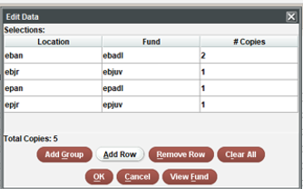

Before starting Fiscal Close Method Two you will need to have created the previous year fund structure. For example, if we currently have open orders in Main – Books – Fiction we will need a Previous Main Books Fiction fund to move those open orders to.

During the Tab Four – Copy and Clear Funds you will indicate which previous year funds these orders should be moved. Again, those funds must already be in Sierra. Here we see the corresponding previous year funds that match with the above example. Method Two will update the open orders to the previous year fund codes.

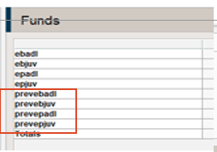

Here we see what our Fund Structure would look like before running Fiscal Close. Each fund has a corresponding new prev fund as in ebadl has a prevebadl.
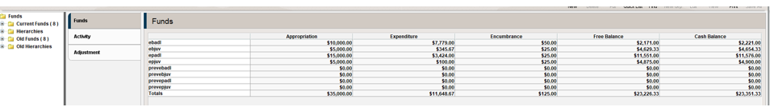

To only update a group of specific open orders and not all of them you will need to use the Manual setting of Fiscal Close Method Two and have those orders in a review file. The two automatic versions of Method Two work with all open orders. There is not an option to exclude certain orders with either Automatic setting. With the Manual version you select ahead of time which orders to update.

The desired outcome of a Method Two Fiscal Close is that we have outstanding encumbrances and a remaining cash balance.

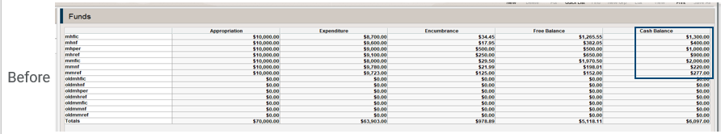

After Fiscal Close we have an appropriation (amount depends on the type of Method Two) and encumbrances on our previous year funds.

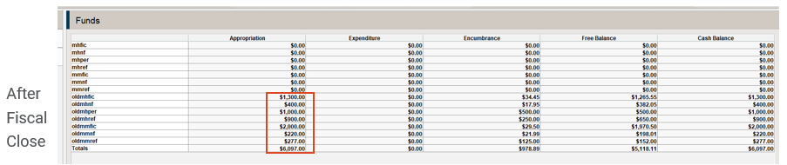

Walkthrough of Method Two Fiscal Close – Automatic Methods

There are five tabs to work though. Note you must complete each tab and click on Next to correctly advance to the next Tab. Do not click on Tabs out of order. The first three tabs are common to all Fiscal Close methods and are often done separately, as part of normal acquisitions activity. Make sure to wait after clicking on Next for Sierra to complete the operation when moving to the next Tab.

Tab One – Posting

This is the normal sequence of posting that you would see under Pay an Invoice. Sierra needs all current acquisitions activity to be completed. Any new orders or cancelations have been accounted for along with any invoices or fund adjustments. Once posting is completed or if Sierra replies that there is nothing to Post then click on Next. The Continue and Quit options are specific to Posting.

- A message indicating unable to post due to the fund activity file being full would require you to quit Fiscal Close and clear the Fund Activity file. While this is the next tab in Fiscal Close, you cannot jump to Tab 2 and print and clear the file and then go back to Posting. Click on Funds on your Workflow dropdown to exit Fiscal Close and to proceed with printing and clearing the Fund Activity Report. Once that is done, then reenter Fiscal Close to finish Tab One and click Next.

Tab Two – Fund Activity Report

This is the normal sequence of running the Fund Activity Report and then the Print and Clear step. The report must be cleared before you can click Next to move to Tab Three.
- A message at the bottom of the screen indicating a fund or funds out of balance must be resolved before continuing. See resolving funds out of balance FAQ
- Printing the fund activity report can be accomplished by: a. sending the report to an actual printer or b. emailing the report or c. exporting the report to a file save printer. In addition, there is the option to Export the report. If you wish to have multiple copies, do not click the clear payment history checkbox until you have confirmed you have all desired printouts.
- The question about clearing the appropriation history can be left unchecked during Fiscal Close if your institution has opted to keep appropriation history.

Tab Three – Statistics and Reports

These are the three Sierra report functions combined on to one screen. See the year end events in acquisitions recorded webinar for additional information. Note the Hierarchy reports are critical to Manual method of Fiscal Close two. Once you have all necessary reports, click on Next.
- Sierra Statistics are often run to analyze paid orders to calculate appropriations for the new fiscal year. Since paid orders will remain in Sierra until they are deleted, this step can be done outside of Fiscal Close. It can be handy however to have this information for the final step which is the optional appropriation of funds.
- Vendor Statistics are often run at year end as part of analysis of which vendors have been active or not active in the fiscal year and to review order fulfillment rates. And like order statistics this report can be run separately from fiscal close.
- Fund Hierarchy Reports – this report is used to review groups of funds with a percent spent column. Again, to gather information used for setting next year’s appropriations.
  - Note this report can be cleared in Tab Four if the option to Copy old funds and old hierarchies is not checked. Or information on a what was the year before you run this year’s fiscal close will be lost as Sierra keeps only one group of old funds and old hierarchies.
  - Before exiting this tab by clicking Next make sure you have any needed information on the current and the previous year hierarchy report.

Method Two – A Summary of the differences between versions

Method two has three different options that essentially deal with how the starting appropriation for ‘new’ set of funds should be calculated. By ‘new’ these are the funds that were created to move the remaining open orders to at fiscal year-end. The “previous year funds”.
- Automatic/Copy – with this method you are starting the new fiscal year with your previous year funds reflecting what it looked like at the beginning of the year. The appropriation and the expenditure totals are copied to your previous year fund.

Prior to Fiscal Close
Fund Code | Appropriation | Expenditure | Encumbrance
Adultbks | $10,000 | $1,000 | $100
Prevadultbks | $0.00 | $0.00 | $0.00

After Fiscal Close
Fund Code | Appropriation | Expenditure | Encumbrance
Adultbks | $0.00 | $0.00 | $0.00
Prevadultbks | $10,000.00 | $1,000 | $100

- Automatic/Transfer – with this setting, the difference is Sierra will do the math to subtract the year-end expenditures from the Appropriation. Thus, your previous year fund starting appropriation will be your original appropriation minus your expenditures for the year.

Fund Code | Appropriation | Expenditure | Encumbrance
Adultbks | $10,000 | $1,000 | $100
Prevadultbks | $0.00 | $0.00 | $0.00

After Fiscal Close
Fund Code | Appropriation | Expenditure | Encumbrance
Adultbks | $0.00 | $0.00 | $0.00
Prevadultbks | $9,000 | $0.00 | $100

- Manual – this setting is the only method where you can select which orders you wish to transfer to the previous year funds. With this method the starting encumbrances and appropriation must be entered manually. Sierra does not retain the encumbrances from the specific orders you are moving, nor does it calculate the appropriation. It becomes critical to have the appropriation estimate information from usually Statistics or the Hierarchy reports. The moved Encumbrance totals will be shown for you to Print.

Tab Four – Change Funds in Orders for either of the two Automatic methods

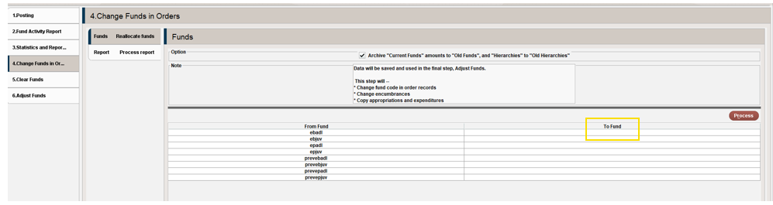

First let’s review the process for the two Automatic modes. The only difference between these two is how the starting appropriation for the migrated order funds are handled.

- The first decision is the Archive “Current Funds” amounts to “Old Funds” and “Hierarchies” to “Old Hierarchies”. This is a copy of what the fund structure looked like at the end of the year. If you decide to come back to this tab, make sure you uncheck this box otherwise you will replace your snapshot with cleared results.
- Funds Tab – Reallocate fund. You will see two columns.
  - From Fund column – these are all your funds however you are working with the ones that are not the previous year. The assumption is these funds have open orders and you will be mapping the contents of the fund to the matching previous year.
  - To Fund – click in this column to see a list of your funds. Select the matching new previous year fund. For example, you might have Adult Fiction with open orders. In the From column find that line and click in the empty matching box under the To Fund column. Select the Previous Adult Fiction fund.
  - Go through the list setting the direct mapping to the appropriate previous year fund.
  - Once this is done then click on Process. Sierra will change the fund code of the open orders to the new fund code. In effect doing a rapid update of the funds.
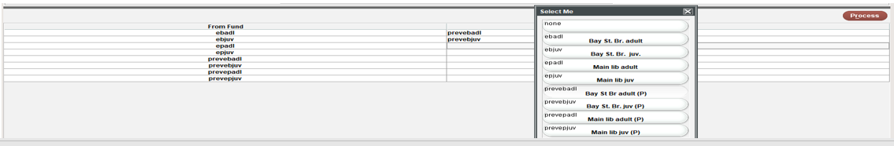
- Sierra will move to the second tab which is called Report – Process Report. Print this for your records and click on Next.
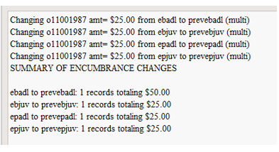

Tab Five – Clear Funds

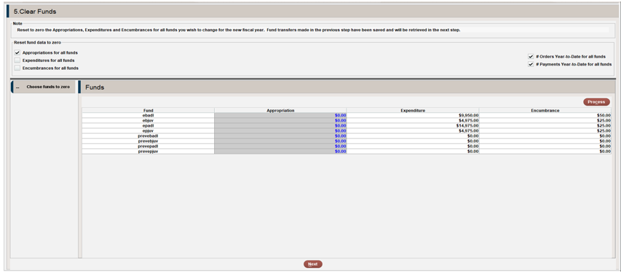

You will see a notation that the encumbrances that were moved in the previous step, using the associating the open orders with their new previous year fund codes have been saved. They will be finalized in the final Adjust Funds via a Posting step. Before we review what to do with fund totals, decide regarding the statistics being kept in the Fund records. The # Orders Year to Date for all funds and the # Payments Year to Date for all funds. Essentially do wish those funds to record all the activity for multiple years or reset for the current year.

- Appropriation column. Typically, this would be reset to zero. The current funds that are starting the new fiscal year are set to zero pending an appropriation step under Adjust Funds. The calculated appropriation for the previous year funds will be finalized during the Processing and Posting steps.
- Expenditure column. You would zero out the expenditures in the current year funds. There would be no expenditures in the previous year funds.
- Encumbrance column. This column will show zero for each fund which can be confusing since the purpose of Method Two is to associate those orders and their encumbrances to their new previous year funds. This will occur after the Process and Posting step.
- Once your changes are shown correctly on the screen click the Process button.

Tab Six – Adjust Funds

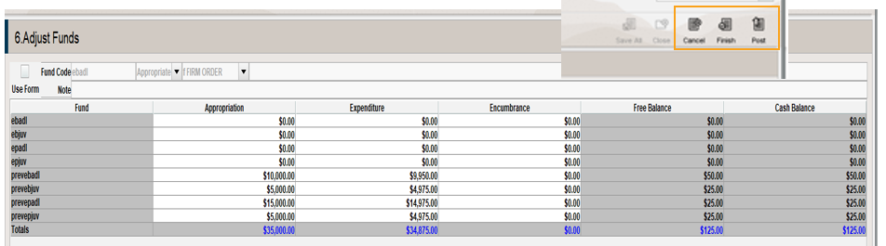

After you click on Process and then Next you will move to the Tab Six – Adjust Funds tab. We see the appropriation was copied from the original funds to their previous year funds. We see the expenditures in those funds as well. However, we don’t see the Encumbrances. That requires you to do the Posting step. At this point you could use the Fund Adjustment tool to add your starting appropriation for your current Funds or skip that step and just click on Post.

After Posting you should see the encumbrances from your open orders on your previous year funds. After Posting you will receive a Fiscal Close Complete message. Then click on another function in your Workflow dropdown to exit Fiscal Close.

Tab Four – Change Funds in Orders using the Manual Method

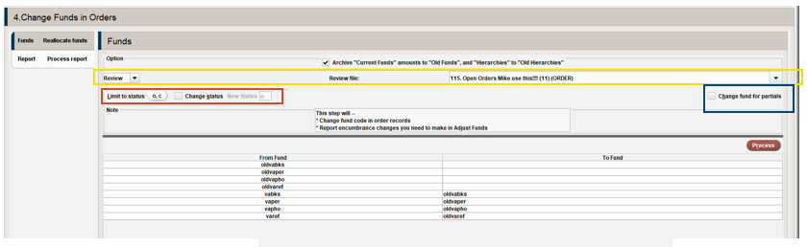

- The first decision is the Archive “Current Funds” amounts to “Old Funds” and “Hierarchies” to “Old Hierarchies”. This is a copy of what the fund structure looked like at the end of the year. If you decide to come back to this tab, make sure you uncheck this box otherwise you will replace your snapshot with cleared results.
- Next, we see the option to select a review file. Here is the major difference between this method and the Automatic methods. You chose which funds ahead of time by including them in a review file.
- You also have the option to Limit by Order Status, an option to change that Status and the option to include orders that have been partially paid.
- We then see the same From and To Funds to make our associations.
- After we confirm our choices and our Fund mapping, click on Process.
- Sierra shifts to the second tab under Change Funds in Orders. It is critical to print this Summary as it tells you the amount to enter as the Encumbrance for each Fund. Sierra doesn’t do this for you. If you lose this Summary, then use Create Lists to gather up the orders on these Funds and run the report through Sierra Statistics to note the eprice totals.

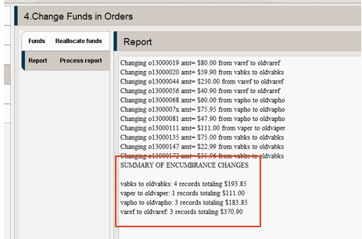

Tab Five – Clear Funds
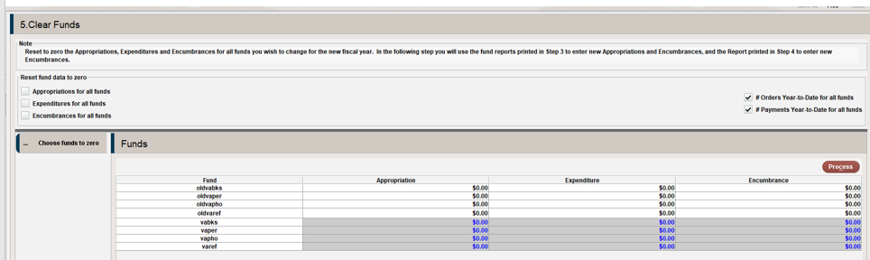

- The notation indicates you should reset to zero the Appropriations, Expenditures and Encumbrances for all funds you wish to change for the new Fiscal Year. In the following step you will use the report you just printed to enter your starting Appropriation and the required Encumbrances into your previous year Funds.
- The same decision regarding the statistics in the Funds.
- Then Process.

Tab Six – Adjust Funds
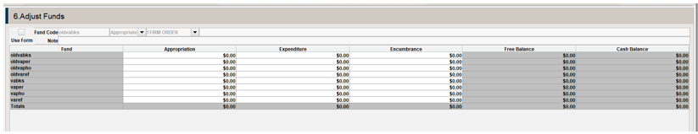

The difference with this method is nothing is copied over for your previous year funds. Using the Fund Adjustment tool enter the appropriation amount and the encumbrance amount from your summary. Then Post and Quit Fund Adjustments to finish Fiscal Close.
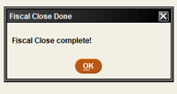

This publication is supplied for the exclusive use of customers of Innovative Interfaces with the understanding that it shall not be shown or distributed to anyone outside of the customer's organization without the prior written permission of Innovative Interfaces. This publication may be copied only if the copies are for the exclusive use of staff members of libraries that have purchased the Innovative system.
© 2022, Innovative Interfaces, Inc.

