sierra ACQUISITIONS

Fiscal Closing - Method One

This document reviews the steps for Fiscal Close Method One. For information on the differences between the methods consult the summary of fiscal closing.

There are five tabs to work though. Note you must complete each tab and click on Next to correctly advance to the next Tab. Do not click on Tabs out of order. The first three tabs are common to all Fiscal Close methods and are often done separately, as part of normal acquisitions activity. Make sure to wait after clicking on Next for Sierra to complete the operation when moving to the next Tab.

Tab One – Posting
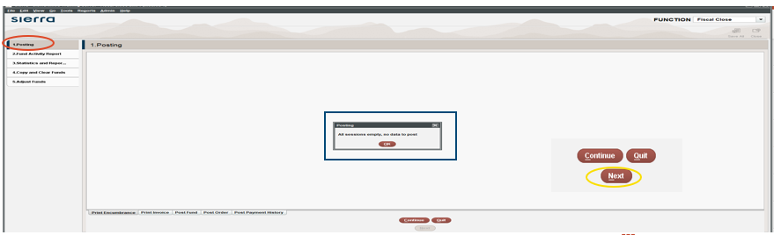
This is the normal sequence of posting that you would see under Pay an Invoice. Sierra needs all current acquisitions activity to be completed, namely, any new orders or cancelations have been accounted for along with any invoices or fund adjustments. Once posting is completed or if Sierra replies that there is nothing to Post then click on Next. The Continue and Quit options are specific to Posting.

- A message indicating unable to post due to the fund activity file being full would require you to “quit” Fiscal Close and clear the Fund Activity file. While this is the next tab in Fiscal Close, you cannot jump to Tab 2 and print and clear the file and then go back to Posting. Click on Funds on your Workflow dropdown to exit Fiscal Close and to proceed with printing and clearing the Fund Activity Report. Once that is done, then reenter Fiscal Close to finish Tab One and click Next.

Tab Two – Fund Activity Report
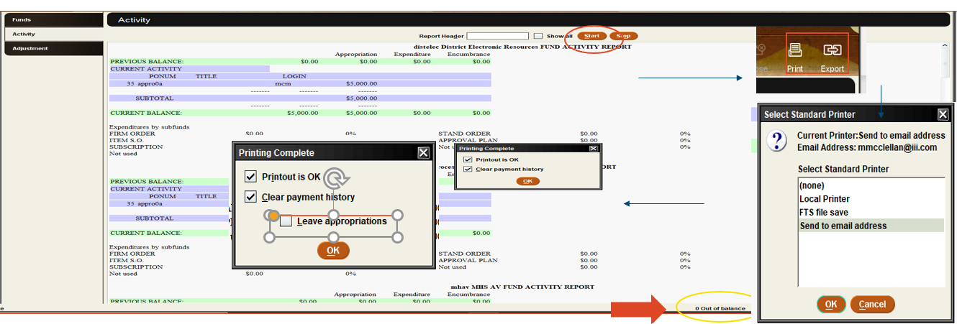

This is the normal sequence of running the Fund Activity Report and then the Print and Clear step. The report must be cleared before you can click Next to move to Tab Three.
- Click on Start at the top of the screen
- Click on the Print icon and select a printer.
- Printing the fund activity report can be accomplished by: a. sending the report to an actual printer or b. emailing the report or c. exporting the report to a file save printer. In addition, there is the option to Export the report. If you wish to have multiple copies, do not click the “clear payment history” checkbox until you have confirmed you have all desired printouts.
- The question about clearing the appropriation history can be left unchecked during Fiscal Close if your institution has opted to save appropriation history.
- A message at the bottom of the screen indicating a fund or funds out of balance must be resolved before continuing. See resolving funds out of balance FAQ.

Tab Three – Statistics and Reports
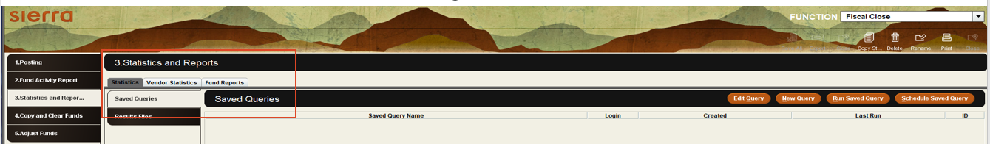

These are the three Sierra report functions combined on to one screen. See the year end events in acquisitions recorded webinar for additional information. Once you have all necessary reports, click on Next.
- Sierra Statistics are often run to analyze paid orders to calculate appropriations for the new fiscal year. Since paid orders will remain in Sierra until they are deleted, this step can be done outside of Fiscal Close. It can be handy however to have this information for the final step which is the optional appropriation of funds.
- Vendor Statistics are often run at year end as part of analysis of which vendors have been active or not active in the fiscal year and to review order fulfillment rates. Similar to order statistics this report can be run separately from fiscal close.
- Fund Hierarchy Reports – this report is used to review groups of funds with a percentage spent column.
  - Note this report can be cleared in Tab Four if the option to Copy old funds and old hierarchies is not checked. Or information on what was the year before you run this year’s fiscal close will be lost as Sierra keeps only one group of old funds and old hierarchies.
  - Before exiting this tab by clicking Next make sure you have any needed information on the current and the previous year hierarchy report.

Tab Four – Copy and Clear Funds
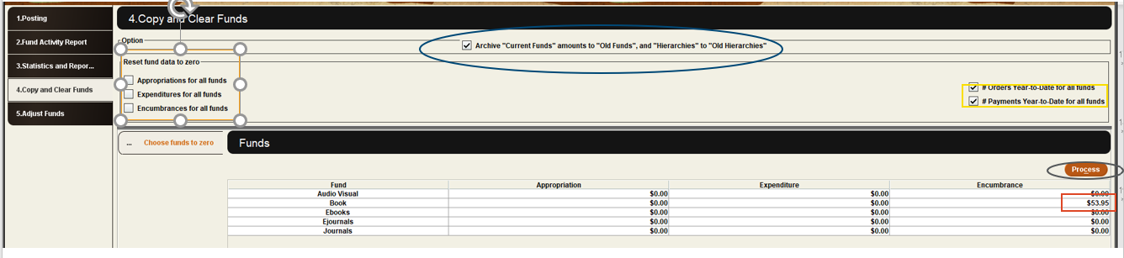

For a Method One library this is Fiscal Close. You are making decisions regarding:

- Archive “Current Funds” amounts to “Old Funds” and “Hierarchies” to “Old Hierarchies”. This is a copy of what the fund structure looked like at the end of the year. If you decide to come back to this tab, make sure you uncheck this box otherwise you will replace your snapshot with cleared results.
- Reset data to zero. Placing a check will highlight and zero out each column.
  - Appropriation – normally this is cleared. The assumption is the appropriation will differ for the new fiscal year. If this is not correct for one or more funds, in that the appropriation will be the same (for a multiyear grant for example) then click in a cell to undo the zeroing out for that cell.
  - Expenditures – normally this is cleared as the expenditures will most likely differ in the new fiscal year.
  - Encumbrances – it is critical that this checkbox and the column not be zeroed out. In the above screen shot we see one of the funds as a carryover encumbrance that must not be cleared. Doing so will result in negative encumbrances as the amount pledged for an open order will no longer exist. When you invoice that number, Sierra will enter a negative amount to offset what it assumes still exists.
  - Orders Year to date for all funds – this is a statistical counter in the Fund record. The decision is do you wish this to be a running total for multiple years. Then you would not check this box. If you want the total to reflect the current fiscal year then check the box.
  - Payments Year to Date for all funds – like the previous. Checking will zero out this statistical counter in the fund records.
- Once you have made your decisions then Click Next. Note review your decision carefully as once done, many of these decisions cannot be undone.

Tab Five – Adjust Funds
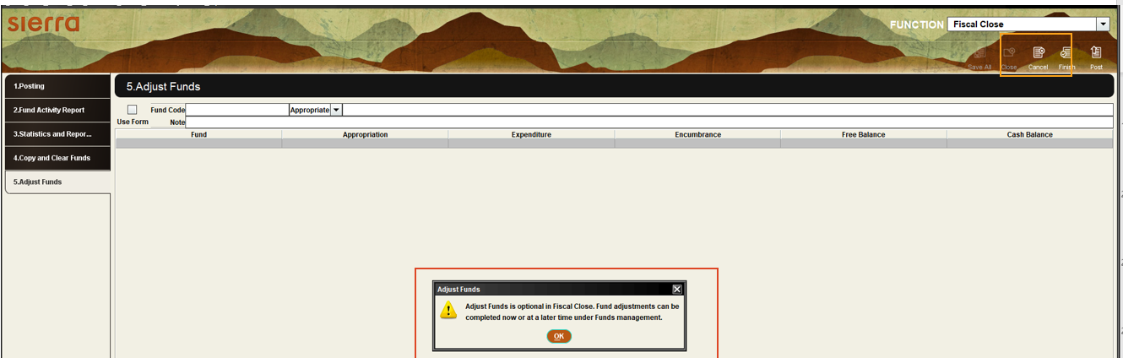

When you first move to this final tab there will be a message to acknowledge that Adjusting funds is optional in Fiscal Close. Essentially Fiscal Close was completed in Tab Four. You now have an opportunity to enter your initial Appropriations into your library funds using the normal Fund Adjustment tool. This can be completed at any time. If you are not ready to enter anything into your funds, then click Cancel. Note this is not cancelling Fiscal Close. It is cancelling fund adjustments. You will receive a Fiscal Close Complete message. Then click on another function in your Workflow dropdown to exit Fiscal Close.

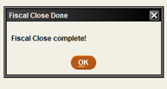

This publication is supplied for the exclusive use of customers of Innovative Interfaces with the understanding that it shall not be shown or distributed to anyone outside of the customer's organization without the prior written permission of Innovative Interfaces. This publication may be copied only if the copies are for the exclusive use of staff members of libraries that have purchased the Innovative system.
© 2022, Innovative Interfaces, Inc.

