sierra ACQUISITIONS

Fiscal Closing Methods Summary

What is Fiscal Close?

In general terms, fiscal closing is the process of closing one set of financial books at the end of the current fiscal year and opening a new set of books for the coming fiscal year. The nature of the “closing” depends on which method the library uses. You chose your method of fiscal closing based on the accounting practices of your funding organization. Once you have determined your fiscal close method, consult the specific document for that method on the Sierra Training and learning Resources.

Is there an easy way to determine which method we should use?

The answer to the following scenario can often indicate which method to use. At year end, we see that several funds have outstanding encumbrances. There is at least one open order in each fund.

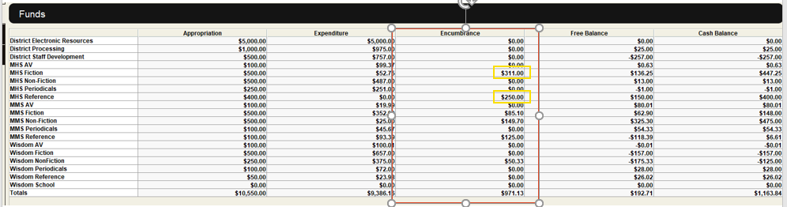

The question is can we leave these open orders in their original funds or do we need to move them to a fund that is tied to the soon to be current fiscal year, or, a previous year fund.

A method one library is ok with leaving these open orders in the current funds. The fund structure represents a funding concept like material type or academic department that is not tied to a fiscal year. The library starts the new fiscal year with open orders tying up a percentage of the Free Balance. Note Sierra is fine with a fund starting the year with a negative Free Balance.

A method two library needs these open orders to remain with the previous fiscal year. The fund structure has current and previous year funds. Fiscal Close is used to change the open orders to the previous year fund codes.
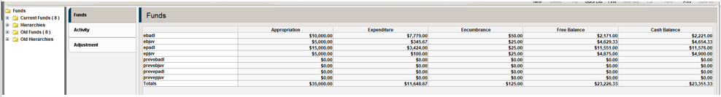

A method three library is like a method two library in that open orders must remain with the fiscal year they were originally ordered in. However, they have more than two open years. Each year new funds are added to the database and ultimately more than two years are listed.

At the end of this FAQ is additional information on all three methods.

How do I know which method my library is using?

In the Sierra Desktop Application (SDA) click on Help and About. Your method of fiscal closing will be listed here.

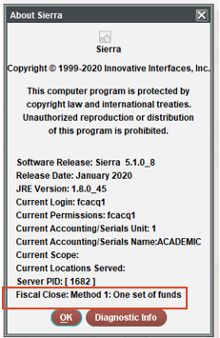

I’m part of a consortia, can our methods differ from other libraries on our server?

Yes, if your system is set up with Accounting Units then your method can be different as the methods are tied to the Accounting Unit.

We wish to change our method of Fiscal Close. Where is that set?

This is set in Admin Corner (telnet). Navigate to your System Options and then to Acquisitions Options. It will be under line 25>Fiscal Year Closing.

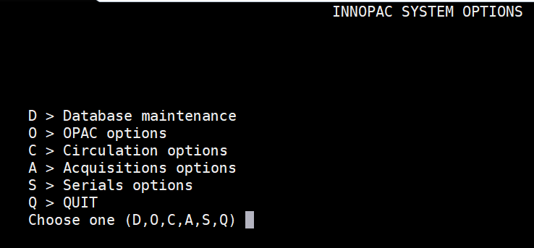

Summary of all three methods

Method 1 – the library keeps only one set of funds (i.e., books). On order material that comes in the next fiscal year is paid in that year. If your library makes only minimal distinction between fiscal years, you should use this method. It carries over encumbrances from one fiscal year to the next in the same set of funds. Consequently, as you receive orders from previous years, the system posts those expenditures and disencumbrances in the current fund balances.

Method 2 – the library keeps one set of funds for the current year and a second set of funds for the previous year. On order material that arrives next fiscal year is paid for out of that year’s fund. The library keeps a two-level fund structure. Current and preceding fiscal years. At year-end, you change the fund code in all existing order records (or only selected if using method 2, manual) to a previous year fund code. In some cases, several current year funds are combined into one previous year fund. You also move outstanding encumbrances to previous year funds. As you receive the previous year’s orders, the system posts those expenditures and disencumbrances in the previous year fund balances. With method two there are choices as to how Sierra handles the starting appropriations for the previous year funds. The choice is Automatic (which has a choice of Copy or Transfer) Manual. Additional information on these choices is listed on the Method 2 document.

Method 3 – the library builds an entirely new set of funds for the new fiscal year. Orders remain tied to their original funds. With this method, all existing fund assignments and fund balances remain intact and are not affected by the change in fiscal years. For the new year, a new set of funds is created. This method requires that the library have enough space in its system for two or three (or more) years of order records. And eventually old funds will need to be deleted from the system.

This publication is supplied for the exclusive use of customers of Innovative Interfaces with the understanding that it shall not be shown or distributed to anyone outside of the customer's organization without the prior written permission of Innovative Interfaces. This publication may be copied only if the copies are for the exclusive use of staff members of libraries that have purchased the Innovative system.
© 2022, Innovative Interfaces, Inc.

