Polaris System Admin

How to Set Up Printing in the Client

Introduction:
This article describes the configuration steps to set up label printers and configure Label Manager in the Polaris Client.

Label Printer Settings (Admin)

On the Polaris Tool Bar select the following path:
Admin>Explorer>(level)Profiles>Staff Client>Labels: Options
Note: (level) Profiles, refers to system, library, or branch levels.

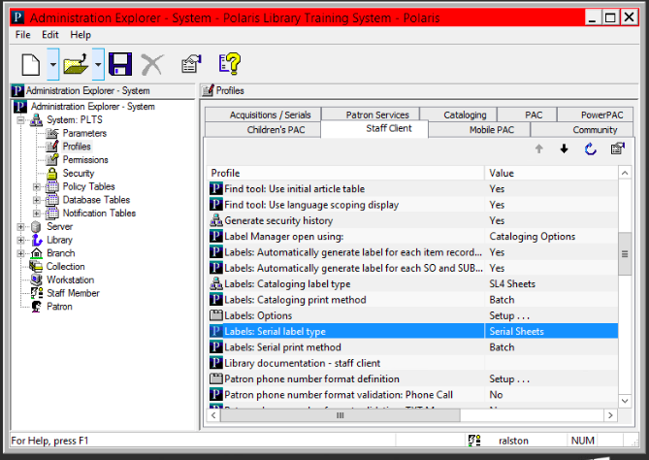

This step is to set the printing defaults; individual users will be able to change.

Note: custom labels must be enabled in this table to make them available for Polaris users. Custom label creation instructions are further down in this article.

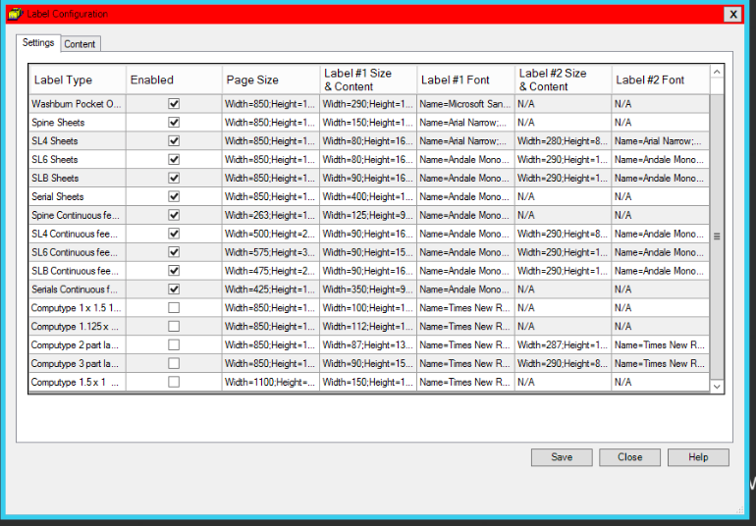

Label Printer Settings (Users):

Each user can choose which label they want to use, and what printing method. Labels have to be set up for Cataloging and Serials.

From the Polaris Toolbar select:
Cataloging>Options

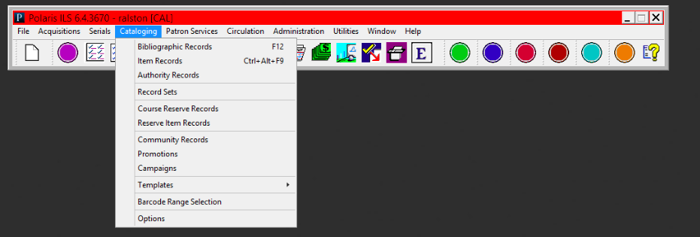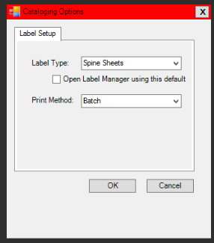

From the Polaris Toolbar select:
Serials>Options

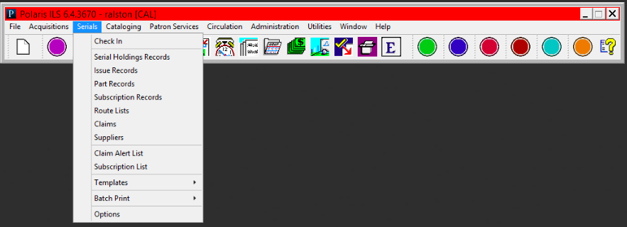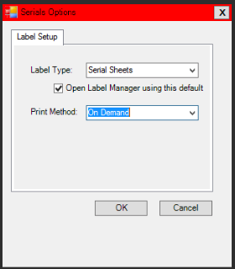

There are 3 printing methods, which depend on the type of label printer and library workflow:

Batch: The label is generated but is not printed until user opens Label Manager and prints.
On Demand: The Label Manager appears when the user requests label and the user can view before printing.
Quick print: The label will print without opening the Label Manger.

Label Manager Access
From the Polaris Toolbar select:
Utilities>Label Manager

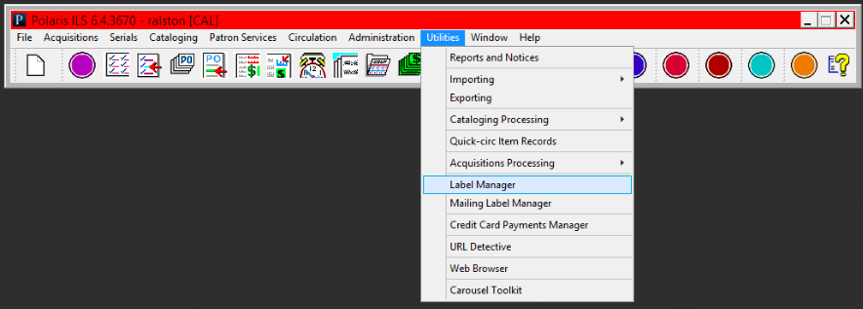

Once the Label Manager opens, you will see the labels that have been sent there (batch printing). By selecting Labels at the top, you can switch to a different label type. The example below displays spine label sheets, but this can be changed to a different label if needed.

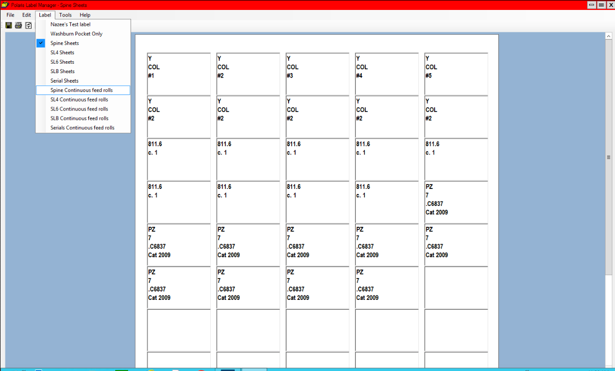
Note: before you print, you can add, change, or delete any labels or information on those labels. It works just like Word and it is possible to copy and paste if needed.

Custom Labels and Content

From the Label Manager, it is possible to design new labels or edit the content of current labels, as well as set different printers for certain label types.

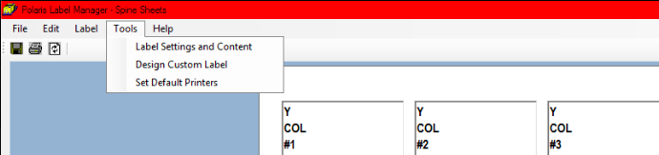

Designing Custom Label
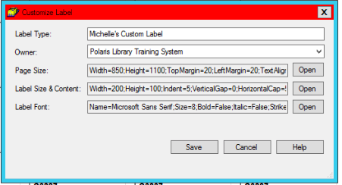

Name it and change page size, label details, and fonts. *Make sure to go back to Admin settings and check the new label so everyone will be able to use it.

Label Setting and Content:
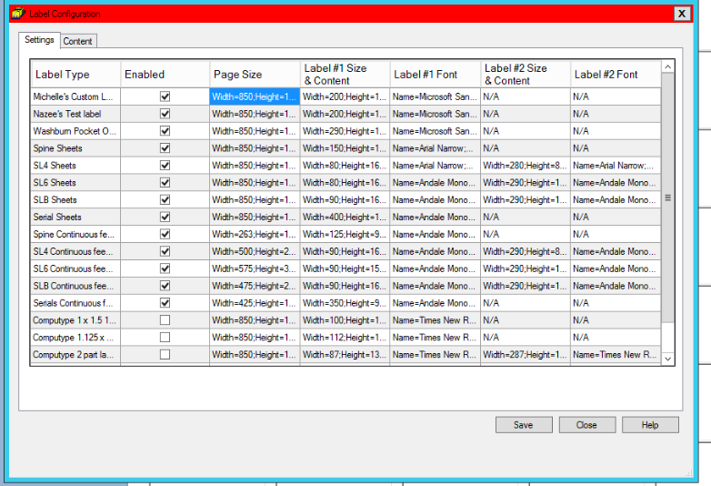

To change settings, right click on the settings to change and click open.
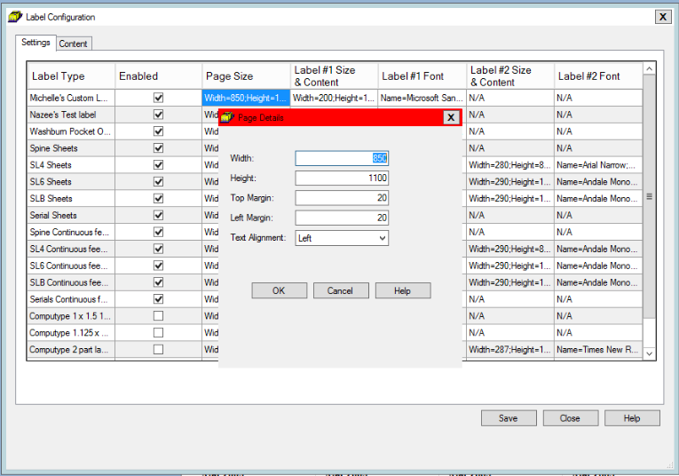
The numbers listed are the inches x100 so 8.5 inches = 850

It is possible to change font and size:
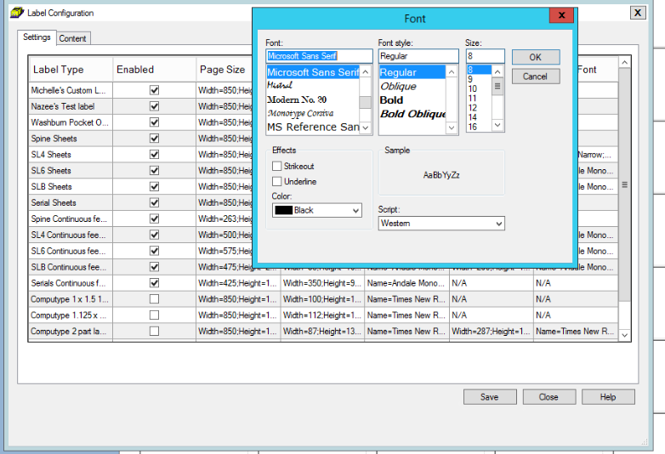
Switch to the Content Tab to choose what information goes on the labels.
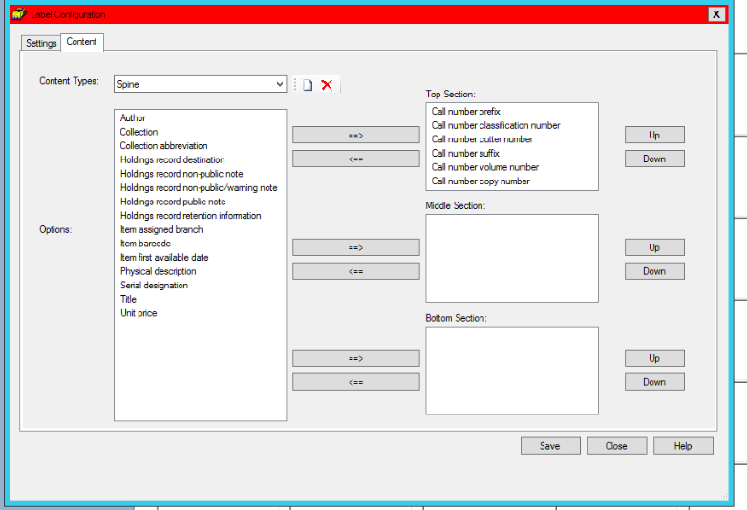

Under the Tools Menu in Label Manager, it is possible to choose specific printers for different labels:
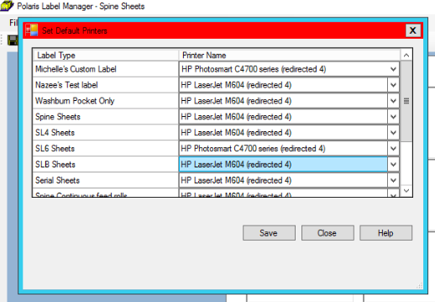

This publication is supplied for the exclusive use of customers of Innovative Interfaces with the understanding that it shall not be shown or distributed to anyone outside of the customer's organization without the prior written permission of Innovative Interfaces. This publication may be copied only if the copies are for the exclusive use of staff members of libraries that have purchased the Innovative system.
© 2022, Innovative Interfaces, Inc.

