polaris System Admin

How to Add Workstations in Polaris Client

Introduction:
This article explains how to add a new workstation in the Polaris Client

Adding a New Workstation:
From the Polaris Toolbar select:
File>New

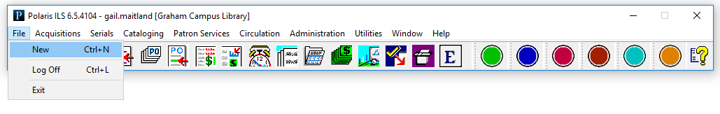

Click on Workstation, then OK:
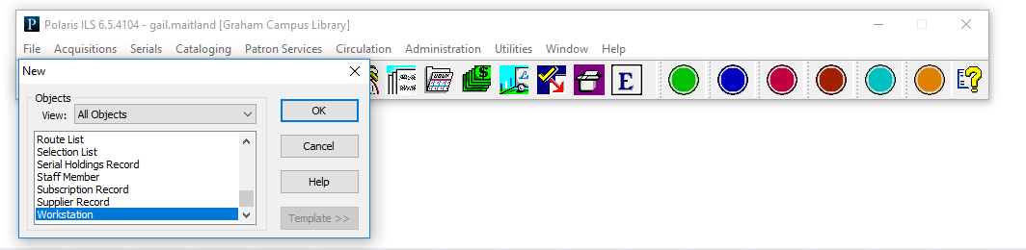

Complete all bolded information in the workstation form:
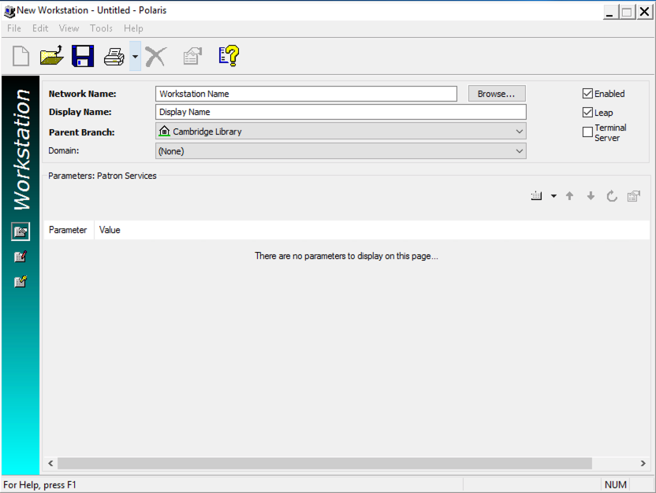
Click Save

Searching for a Workstation:
From the Polaris toolbar select:
Administration>Workstation

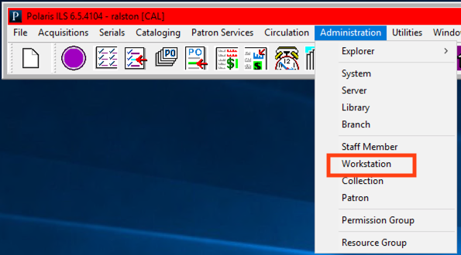
The Find tool will open and you can search for the workstation
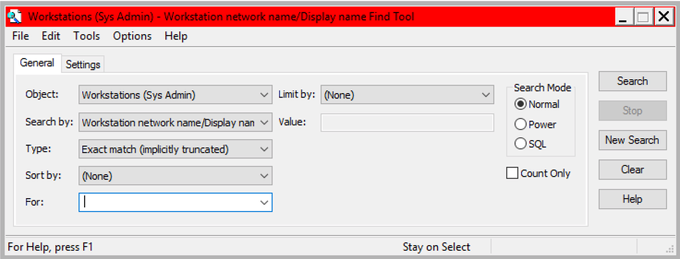
Note: An asterisk (*) will bring up all workstations.

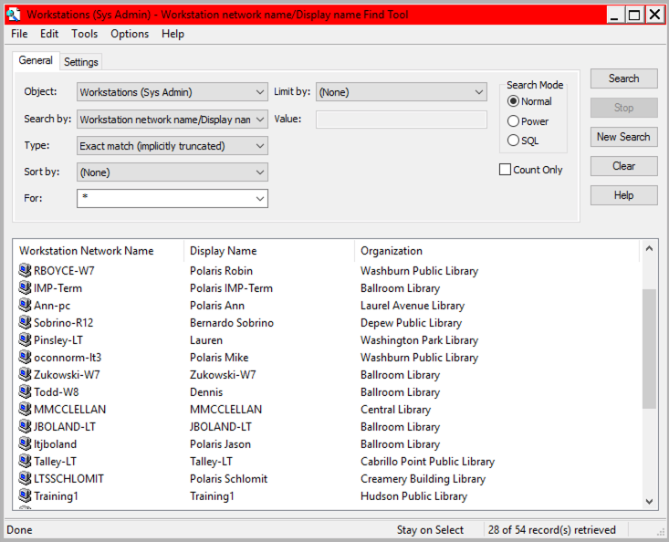

Double click to open and edit the workstation.

This publication is supplied for the exclusive use of customers of Innovative Interfaces with the understanding that it shall not be shown or distributed to anyone outside of the customer's organization without the prior written permission of Innovative Interfaces. This publication may be copied only if the copies are for the exclusive use of staff members of libraries that have purchased the Innovative system.
© 2022, Innovative Interfaces, Inc.

