POLARIS SYSTEM ADMIN
How to Add a Staff Member - Polaris Client

Introduction:
This article explains how to add a new staff member in the Polaris Client

Adding a New Staff Member:
From the Polaris Toolbar select:
File>New

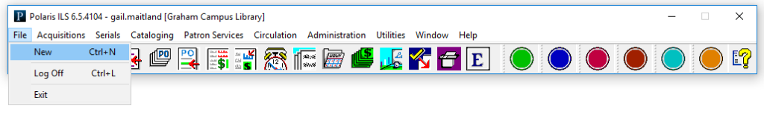

Click on Staff Member, then OK:
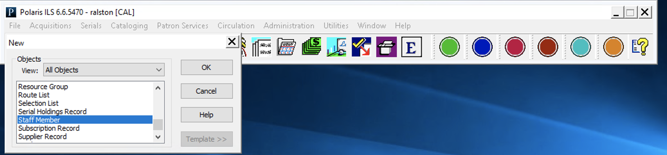

Complete all bolded information in the workstation form:
- If the organization is not branch level, you must choose an affiliated branch.
- The name must match the name in Active Directory.
- Email is not required, unless the staff member will receive Ask Us or Self Registration information.

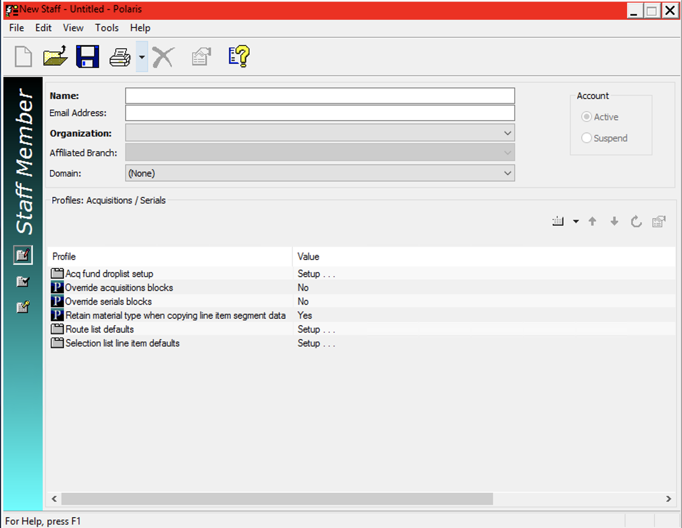
Click Save, there will be a warning that the staff member has no permissions. After saving, assign the staff member to the correct permission groups, or grant them the permissions needed.

Searching for a Staff Member:
From the Polaris toolbar select:
Administration>Staff Member

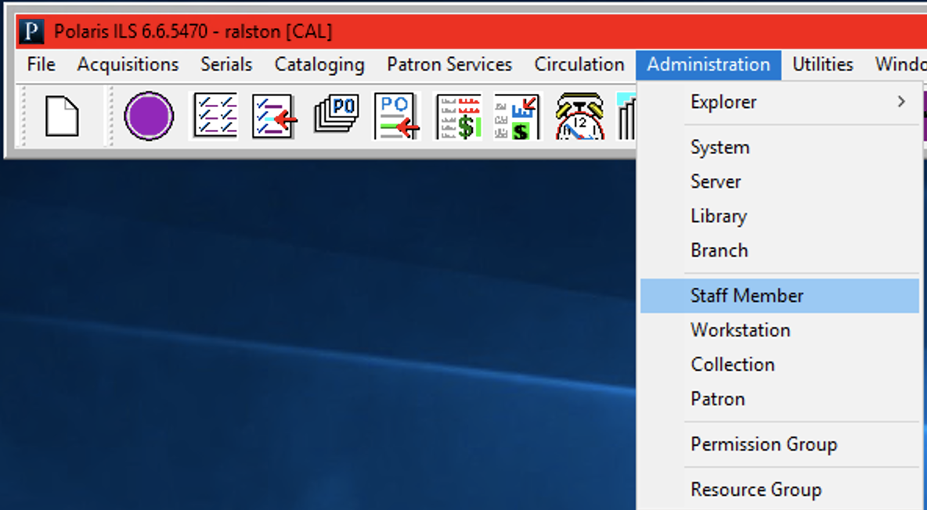

The Find tool will open and you can search for the staff member.
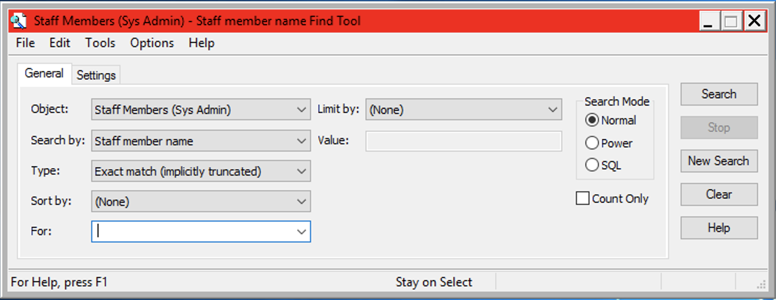
Note: An asterisk (*) will bring up all staff members.

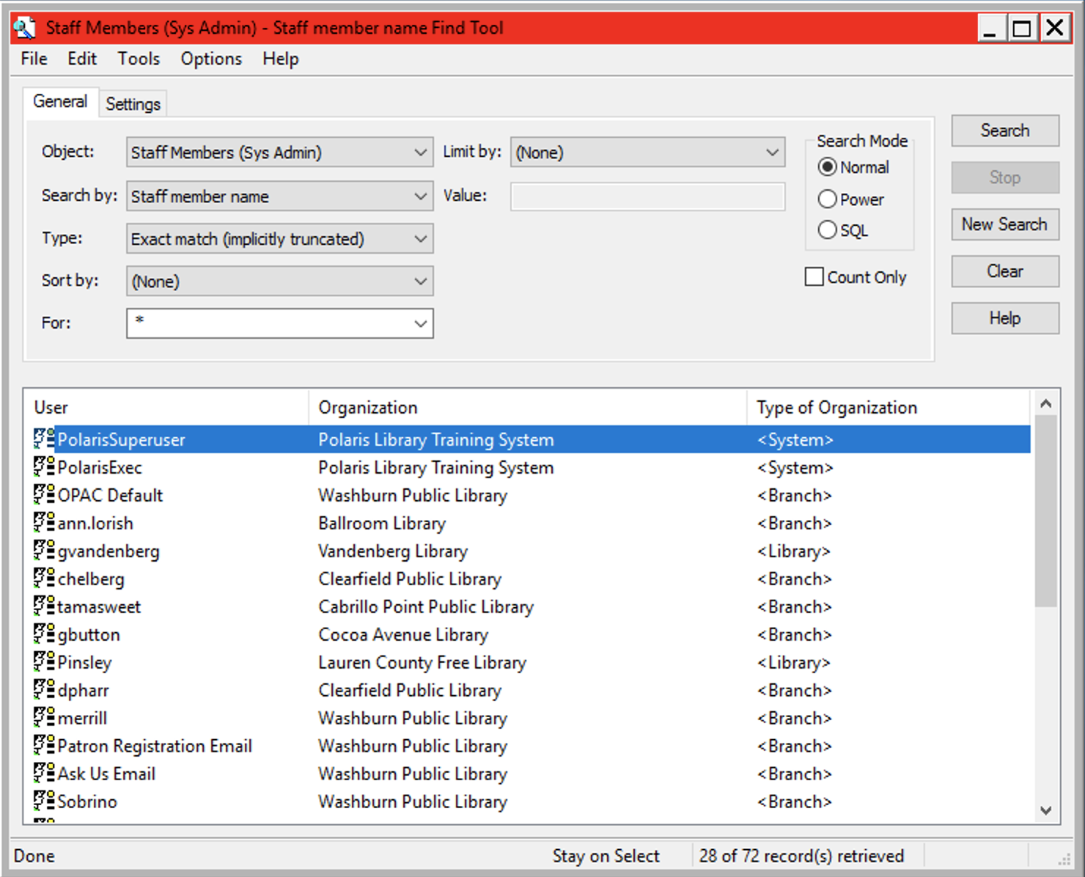

Double click to open and edit the staff member.

This publication is supplied for the exclusive use of customers of Innovative Interfaces with the understanding that it shall not be shown or distributed to anyone outside of the customer's organization without the prior written permission of Innovative Interfaces. This publication may be copied only if the copies are for the exclusive use of staff members of libraries that have purchased the Innovative system.

© 2022, Innovative Interfaces, Inc.

