polaris serials

How to Create a Pattern

Create the Publication Pattern

There are three options for creating new publication patterns
- Click the New icon on the Publication Pattern Template Manager.
- Right-mouse click on an existing template and copy it by using Create.
- Click the Create a New Pattern icon on the line item toolbar on the General view of the SHR—when completing the pattern, it can be saved as a template.

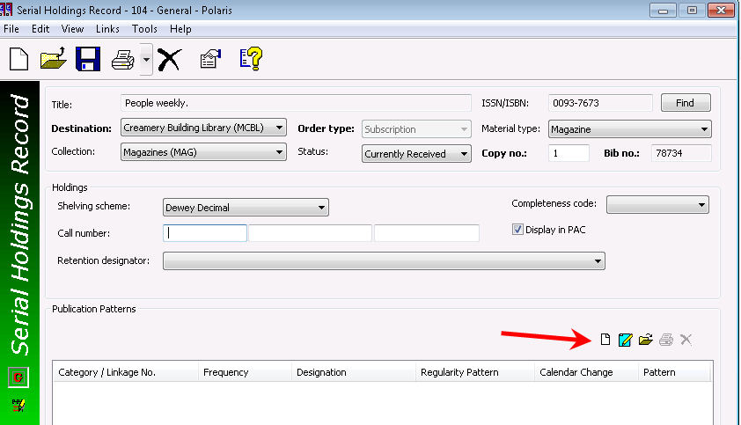

The publication pattern wizard will appear:
- Choose a category:
  - Basic Bibliographic Unit
  - Index
  - Supplementary Material
- If not using a pattern, the start date must be based on the issue in hand when check in will begin.
- The arrival pattern date is the number of days before or after the issue’s published date that it is expected at the library—important in regard to claiming.
- Check “Generate items at check-in” and “Prompt for barcode” if desired
- The default unit price will be automatically transferred to the issue and item record that is created.
- If publication pattern templates were created earlier, one can be selected from the templates box—the start date will be the start date from the template.
- Click on Next to continue.

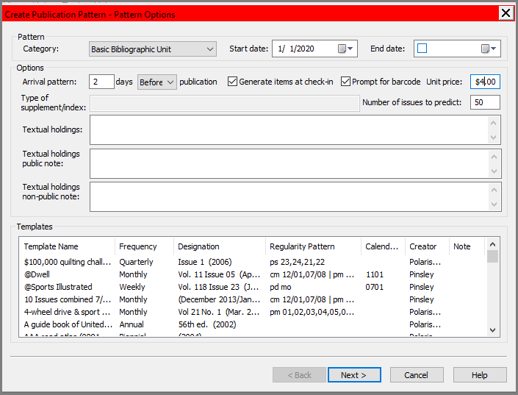

Note: Staff can use the Back button in the wizard at any time to correct errors.

On the Create Publication Pattern – Enumeration and Chronology form:
- Select a frequency
  - Enter enumeration and chronology as they appear on the issue in hand.
  - Chronology must be entered in reverse order—e.g. year, day of month, month if the issue says January 14, 2020.
  - Enumeration must be entered in direct order—e.g. Vol., No. if the issue says Vol. 24, No. 1.
- Remember to click the Add button as each level is entered

Note: When adding a new Chronology or Enumeration level, fill in all fields (Caption, Format, etc.)
Tip: Bib units per next higher level is the total number of issues that are published in a cycle before the volume will increment

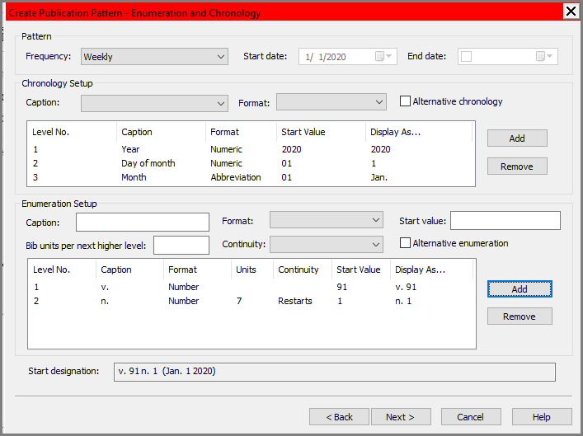

- When entering enumeration, if a second level is present, it must include a number in the “Bib units per next higher level”—e.g. 12 for a monthly, 11 for a monthly with one combined issue, 6 for bimonthly.
- Select restarts or continues in the Continuity drop-down box.
- If a free text format is selected, a start value is not required.
- If the Start designation at the bottom of the screen looks correct, click Next to continue.

To continue, click Next.

- The Regularity Pattern screen is used only if there are irregularities in the serial’s pattern.
- A default regularity pattern may or may not display under the Publication Details box.
- Exceptions can be added to the default publication pattern by using publication code to publish additional issues, to omit issues and/or to combine issues.

In this example, there are several combined months.
The Calendar Change can be used to indicate the chronological point at which the highest level increments or changes—in essence, it forces the change to a new volume.
Click Next to continue

Note: Click the Publication code drop-down to select Combine, Omit or Publish and then the Calendar unit drop-down to select what you are combining, omitting or publishing. Fill in the From and To boxes if appropriate and remember to click the Add button.

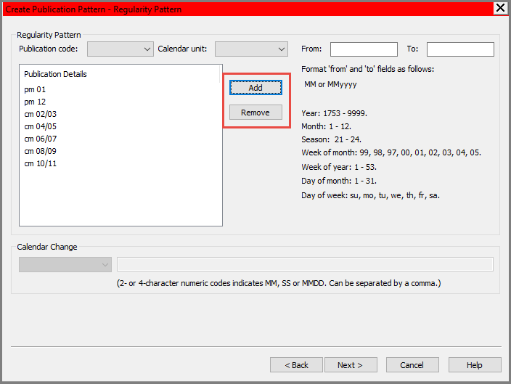

Note: After selecting a Publication code and a Calendar unit, pay careful attention to the format values on this screen for additional help. The hint will change with each combination selected

Use the ‘from’ and ‘to’ fields alone or in combination with any of the following to create the desired pattern:
- Year (y): 4 digit format
- Month (m): number 1-12
- Season (s): 21 spring, 22 summer, 23 autumn, 24 winter
- Week of month (w): 99 last, 98 next to last, 97 third to last, 00 every, 01 first, 02 second, 03 third, etc.
- Week of year (w): number 1-53
- Day of month (m): number 1-31
- Day of week (d): Two letter code for day

Prediction Results

Prediction results can be reviewed to ensure the pattern came out as expected.
If the prediction results are not correct, click the Back button and make the correction on the appropriate screen of the wizard.
You can use the View More button to go further into the future to check the pattern.

- A new publication pattern can be saved as a template and used again when setting up the same title—save the new pattern using the serial title as patterns are title specific.
- A maximum of 50 issues can be predicted.
- More issues can be predicted upon demand when needed.
- The expected arrival date is calculated using the start date (publication date) and defined arrival pattern (days before or after the issue is expected).
- Click Finish to generate issue records and close the wizard.
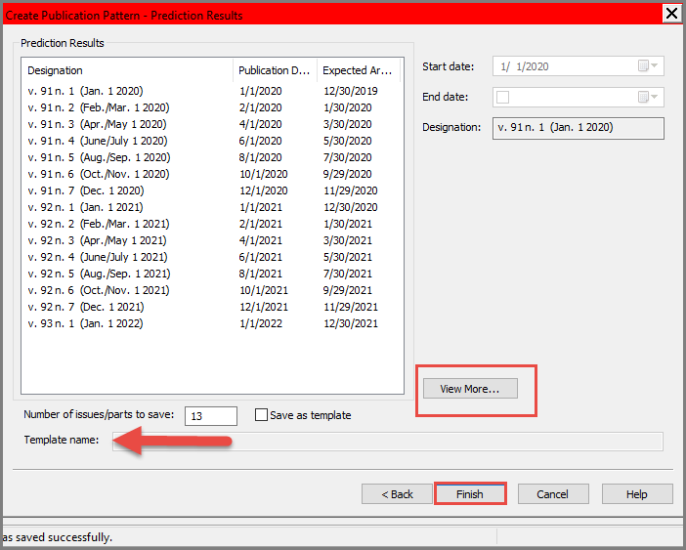

Select Yes on the prompt.

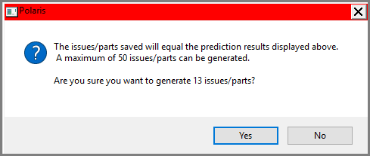
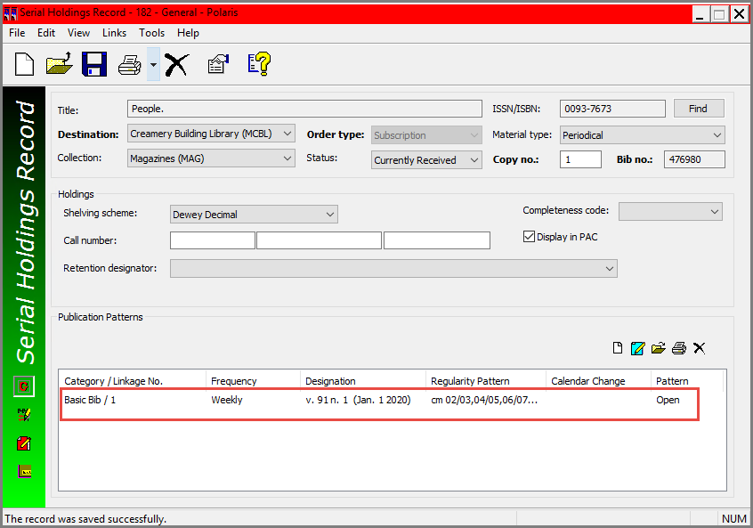

This publication is supplied for the exclusive use of customers of Innovative Interfaces with the understanding that it shall not be shown or distributed to anyone outside of the customer's organization without the prior written permission of Innovative Interfaces. This publication may be copied only if the copies are for the exclusive use of staff members of libraries that have purchased the Innovative system.
© 2022, Innovative Interfaces, Inc.

