Polaris Serials

How To Check In Serials in Polaris Client

Introduction:
This article will go through the basics of checking in serials in the Polaris Client.

Check In:
To find a title to check in, from the Serials drop-down menu, select Check In.

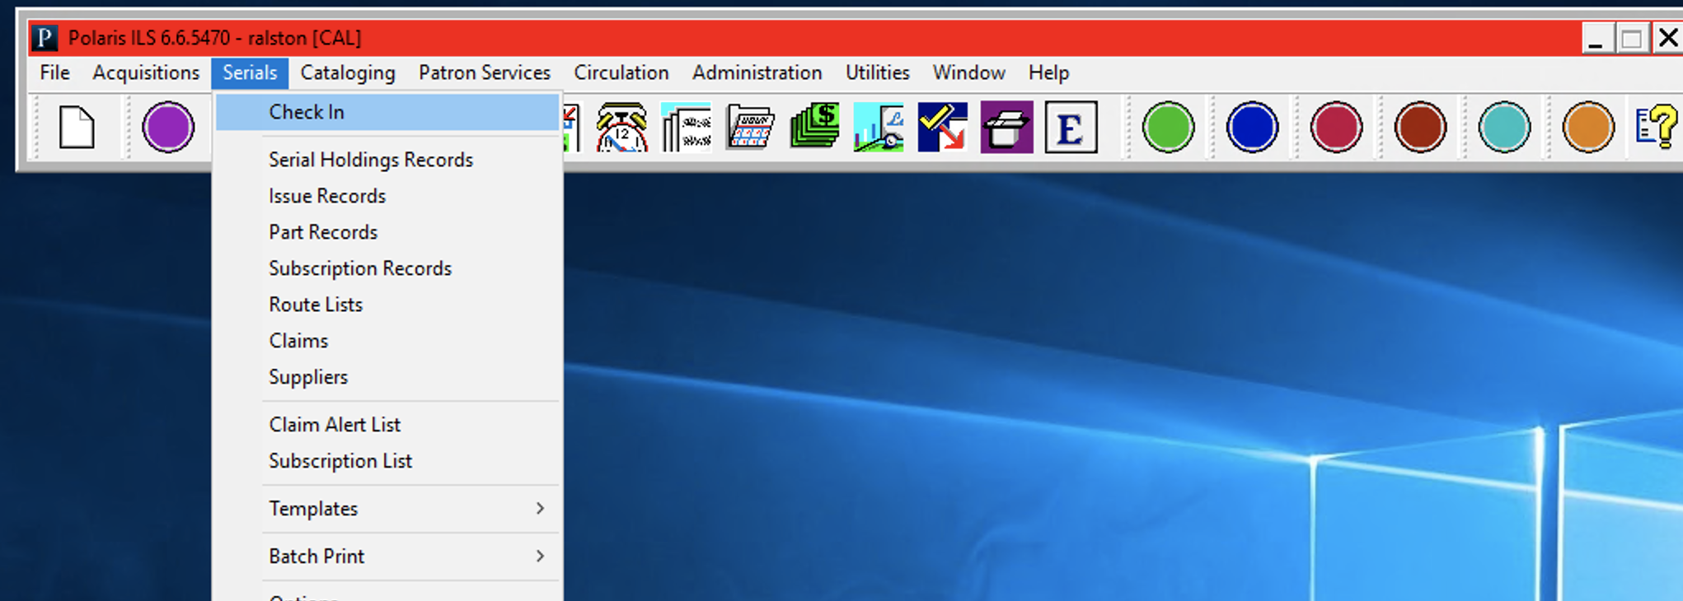

Use the find tool to get to the correct serial title.

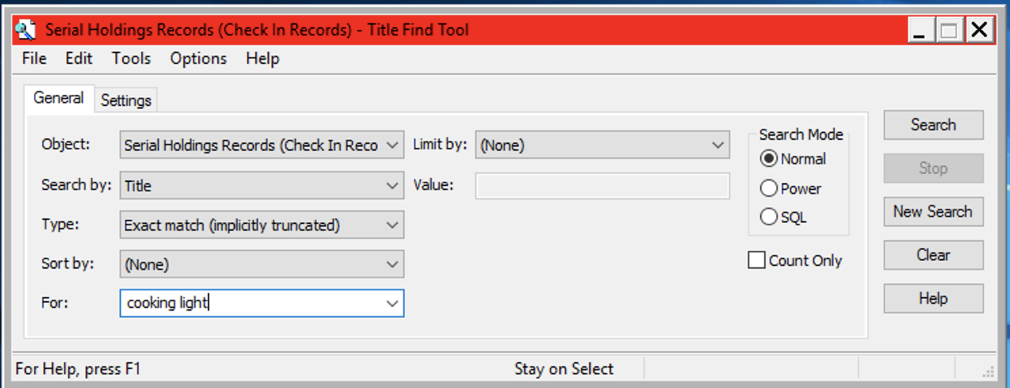

Select the desired title/branch combination. The list of issues can be sorted by category and issue/part status.

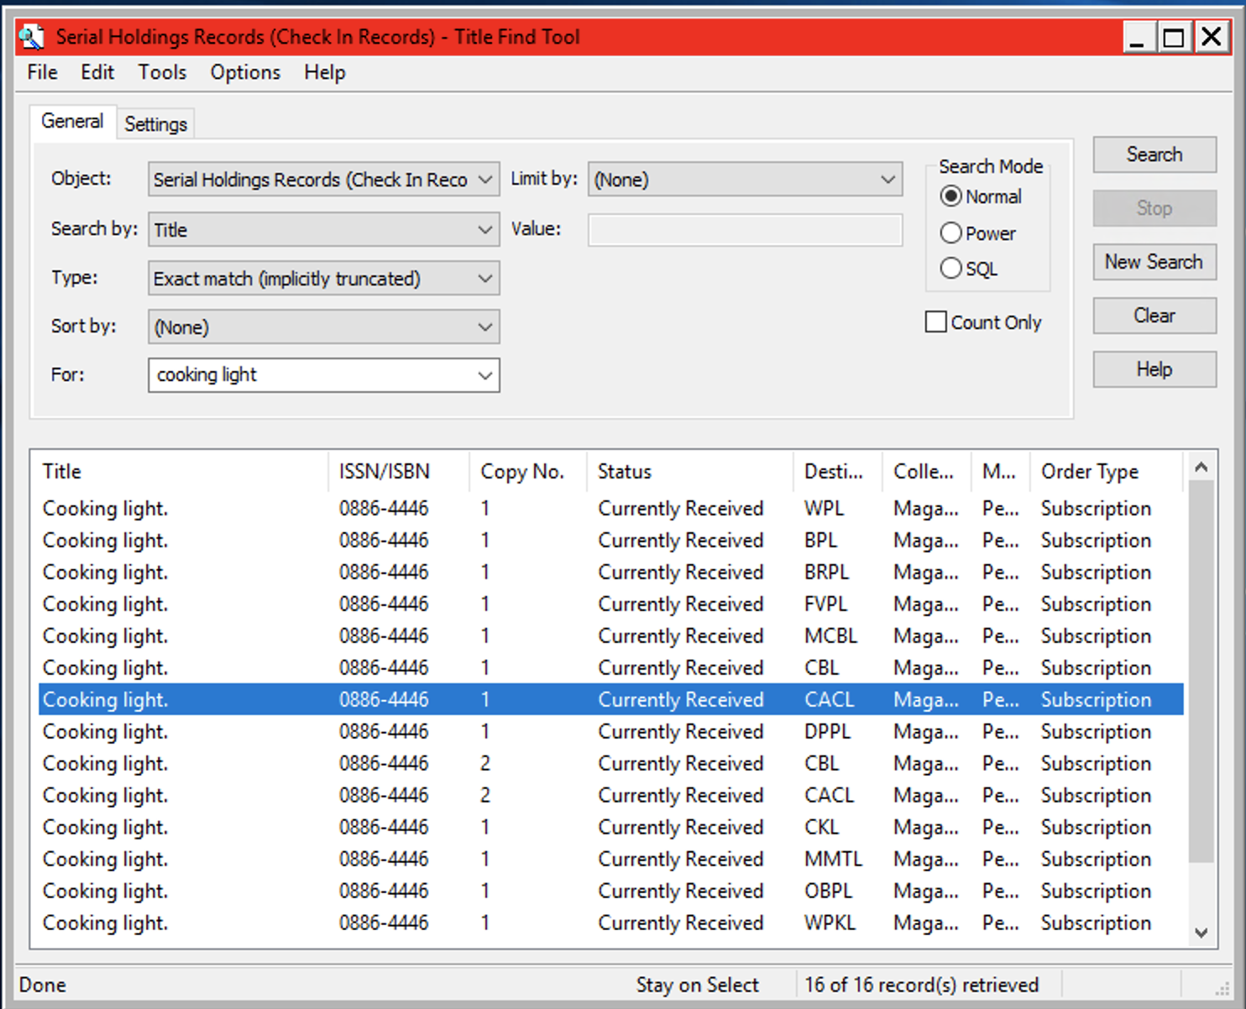

Double click on the correct Copy/Destination to open the Subscription Check In window, highlight the issue to be checked in--click the Check In icon on the top or double click the selected issue.

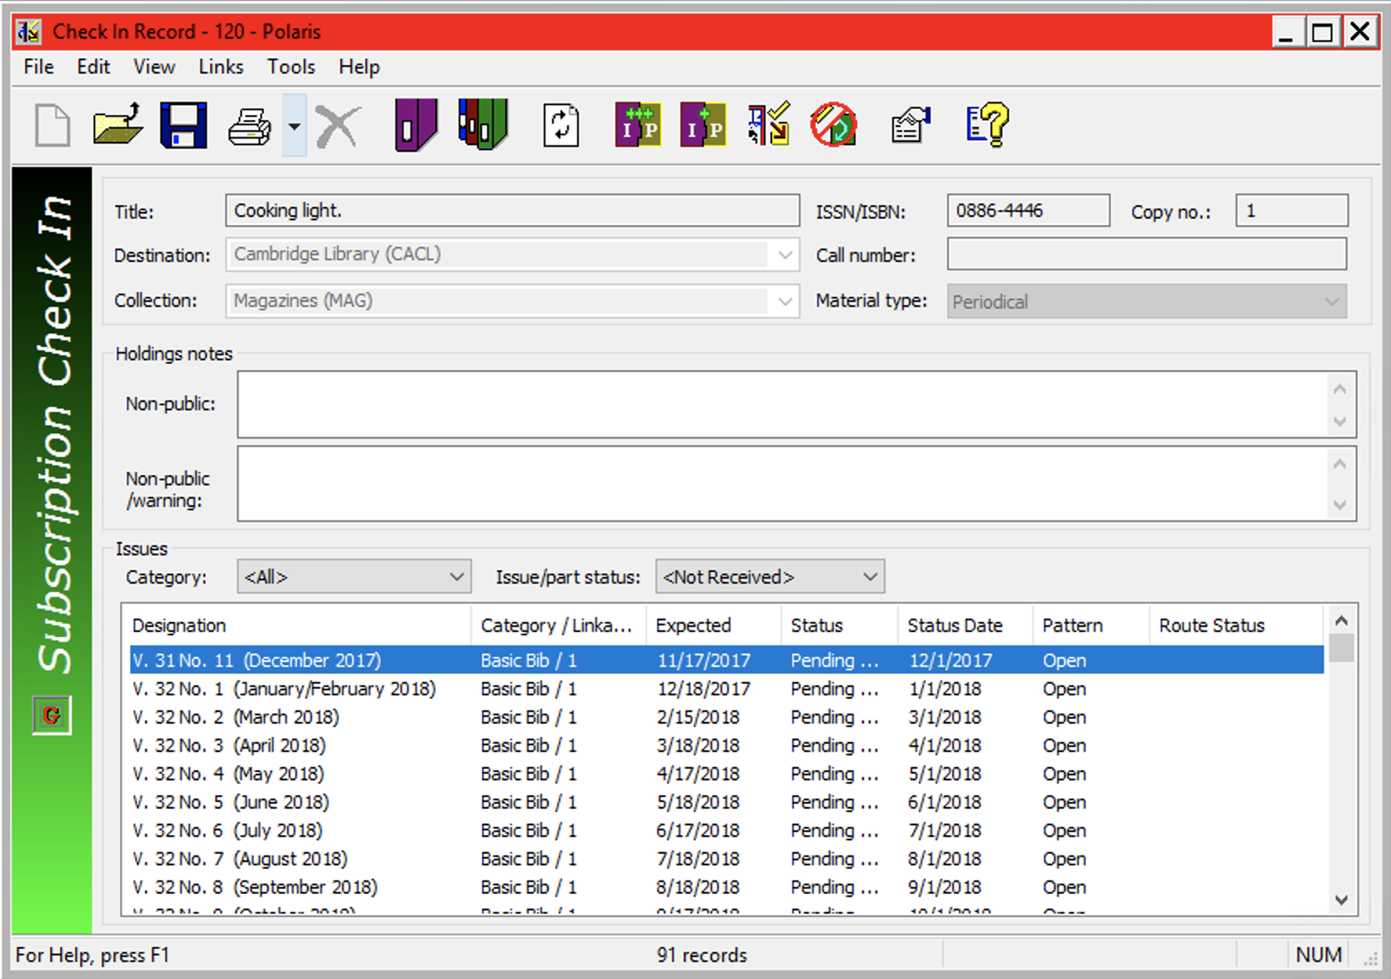

If “Generate items at check in” and “Prompt for barcode” have been turned on, the Create Item for Issue/Part dialog box appears. The unit price is copied over if it was added in the publication pattern wizard.

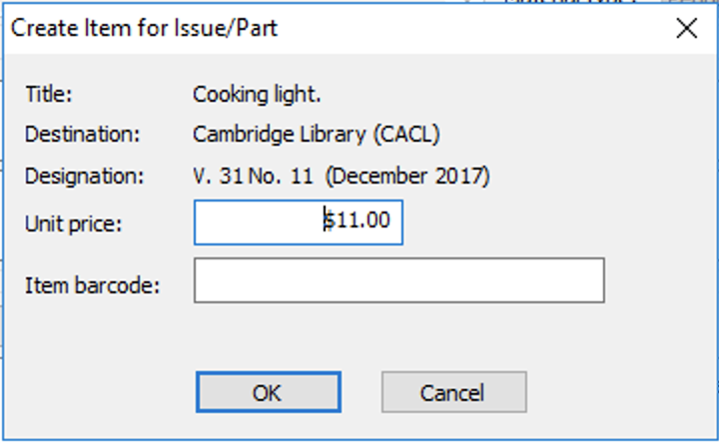

The checked in issue is moved to the received list.

This publication is supplied for the exclusive use of customers of Innovative Interfaces with the understanding that it shall not be shown or distributed to anyone outside of the customer's organization without the prior written permission of Innovative Interfaces. This publication may be copied only if the copies are for the exclusive use of staff members of libraries that have purchased the Innovative system.
© 2022, Innovative Interfaces, Inc.

