Polaris Serials

Claiming Methods for Serials Issues/Parts

This guide reviews the methods for claiming serials in Polaris. There are two methods for claiming serials:

- Mediated
- Automatic

To claim a title, a supplier must be attached to the SHR and claim intervals defined on the supplier record Claim view or on the holdings record the fourth view.

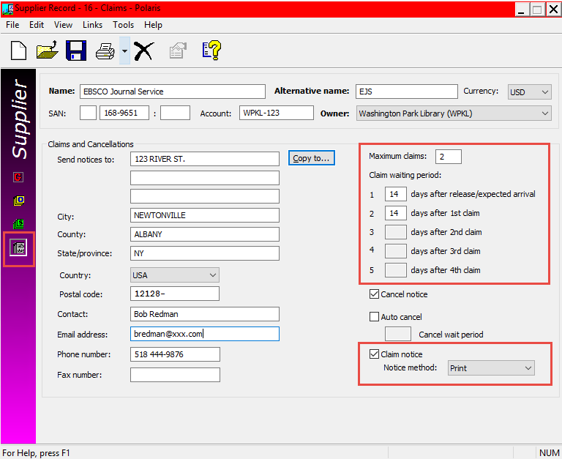

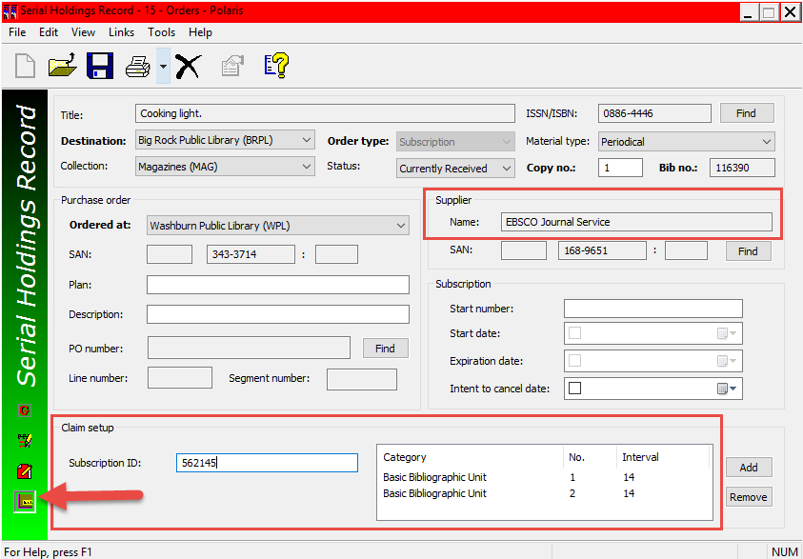

Note: Serial claiming must be enabled in System Administration--go to Parameters/Notification/Notification Options/Serial and check the Serial claim box

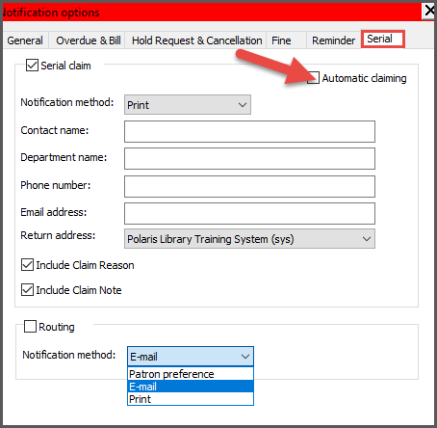

Automatic Claiming

If you select automatic claiming, issues or parts change to a Claimed status via overnight processing. The claim notices are generated automatically as e-mail or printable notices, depending on your claiming notification method.

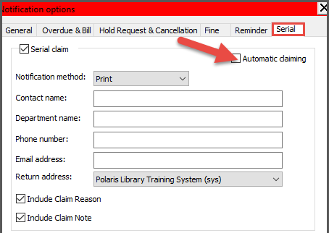

When the claiming method is set to e-mail, the e-mail notices are generated (either by automatic or manual claiming), and they are sent out by the e-mail manager. When the claiming method is set to print, the notices are also generated, but you must print the notices by going to Utilities, Reports and Notices.

If automatic claiming is selected, all issues that have not been received by a specified time are changed to a status of claimed and notices are automatically generated and sent per the Notification method defined.

Note: If you do automatic claiming and print claim notices, all the automatically-generated claim notices will be printed for the date range you specified. See Claim Alerts List, and Claim Notice section of the Claim Alerts List article.

Manual Claiming

If the automatic claiming box is unchecked, all issues that have not been received by a specified time appear on the Claim Alerts List with a pending claim status and must be mediated and claimed.
When manually claimed, the notices are sent per the Notification method defined.

Select image, right click and select Format Picture, 3rd icon from the left, select ALT TEXT and add a description for the image.

This publication is supplied for the exclusive use of customers of Innovative Interfaces with the understanding that it shall not be shown or distributed to anyone outside of the customer's organization without the prior written permission of Innovative Interfaces. This publication may be copied only if the copies are for the exclusive use of staff members of libraries that have purchased the Innovative system.
© 2022, Innovative Interfaces, Inc.

