Polaris Reports

How to Generate Reports

Polaris provides many standard and customizable reports to help you track all aspects of library activities. The default output format for a report is a PDF file, or you can choose HTML 4.0, MHTML, Excel, or Comma Separated Values (CSV). (Depending on the data in the report, the additional formats such as Excel and HTML may not produce the results you expect.)

- To generate, print, or customize reports, the staff must have the Access reports and notices​ permission
- Adobe® Reader® needs to be installed on any workstation that runs reports, notices and many staff client printing tasks​
- Consideration should be given to appropriate times to run reports in order to avoid slowing down the system​

Toolbar Menu

Reports are found under the Utilities menu
Access to Reports and Notices is an all or nothing permission with acceptation of restricting to Library or Branch level

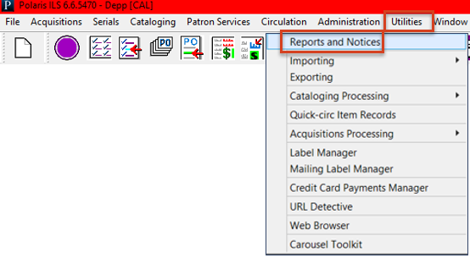

When the Polaris Reports window opens the left pane shows the report categories and the right pane lists available subfolders and individual reports by subsystem​
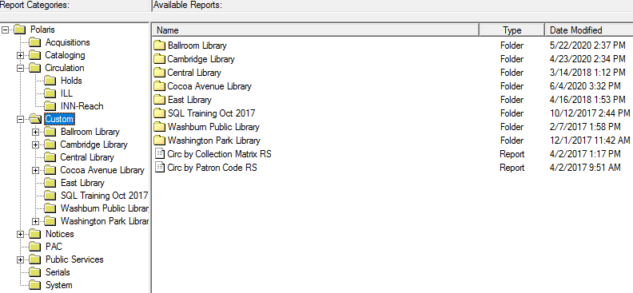

Steps for Generating a Report

- Select the subsystem folder for the required report​
- Double click the report name to open the Report Wizard​
- Select organizations, dates and any other needed parameters ​
- Set sort if available​
- Click Submit to produce the Report Preview Window
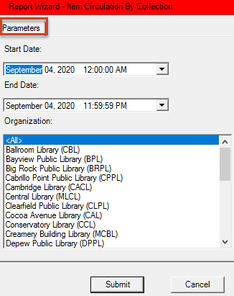

Save, Print or E-mail

By default, the report will be displayed in PDF format with options to save, print (all pages or just selected ones) or e-mail the report​

There are sticky notes and highlighter tools available in this format​

The report will stay in the cache for approximately 30 minutes, causing a repeat generation to possibly produce the same results even when other data is available
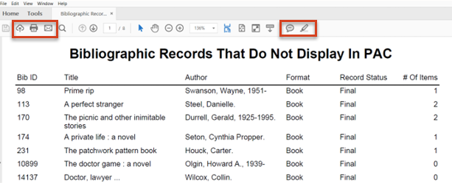

Output Options

- PDF is the default output option but there are other formats available​
- PDF – some printers, without an appropriate driver may not be able to print these documents successfully
- HTML – useful for large reports as it is faster than PDF
- MHTML – Mime HTML with ability to include links
- Excel – Excel should be loaded on the PC or server to view the report immediately
- There will be a choice to save to another location if Excel is not available
- CSV – Comma Separated Values – a simple plain text format
- Word – Word must be loaded on the PC or server to view the report immediately. There will be a choice to save to another location if Word is not available
- To change the output format either use the down arrow by the Report Output icon or right click on the report and select from the Output Type submenu​
- If you have difficulty generating a report, click the Refresh Reports icon to the left of the Report Output icon​

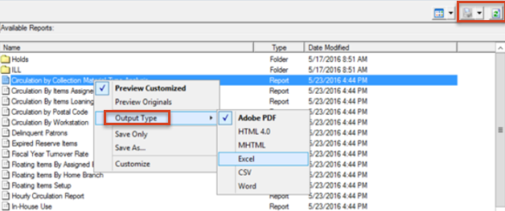

Custom Folder

- To copy a report to the Custom folder, select the toolbar report, right click and select Customize from the context menu​
- The copied toolbar report may be customized using the Reporting Services website​
- Customized reports will not be overwritten during upgrades​
- SimplyReports also allows reports to be saved to this location by “publishing” the desired report and further customization may take place from the Reporting Services website​
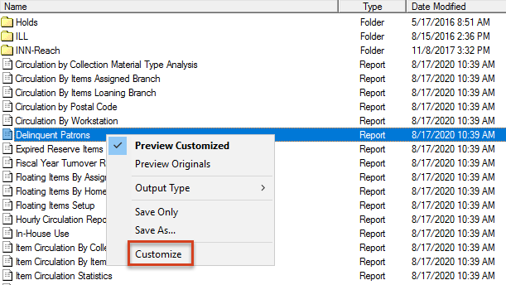

Help – Using Polaris Standard Reports​

The Using Polaris Standard Reports section of the Polaris Basic Topics guide includes step-by-step instructions for generating, sending and customizing toolbar reports

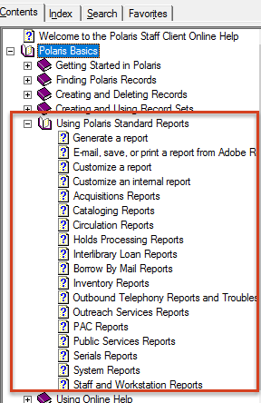

This publication is supplied for the exclusive use of customers of Innovative Interfaces with the understanding that it shall not be shown or distributed to anyone outside of the customer's organization without the prior written permission of Innovative Interfaces. This publication may be copied only if the copies are for the exclusive use of staff members of libraries that have purchased the Innovative system.
© 2022, Innovative Interfaces, Inc.

