Polaris Reports

Introduction to SimplyReports

What is SimplyReports

- SimplyReports offers ability to create thousands of reports using a simple Web-based interface.
- Easy to select criteria (parameters) using multiple filters
- No need for in-depth knowledge of the Polaris database or expertise in Structured Query Language (SQL).
- Select specific data to output

How to Login

- Administrator assigns the permission for all or selected records.
- Using any browser, go to:
http://<yourlibraryIP/simplyreports>
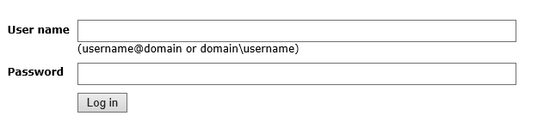

How to Logout

- Make sure to logout.
- If not logged out, the connection will remain for 59 minutes after inactivity.

Data Source for Reports
- Patron —Data from patron registration records and patron account (status) records
- Patron account —Data from patron account (status) and their linked patron registration records, item and bib records
- Holds —Data from hold request records and their linked bib, item, patron account and patron registration records
- Items --Data from item records and their linked patron accounts, patron registration and bib records
- Bibs --Data from bib records and their linked items
- Authorities --data from authority record, their linked bib and item records
- Serial --Data from Serial Holdings records (including data from publication patterns and compressed holding statements) serial issues/part records and subscription records, linked suppliers and item records
- Funds --Data from fund records, fiscal year records, their linked bib and item records
- Invoices --Data from invoice records, their linked fiscal year, fund, item, bib and supplier records
- Orders --Data from PO (including POLI and segment data), their linked fiscal year, fund, item, bib and supplier records

Types of Reports Available

List– As the name of the report indicates, you can create a list of records containing a set of information. List reports subtab is available for all records.

Count – If you are interested to know how many records contain a set of conditions, use Count reports. So, count reports give the number of records where list gives you the actual records containing the similar information.
Statistical reports show number of transactions, stats on records created or deleted – it looks different from the other reports. This will produce # of transactions for the type of record we’ve selected.

Counts and statistics are available for all records except order, fund and invoice records. The order, fund and invoice records have the summary reports instead.

- List : All records
- Counts: Patrons, Patron Account, Holds, Items, Bibs, Authorities, Serials
- Statistics: Patrons, Patron Account, Holds, Items, Bibs, Authorities, Serials
- History: Items, Patrons
- Export files: Bibs
- Summary: Funds, Invoices, Orders

List or Count Report Workform

Maximum Rows to Retain: The default number can be changed.

Report Output Column: List of available fields for the selected report
Columns Selected for Output: Select the fields from the Report Output Column to be included in the report. To reorder the columns from left to right on the report, use the up or down arrows. Column Selected for Sort: To sort the report results
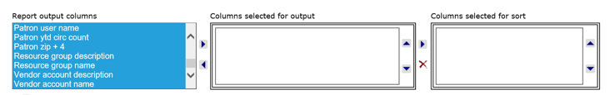

Include header rows: To include a header row
Select the file type for the report:
- Text file - If you select this file format, select an entry in the Delimiter type box.
- Excel - This is the default file type. When you save the report output in this file type, the file is saved in Microsoft Excel format.

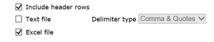

Filters: Report filters limit the report output by characteristics of the records for which you are creating the report, or by characteristics of linked records.

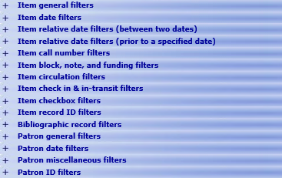
Statistical Report Workform

The statistical report uses the transactional data from the appropriate record.

The statistical reports use the database server and will place a great deal of demand on it. It will slow down Polaris performance. It should be scheduled for a time outside the normal library hours. The “run report now” is unchecked by default.
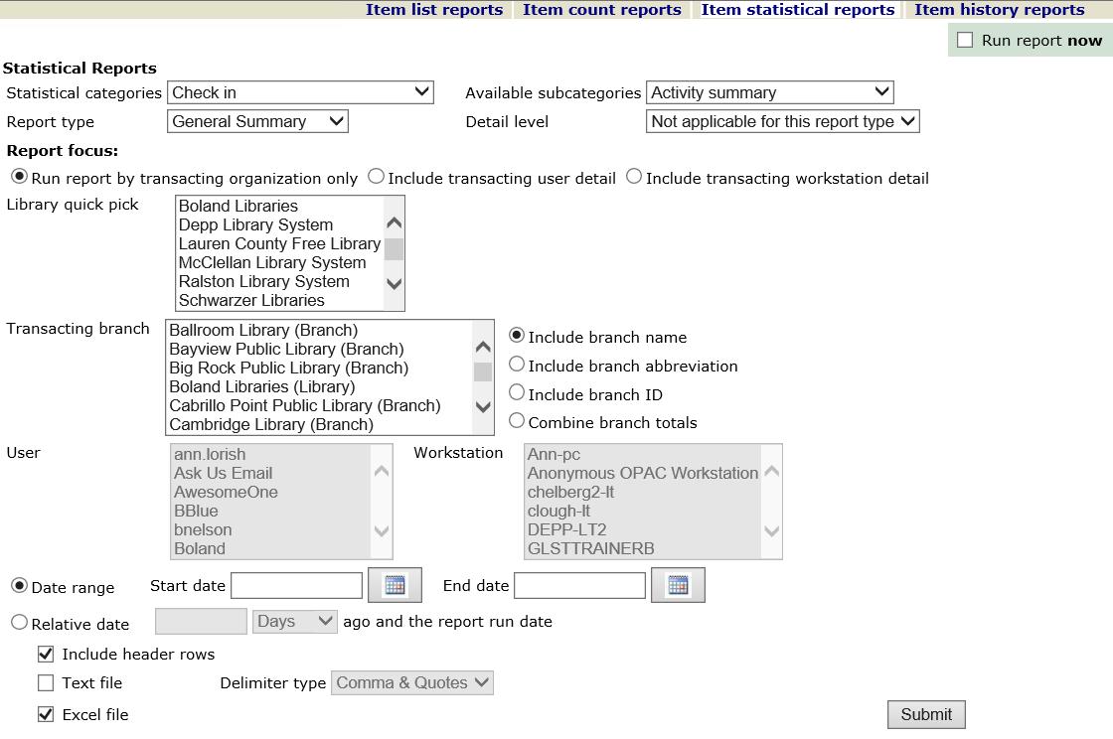

Click “run the report now”, if you like to run the report now. You will get a warning that you should not run the report at this time.
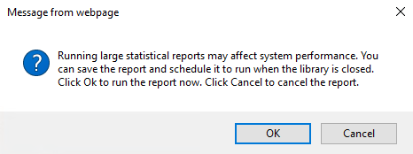

To download reports

The format of the report has already been selected
- Click Download report Output
- Have the option to open the report
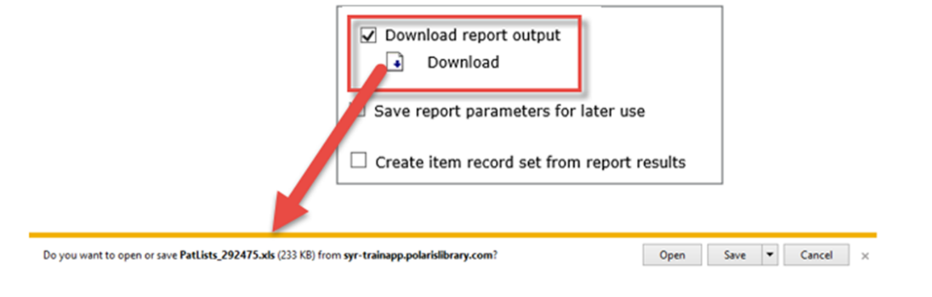

Format in Excel
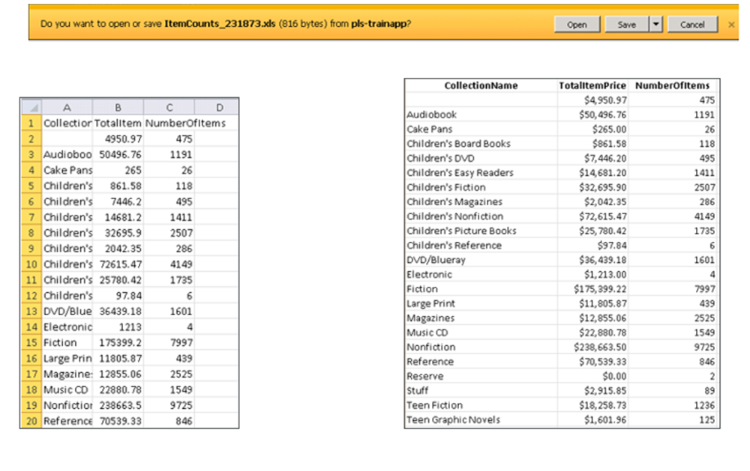

Format in Text Delimited
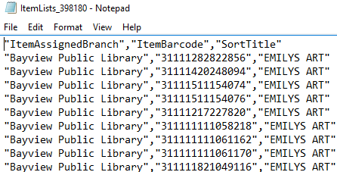

Save the Report Parameters

- Click “save report parameters for later use”
- Enter a report name, click “save”
- The report description is optional
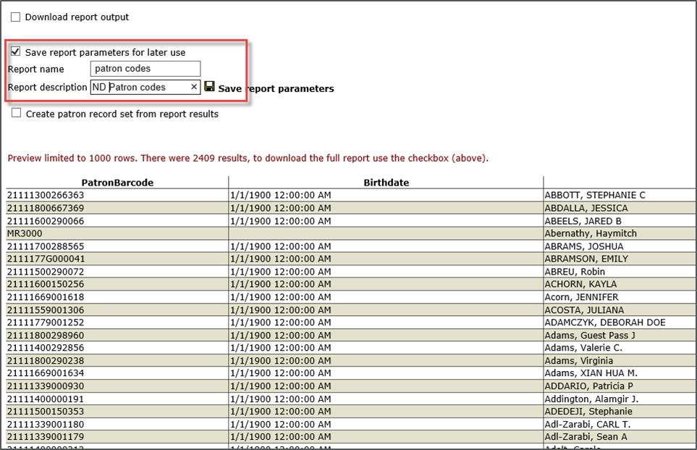

- Confirmation that the report is saved
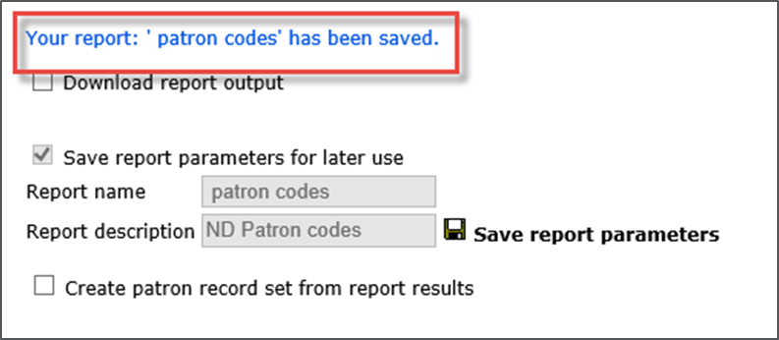

Create a Record Set

You can create a record set for bibliographic, item, authority and patron records, if you need to work with these records in the Polaris client.

- Check “Create item record set from report results”
- Name the record set, save
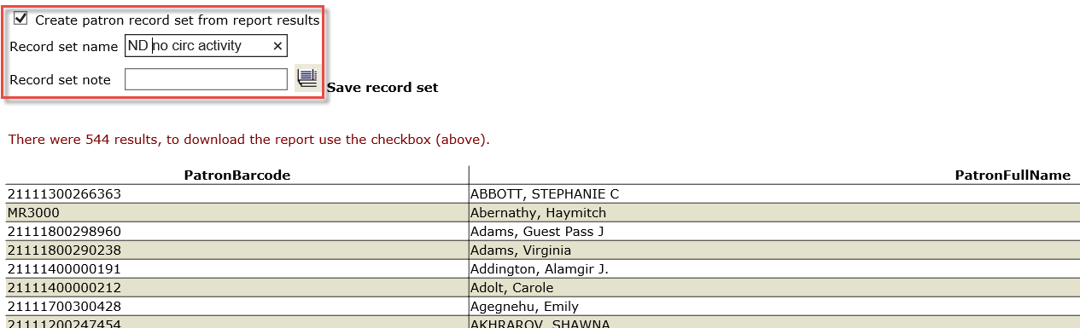

- You will get a confirmation
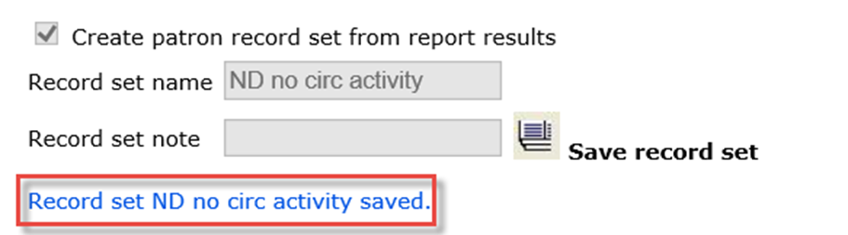

- Search for the record set in the Polaris Client
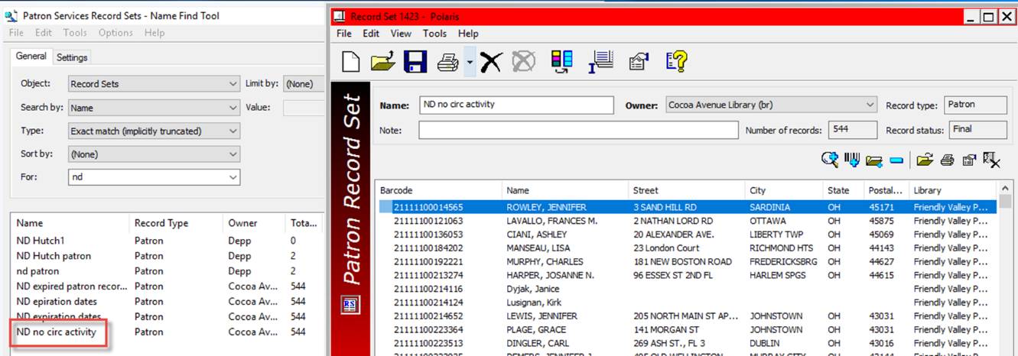

My Reports Tab

To manage your reports, select “My Reports” tab
There are three tabs:
- My Reports
- File Maintenance
- Scheduled Jobs

My Reports: To access your saved reports. You need to know the type of report
There are options to:
- delete the saved report or edit each report
- Schedule reports
- Run reports
- Publish report
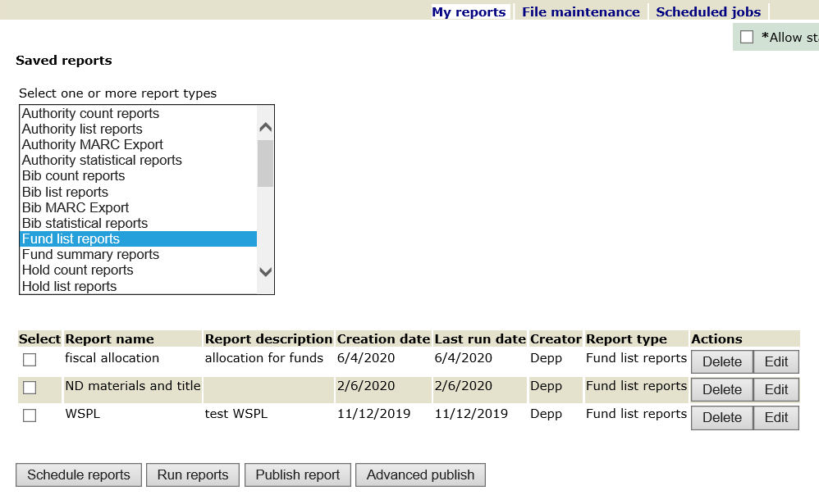

Schedule reports
Fill in appropriate fields | Save
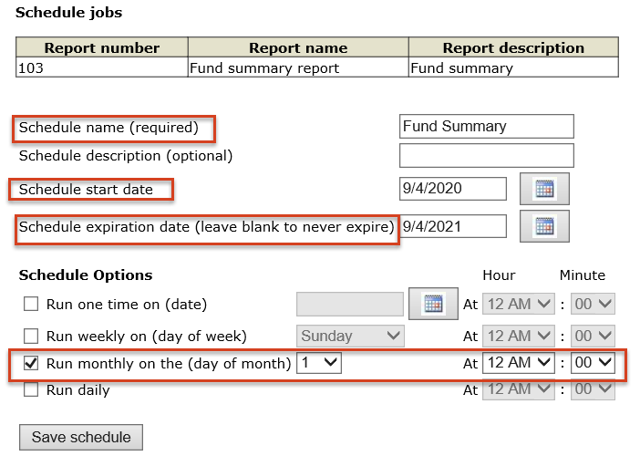

Publish Report: The reports can be published to Polaris toolbar reports.
- Select the report you would like to publish and click publish report.
- The report name is automatically populated from your report.
- Select how the report to be oriented: landscape or portrait.
- Choose your branch. Is this report just for you or to share with others?
- If it is for you, place in the personal folder.
- If to share, place it in the branch folder.
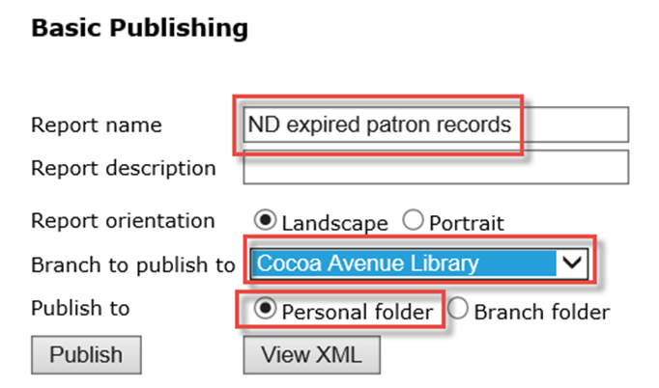

In the Polaris Client, Utilities | reports and notices, select Custom folder.
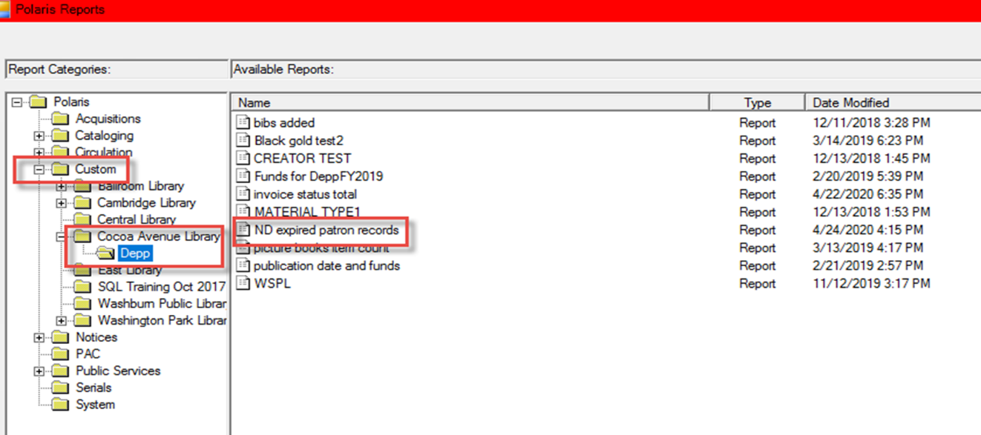

File Maintenance:

- Select Ad-Hoc reports file to open a report that was not saved
- Look for the report type/date
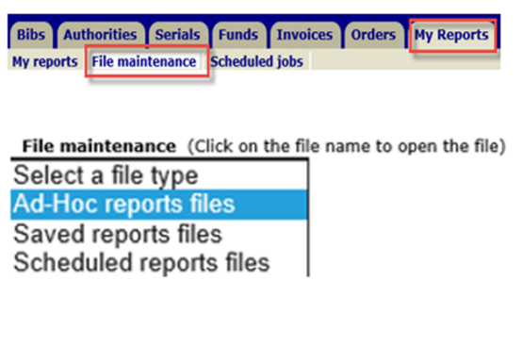

- Click the blue link to open the report
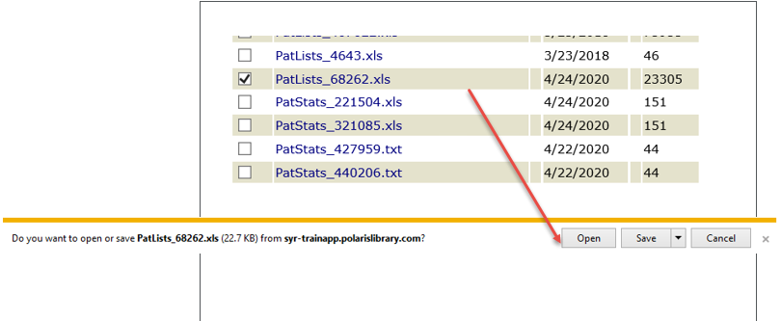

- Select Saved reports File to delete the saved reports
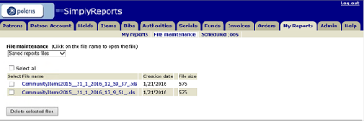

Scheduled Jobs: To delete the scheduled reports no longer needed
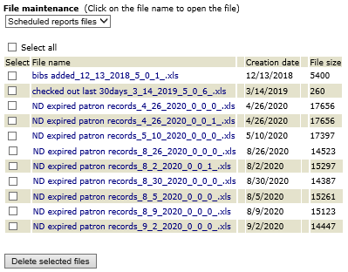

This publication is supplied for the exclusive use of customers of Innovative Interfaces with the understanding that it shall not be shown or distributed to anyone outside of the customer's organization without the prior written permission of Innovative Interfaces. This publication may be copied only if the copies are for the exclusive use of staff members of libraries that have purchased the Innovative system.
© 2022, Innovative Interfaces, Inc.

