Polaris Circulation

ILL Workflow in LEAP

Introduction:
This article explains how to create, receive and manage ILL in LEAP.

Creating an ILL Request:
Search for the patron record in LEAP using the patron name or barcode:

On retrieved patron record, select the Holds/Held tab and click the New Hold icon. (If a hold with status not supplied, active, expired, or inactive exits on the patron record for the title, it can be converted into an ILL request)
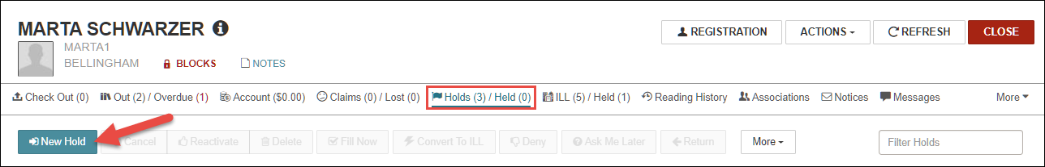

Click Unlock to unlock the hold request (this allows staff to manually complete the request information).
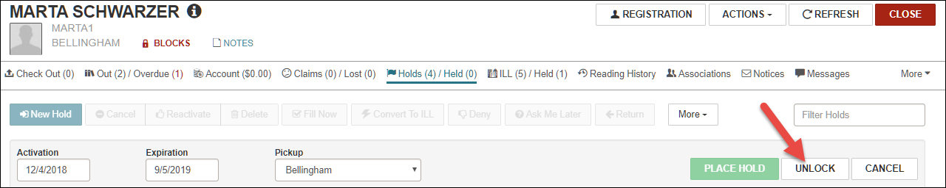

A pop-up will display alerting staff that unlocking the hold request will allow staff to manually edit the request form

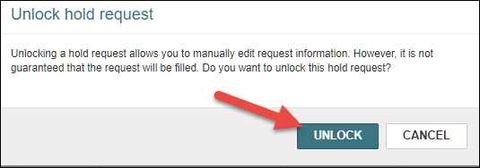

Complete the unlocked hold request with the bibliographic information: select the pickup branch, change expiration date as needed. Click Place Hold.

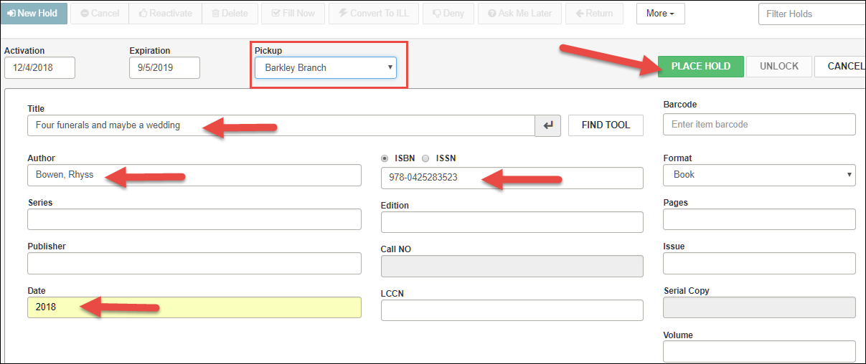

On the patron’s Holds/Held tab, check the box on the unlocked hold request. Notice the request status, it is Not Supplied. Click the Convert to ILL icon.

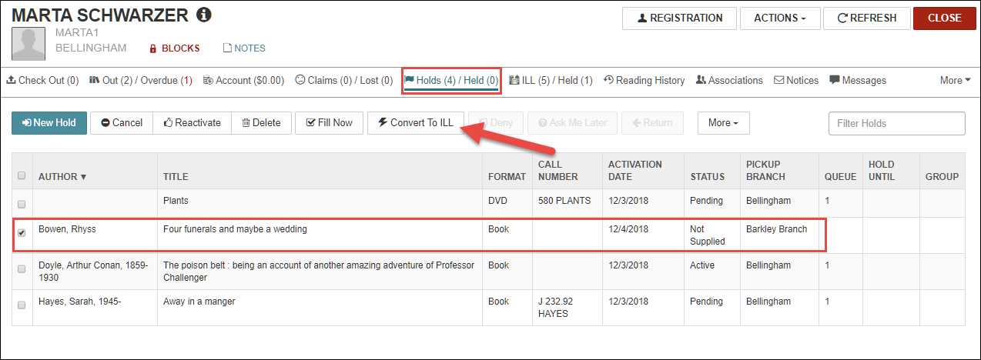

The request is now an ILL Request and can be viewed from the ILL/Held tab of the patron record with a status of Inactive.
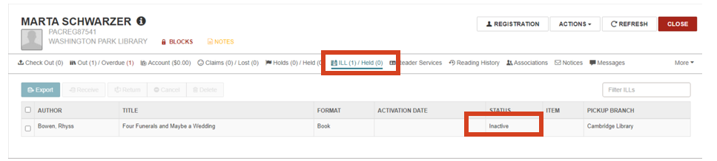
Note: For OCLC users only, check the box next to the request, and click the Export icon to export ILL request to OCLC’s Review File, and to make the ILL request Active. (OCLC information needs to be set up in Admin ILL Settings)
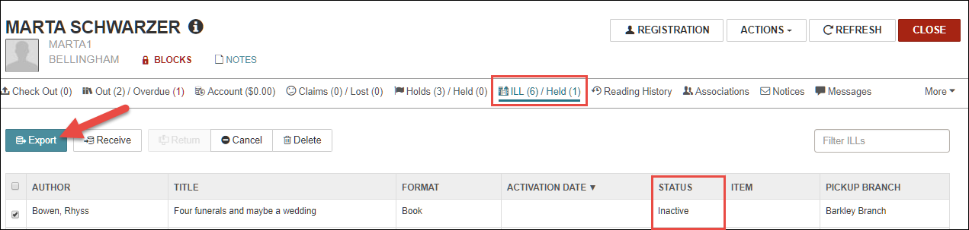
The ILL request status will change to Active.
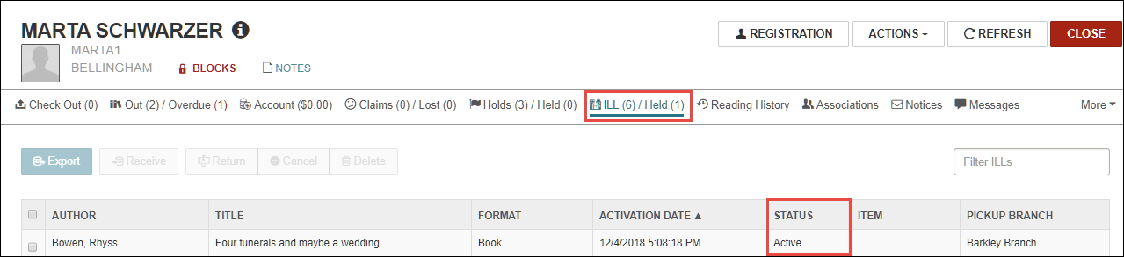

In either scenario (OCLC or other system) The actual request must be placed in the other system. Polaris doesn’t connect to place the request.

Receiving an ILL Requested Item:

In LEAP click Find Tool to open the find tool:
Search ILL Request, by title, author, ISBN, etc. Click the search icon (magnifying glass). Once the ILL request displays in the results, double click on it to open the request.
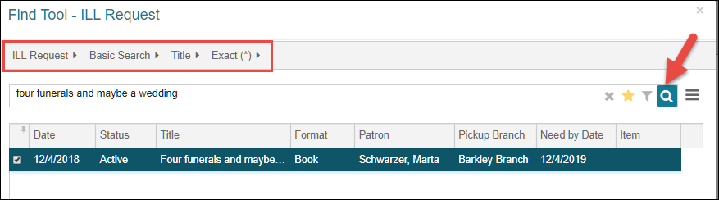
Click the Action icon, and select Receive
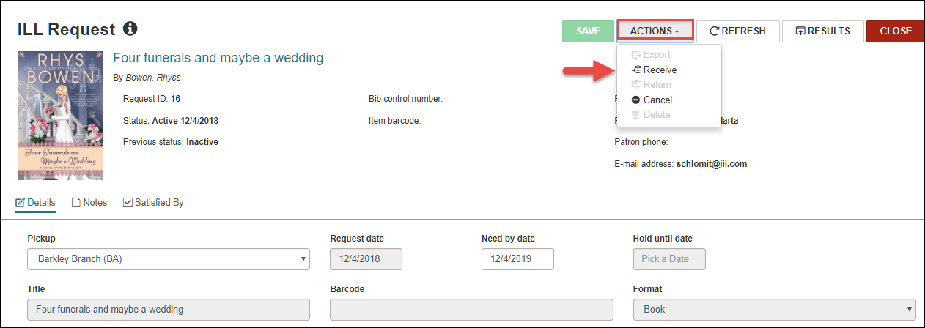

The Receive action will display a pop-up that is used by the system to create the temporary bib and item record, which allows circulating the ILL materials.
Scan barcode on the item and adjust the loan period as needed.

Click Continue to complete the receiving process.

Note: The item is created using an item template (for each branch) that must be named ILL Item.
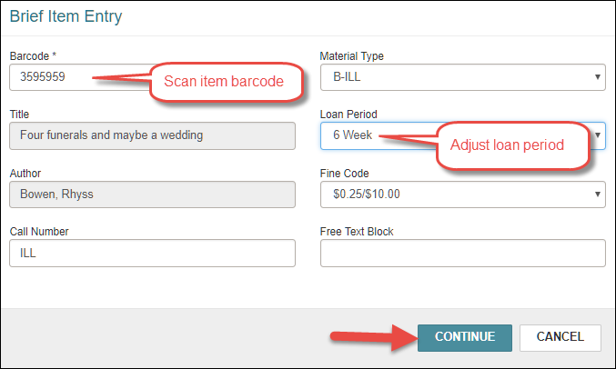

A pop-up displays information confirming that the ILL item was created.
If the ILL request was received at the same branch as the pickup location, the item will be held.

In the example below the ILL item has been transferred (set in transit) to the patron chosen pickup location.
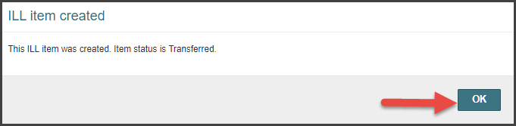

Circulation of ILL Items:

Check out to the patron as normal.
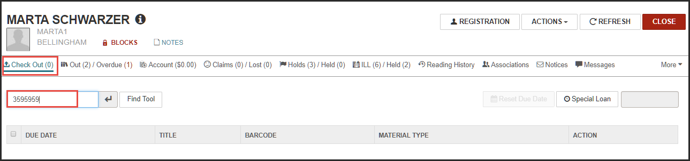

A pop-up shows an item block (that can be overridden) alerting staff that this is an ILL item.
Click Continue.

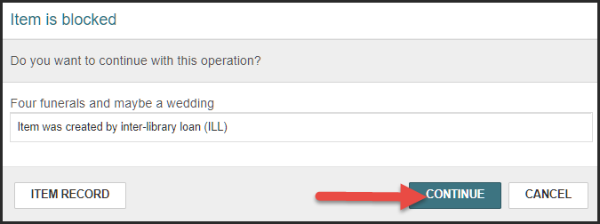

Note: During check out, staff may change the due date using Reset Due Date.

When patron returns ILL item to the library, Use the Check In function to check in the ILL item.
Scan item barcode.
The item block pop-up alerts staff that this is an ILL item.
Click Continue.
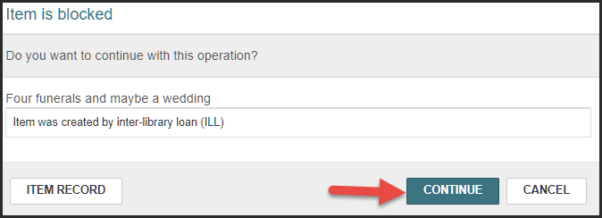
If ILL processing happens at another branch, the item will go In-Transit. Otherwise, the item is checked in and returned to the ILL department.
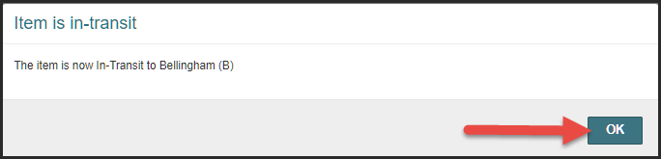
Circulation staff at the branches use the Picklist functionality to get a list of unclaimed ILL requests. A report on unclaimed ILL items is available through the Polaris client.
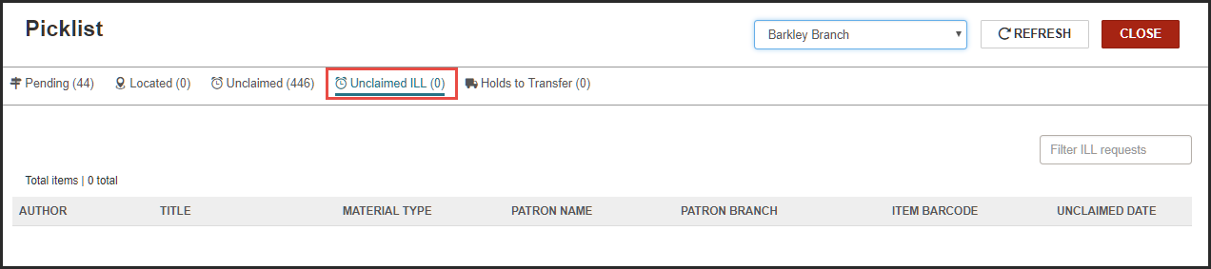
Returning ILL Requested Items:

ILL staff uses the Find Tool to search and retrieve ILL request.
Open the request by double clicking on the selected entry, or clicking the Open icon.
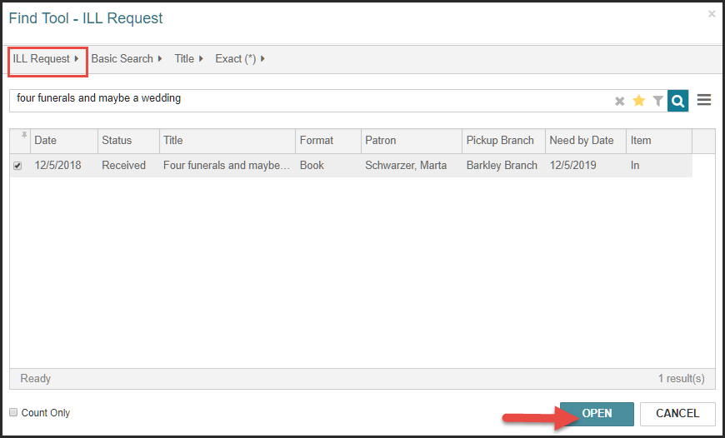
The ILL request displays, select Actions and click Return to move the ILL request to a Returned status. The actual item must be sent back to the owning library through the ILL system.
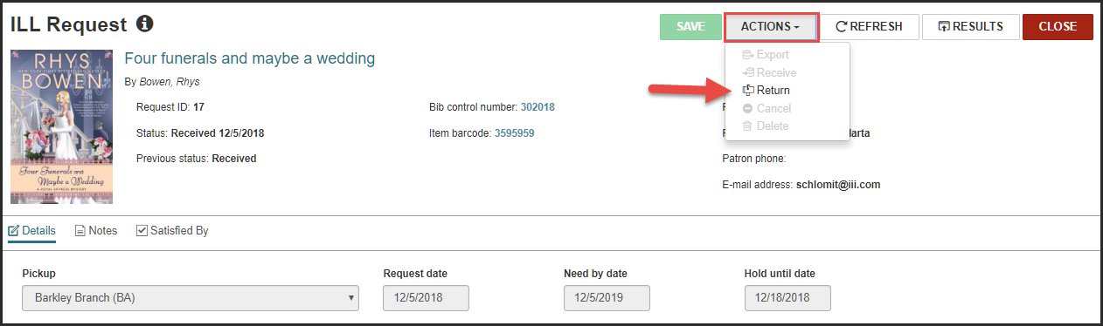

A confirmation message displays alerting staff that ILL request returned successfully.
Once an ILL request is returned, LEAP allows staff to delete temporary bibs and items.
ILL Staff selects Actions and clicks on Delete. A confirmation message displays, confirming that records had been deleted successfully.
Note: At this point the temporary bib and item records are deleted.
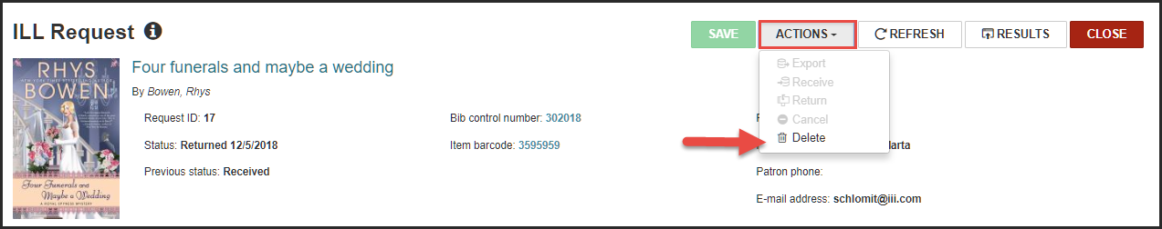
Alternative workflow to delete temporary ILL bibs and items:
ILL staff may opt to delete ILL Request from the Request Manager.
Use the Request Manager to find all ILL Requests in the Returned status. Using the check boxes multiple requests can be deleted at once.
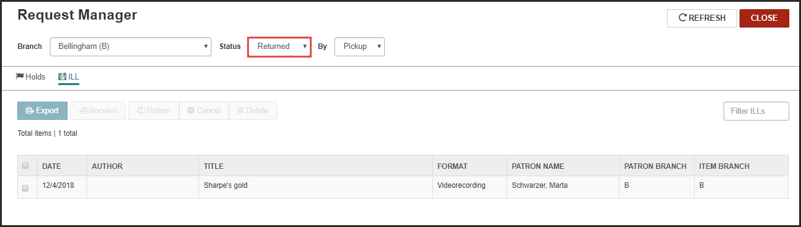
This publication is supplied for the exclusive use of customers of Innovative Interfaces with the understanding that it shall not be shown or distributed to anyone outside of the customer's organization without the prior written permission of Innovative Interfaces. This publication may be copied only if the copies are for the exclusive use of staff members of libraries that have purchased the Innovative system.
© 2022, Innovative Interfaces, Inc.

