leap offline circulation

How to Setup Leap Offline Circulation

Permission based Leap Offline allows you to circulate materials while your database server or network are unavailable.

System Admin Settings

- You must Enable automatic offline uploading: YES​
- Polaris user for automatic upload should be PolarisExec

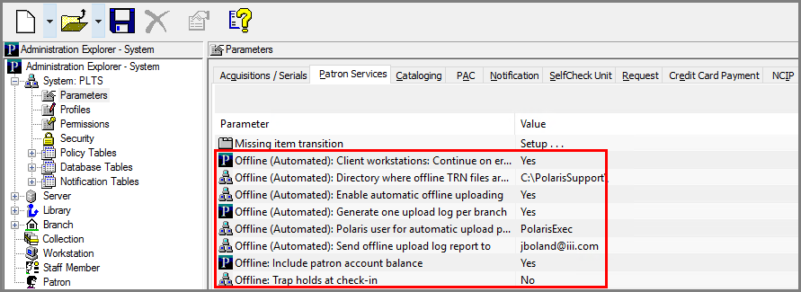

Note: Automatic Offline Processing is not available to Shared Hosted sites.​

Leap Offline Setup Permission

In the Polaris client, go to Administration Explorer, and select:​
Security | LEAP| Setup offline |Allow

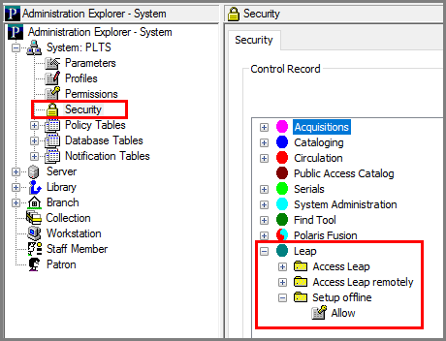

Installing Leap Offline

- You must have the Leap Offline permission enabled and use a compatible web browser to install the application (Not compatible with IE)​
- ​If Leap Offline has not been previously installed, you will see an installation Warning icon. To install, select the Warning icon.​
- Click on Install Offline. A temporary message will display “Installing Offline files.​

​
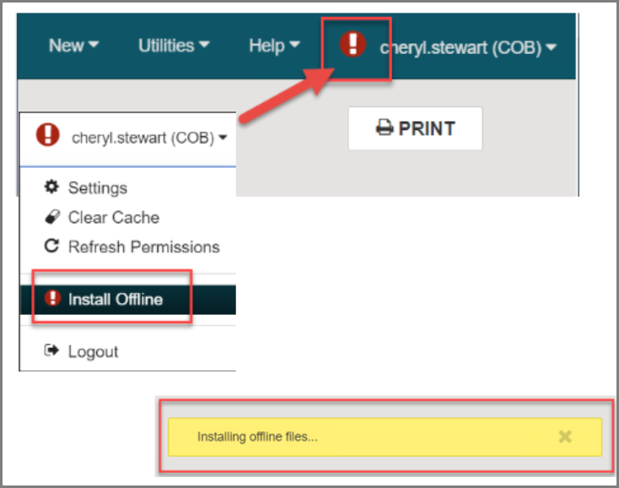

- Once files are installed a confirmation message on a green background will display. ​
- Click on the Leap Offline link.​
- It is very important to bookmark this page, for easy accessibility in the future when offline is needed.

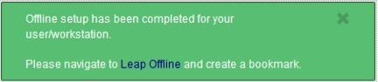

This publication is supplied for the exclusive use of customers of Innovative Interfaces with the understanding that it shall not be shown or distributed to anyone outside of the customer's organization without the prior written permission of Innovative Interfaces. This publication may be copied only if the copies are for the exclusive use of staff members of libraries that have purchased the Innovative system.
© 2022, Innovative Interfaces, Inc.

