polaris powerpac

Setting the dashboard position

In the PowerPAC, the dashboard contains useful options. This can be set on the left or right of the screen. This is set in Systems Administration in the Polaris client: Systems Administration | <level> | Profiles | PowerPAC | Theme dashboard position, in which <level> is System, a specific Library or a specific Branch.

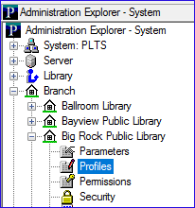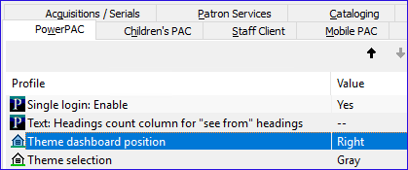

After applying a change, reload the PowerPAC with the following steps:

- Open the Polaris WebAdmin Language Editor and log in.
This is http://[YourCatalogURL]/webadmin/
Example: http://catalog.anygivenlibrary.com/webadmin/
- Click on the second tab, PAC Tools, and you will find a section called Reload.
- From the Reload section you can reload the Power PAC or the Mobile PAC. Click on the link for PAC.
- The PAC will reload. This will take several seconds. During this time, your PAC might be down, or it might look odd; this will end when the reload completes.
- When the PAC Reload is complete, the status to the right of the link you clicked will inform you.
- Open a browser to the PAC or refresh a browser where the PAC is open to see the changes.

Example left side dashboard

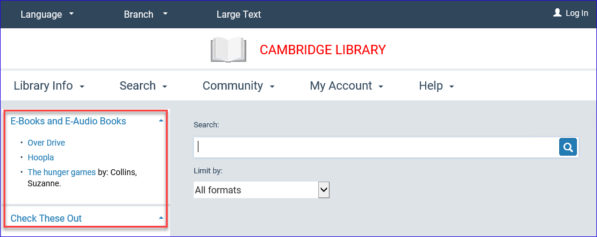
Example right side dashboard

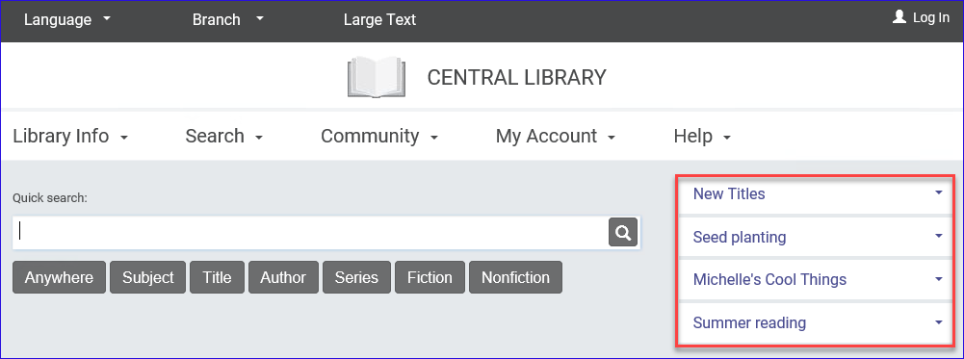
This publication is supplied for the exclusive use of customers of Innovative Interfaces with the understanding that it shall not be shown or distributed to anyone outside of the customer's organization without the prior written permission of Innovative Interfaces. This publication may be copied only if the copies are for the exclusive use of staff members of libraries that have purchased the Innovative system.
© 2022, Innovative Interfaces, Inc.

